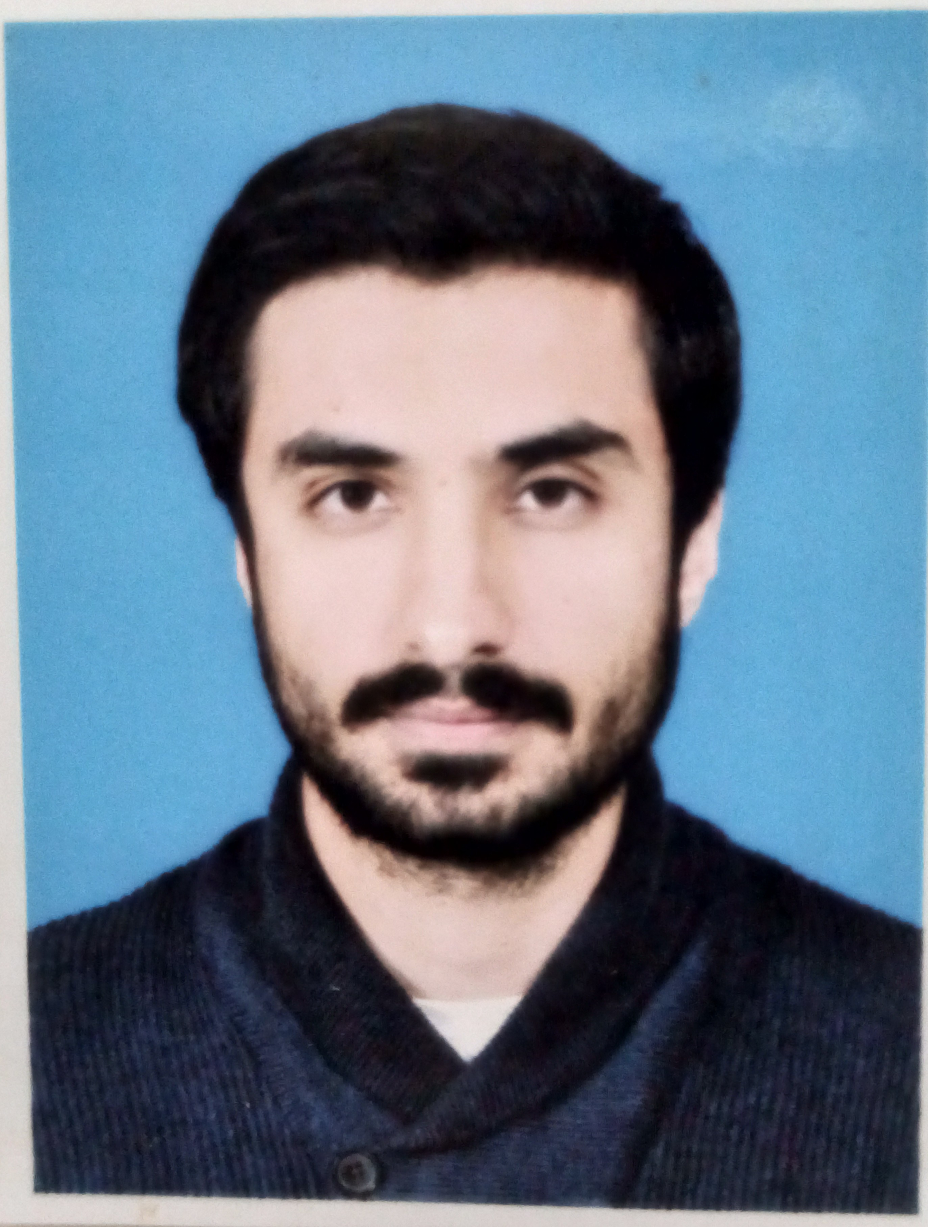

**Dr.Amad**

**uddin Kasi**

03366887663

House#8-19/108Balochistreet ,Qta

amadkasi28@gmail.com

LULsgejkeksA@163.com

* Master in Health Care Management - ZIA UDDIN UNIVERSITY KARACHI (2023 - continued)
* MBBS - BOLAN MEDICAL COLLEGE QUETTA (2016-2022)

**District Surveillance Officer(Quetta) Pathfinder International - BMGF**

**September 2023 TO Ongoing**

* **Strategic leadership -** As a DSO i shared the consolidated data and reports generated through the data with District Health officials and provided with insights on the way forwards and to overcome any problem, if any.
* Ensured prompt response/investigation of any epidemiology significant disease outbreak in the district.
* **Project Implementation -** Ensured that data of PPFP and PAFP was collected, entered timely at the facility level and consolidated at the district level for onward submission to provincial DHIS cell. Ensured the availability of all logistical support required for the indicators of the project and health facilities
* **Technical Assistance -** Provided technical assistance to the management and the healthcare providers at the facility, district and provincial level to initiate PPFP/PAFP indicators recording and reporting process. It was my responsibility to cleanse and prepare data for analysis and report generation for senior management. For an accurate and smooth flow of data I had to forward finalized data to Monitoring and Evaluation Supervisor & MIS Coordinator for analysis and forward the finalized data to the Provincial Coordinator HMIS / DHIS Balochistan.

**EDUCATION**

Looking to work in an organization that offers me a challenging role in the field of public health with career prospects that allows me to utilize my academic background, experience and diverse skills to benefit organization.

To get practical field level experience in areas related to monitoring, surveillance, epidemiology and potential to serve local population and put effort to increase community awareness in areas related to infectious and vaccine preventable diseases and family planning.

**WORK EXPERIENCE**

* **Monitoring, Evaluation and Learning Plans -** Developed monthly work plan and shared with PC DHIS and Project Manager Pathfinder International mentioning the field visits of selected health facility of the district to ensure data reporting, data quality and identify gaps if any. Also responsible to provide on-job coaching to health facility and District DHIS staff member during monitoring visits.
* **Financial and Administrative Operations -** Oversees administrative and financial operations implementation to ensure compliance with pathfinder international policies and contract provisions. Supported in developing budgets for training, printing materials and field visit in alignment with project requirements.
* **Security Standards and guidelines -** Ensured that appropriate security standards, guidelines and procedures are established, maintained, updated regularly and adhered to by the staff in all project office in compliance with donor rules and regulations.
* **Management reports -** Developed and presented timely technical and operations reports and updates on the project progress and difficulties. Documents project achievements for communications materials such as annual reports, brochures and website updates.

**IDSR Master Trainer - JHPIEGO**

**July 2023 - August 2023**

* Government of Balochistan-JHPIEGO partnership program on surveillance and prevention of 33 priority disease.
* Provided training to health care workers of 7 districts on Epidemiology, Surveillance and DHIS data reporting tool and software.

**MEDICAL OFFICER-EXPERIENCE IN HOSPITAL**

**June 2022 - June 2023**

**Wards attended-Medicine, Pediatric, Surgery & Plastic Surgery.**

* Worked under supervision of Senior consultants in clinical management of patients by providing clinical and preventive services as follows
* Take complete history, perform appropriate examination, diagnose and treat patients according to MSF guidelines and protocols under-supervision of senior PG or consultant.
* Adaptation and change of medical treatment according to patient evolving condition.
* Adequate delivery of life-saving measures for emergency & life-threatening conditions.
* Communicate any reportable public health disease (e.g. Measles, AFP and NNT, meningitis, etc.) to expert doctor and/or concerned ward

**Research**

**Leadership Disease Surveillance Data Surveillance and reporting Computer Operating**

**Teamwork Strong Communication**

* Knowledge, Attitude and Practice of doctors of tertiary health care in Quetta towards Needle Stick Injury
* Innovation of telemedicine in primary health care

**SKILLS**

**Writing**

**Speaking**

**LANGUAGES**

**EXECUTIVE MEMBER OF BOLANIAN RESEARCH FORUM**

* Published article on Knowledge Assessment and Attitude of Health Worker of Balochistan towards Needle Stick Injury
* Won 1st prize in poster presentation in Gastroenterology conference Pakistan.

**Member of International federation of Medical Student Association**

* New Technology Support Division Director - BMC LC
* Media support to New Technology Director Pakistan

**Member of Clean and Green BMC**

**ENGLISH Fluent Good**

**URDU Fluent Good**

**PASHTOO Fluent Poor**

**BRAHVI Poor Poor**

**PROJECTS**