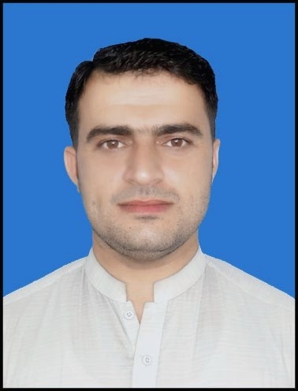
m

Microsoft Word
Microsoft Excel
Good command in all type software installations
LANGUAGES
Personal information

Father Name: Noor Hassan
Religion : Islam
Marital status : Married
CNIC : 17301-3775499-7
Cell # : 03005833205
Email : amjadafridy@yahoo.com
Address : Arhat baba Sherkera Peshawar

SOFTWARE
- English
- Urdu
- Pashto
Hobbies
News, Driving,
Traveling

JOB Experience
- Area Supervisor in CBV programme ( still working from 2015 )
- Private Teaching in Alkhedmat model school ( from 2013 to 2015)

Objective
To utilize my technical skills for achieving the target and developing the best performance in the organization. I would like to implement my innovative ideas, skills and creativity for accomplishing the projects

AMJAD HUSSAIN
as
Personal Skills
Ability to be a leader & to be a loyal
Experience of working in a team
Excellent Presentation and communication skills

Will time mangement & leadership qualities

Education

Degree Title | Obtained Mark's | Total Mark's | Board/university
SSC | 517 | 900 | B.I.S.E Peshawar
FA | 566 | 1100 | B.I.S.E Peshawar
BA | 777 | 1100 | Aiou

