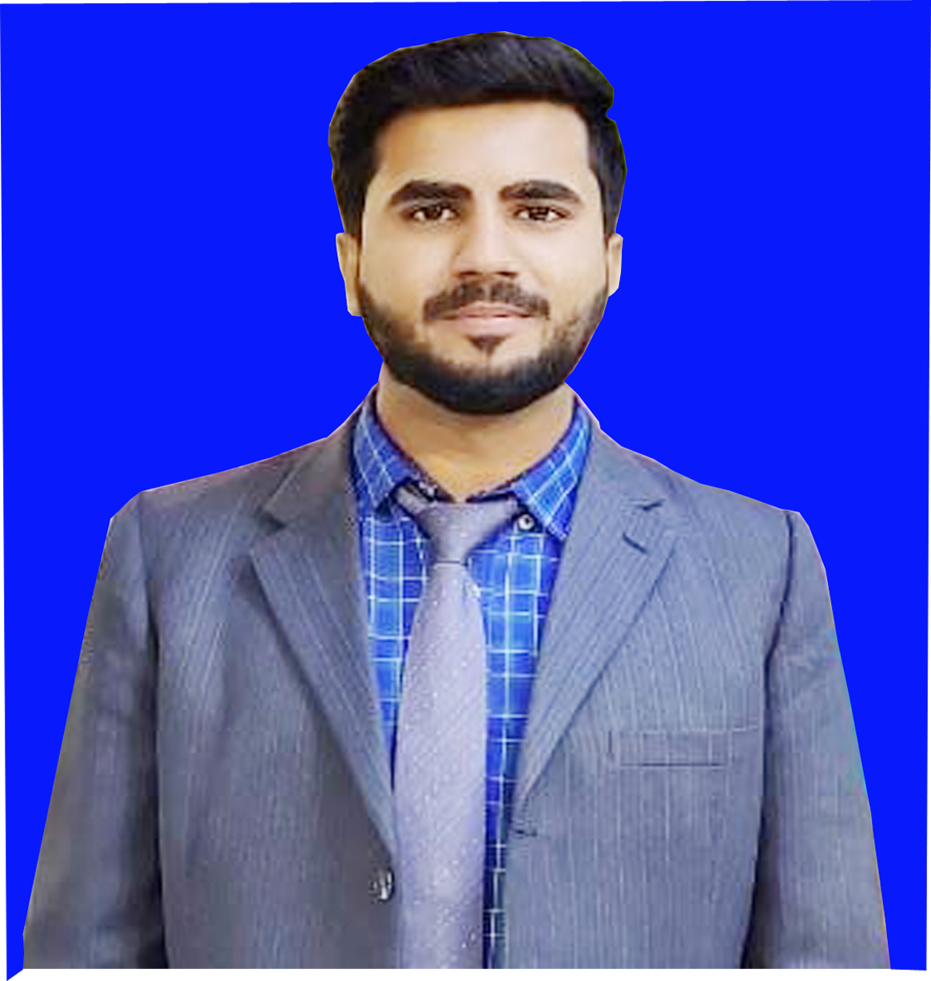

Passport

Size

Photo

**URRICULUM**

**ITAE**

**ANEES QAMAR**

Address : B552 Sector 4 AhsanAbad Karachi.

E-mail Address : **aneesqamarabro615@gmail.com**

Cell# : 0307-3313615, 0318-0348238

**OBJECTIVE:**

To work in an organization which would provide ample opportunities for personal grooming and working as a team player

**PERSONAL INFORMATION:**

* Father’s Name : GhulamNabi
* Date of Birth : 12thApril, 2001
* CNIC No : 45302-0345240-7
* Marital Status : Unmarried
* Religion : Islam
* Nationality : Pakistani
* Domicile/PRC : District Naushahro Feroze (Sindh Rural)

**ACADEMIC QUALIFICATION:**

* M.A in Sociology continue…
* B.A In (Political Science) from (SBBU) ShaheedBenazeerAbad .
* Intermediate(Science) In Grade “A” in 2018, from B.I.S.E Sukkur Sindh.
* Matriculation(Science) In Grade “A” in 2016, from B.I.S.E Sukkur Sindh.

**OTHER QUALIFICATION:**

* 06 Months C.I.T Course at Lingua P.I.A CampusG-Johar karachi.

**COMPUTER SKILLS:**

* Ms. Word
* Ms. Excel

**EXPERIENCE:**

* 2 Years Experience.as a Admin in Averroes public school Dhani Bux Goth Karachi.
* 8 Months Experience as a Supervisor in Aurat Foundation (AF)
* 6 Months Experience as a Supervisor in Benazir income support (B.I.S.P)
* 3 Months Experience as a Validator in SEF Schools.

**ACHIEVEMENTS:**

* Head Teacher Training Program Organized By SEF.
* Best Performance Certificate Awarded in 2020-21 by Averroes public School.
* Best Performance Certificate Awarded in 2022-23 by Sunlight Public school.
* VTT Global (Validator) by SEF

**LANGUAGES:**

* Sindhi
* Urdu
* English

**REFERENCE:**

* Reference will be finished upon request.