|  |  |
| --- | --- |
| Dr. Anum Abdullah  House #297, St #58, i-8/2, Islamabad.  (+92)3355276467  anumrmc@hotmail.com  Rizwan Abdullah  Beckerstraße 2 1/4  Ingolstadt, Bavaria, 85049  017673902354  Rizi.abdullah@gmail.com |  |

**CAREER GOAL**

I aspire to leverage my qualifications and professional knowledge to make a positive impact in the community. As a hard working, diligent and result oriented individual, I am committed to utilizing my skills in the field of public health and community medicine. Rather than limiting myself to academic teaching, I am passionate about actively engaging in fieldwork to drive real change.

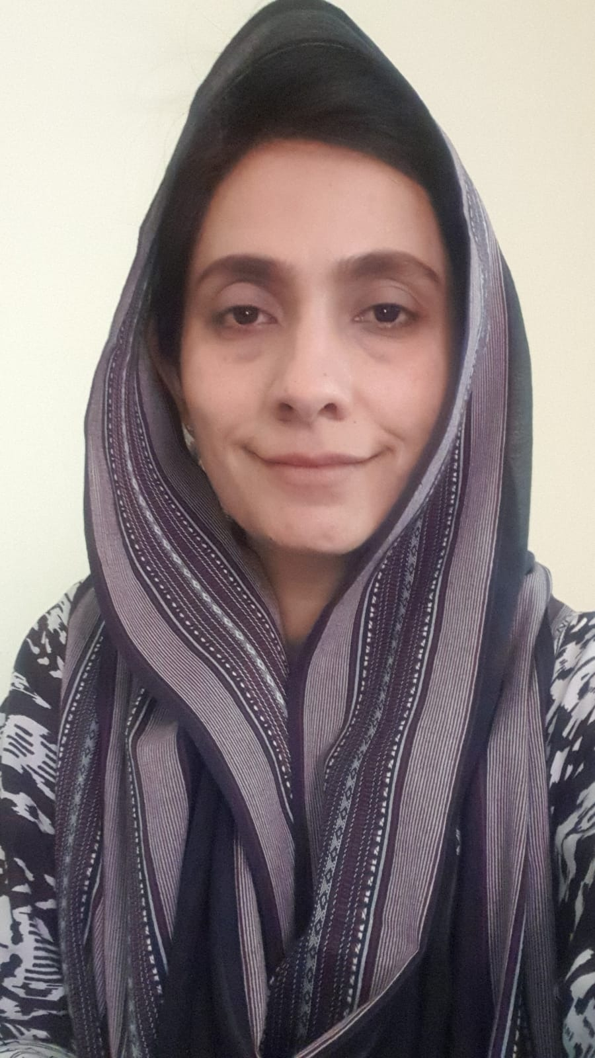

**PRACTICAL EXPERIENCE**

|  |  |
| --- | --- |
|  |  |
| **03-2023 – Present** | **Internship in WHO, Pakistan**   * Supported in Surveillance Training for DSOs and IOs. * Report Writing. * Intra-Campaign Monitoring Support in Islamabad. * Support in Hangu, Kohat for Outbreak Investigation. |
| **04.2018 – Present** | |  | | --- | | **TELEMEDICINE GENERAL PHYSICIAN - Sehat Kahane** | | * Generating daily and weekly reports for such clinics, that adds to the analytical database for future medication and prevention analysis. * Working as telemedicine general physician in a Karachi based company Sehat Kahani, that serves under privileged population in peripheries of Sindh ,KPK and Punjab. * Managing a daily clinic over video conference with support of on-site nursing staff, in rural areas of Sindh. * Educating and emphasizing on the patients and nursing staff the preventive aspects of health problems. | |
| **02.2018 – 01-2022** | **FCPS Training Program** |
|  | During the four years extensive training program, the diverse dimensions of community medicine and public health were covered.   * Organized regular field visits to rural health centers, water sewage and treatment plants, EPI centers , food regulatory authorities, schools etc. were done regularly. * Arranged awareness campaigns were conducted involving 4th year mbbs students, by choosing an appropriate health related topic ( dengue, malaria, congo virus, dehydration, WHO health days etc) and then conveyed to general population emphasizing on the role of prevention. * Active involvement in carrying out research projects with profound knowledge of research protocols and ethics. Each year helped students conduct two research projects. * Was able to actively collaborate with other hospital departments as well as lower staff, good amicable team work. * Having grip on research analysis using SPSS statistical analysis, data management , data presentation, use of Microsoft excel. With good handling of multiple tasks and delivering them on time. have been a part of conducting workshops on research analysis and its protocols. * Presented research work at RMU international research conference in 2020, 2021. |
|  | **VOLUNTEER WORK**   * Participated in 2010 flood relief efforts in Charsadda, KPK, distributed necessary medication and basic life support equipment under supervision of Rawalpindi Medical College. * Participated in 2022 flood relief efforts in district Ghotki, Sindh; formulated brochures for preventive medication, mosquito repellants, soaps and basic hygiene. * Arranged COVID awareness campaigns in district Attock, Punjab, targeting rural population. |

**EDUCATION**

|  |  |
| --- | --- |
| **02.2018 - 01.2022** | **FCPS Community Medicine and Public Health**  *Rawalpindi Medical College*  **Relevant Courses covered in FCPS:**  Epidemiology, Biostatistics, Primary Healthcare, Communicable and Non-communicable Diseases, Ergonomics, Demography, Environment, health system management, health economics, leadership, health policy, disaster management |
| **06.2006 – 07.2012**  **SKILLS** | **Bachelor of Medicines and Bachelor of Surgery (MBBS)**  *Rawalpindi Medical College* |

|  |  |  |
| --- | --- | --- |
| * Highly proficient in MS Word, MS PowerPoint, MS Excel and SPSS. * Experienced in research and data analysis. * Languages: English, Urdu, Punjabi. |  | |
|  |  |

**ACADEMIC REFERENCES**

**Name:**  Dr. Syed Arshad Sabir

**Institute:** Rawalpindi Medical University.

**Email:** sabirali1930@gmail.com

**Phone Number:** 03355787273

**Name:** Dr. Sana Bilal

**Institute**: Rawalpindi Medical University

**Email:** sanamzhar@gmail.com

**Phone Number:** 03216344553