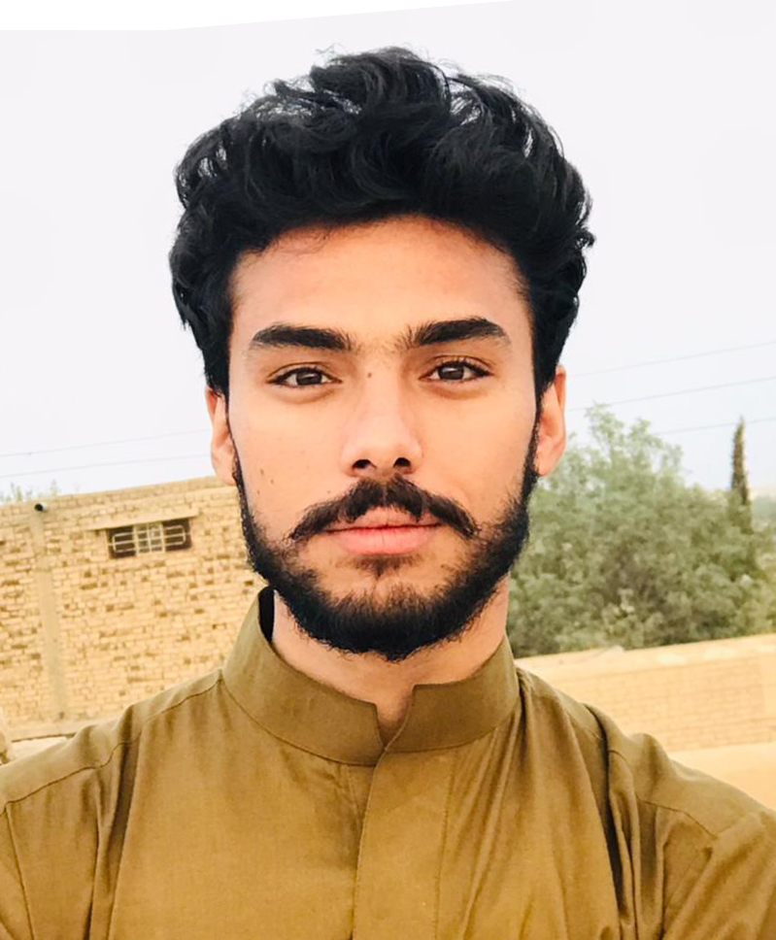

Arsalan Wahab

Contact

**Current Address:**

Near Al Falah Masjid, Truck Adda, Mastung.

**Contact No:**

0336-3123659

0318-8030799

**Email:**

[mirxadaarsiirodeni007@gmail.com](mailto:mirxadaarsiirodeni007@gmail.com)

Languages

English – (R, W, S)

Urdu – (R, W, S)

Brahui – (R, S)

Hobbies

* Writing
* Playing Cricket
* Photography
* Tourism

Career Objective

* To attain in my profession while serving at responsible and challenging position in a reputable organization for gaining experience and heading towards perfection.

Personal Information

|  |
| --- |
| * Father’s Name: Abdul Wahab * Nationality: Pakistani * Date of Birth: 10th February, 2000 * CNIC No. 51602-2455280-9 * Local: Mastung * Marital Status: Single |

Education

* BBA (Hon’s)2022 University of Balochistan.
* B.A in History (2022) University of Balochistan.
* F.Sc (2018) Balochistan Board.
* Matric (2016) Baloshtan Board.

Experience

* 2 years teaching experience in Hira high school Mastung.
* Served as TUSP for 1 year in mastung.
* Worked 6 months as visiting staff in Sub-Campus Mastung.

IT Skills

* Microsoft Word
* Microsoft Excel
* Microsoft PowerPoint
* Internet Browsing

Personal Attributes

* Consistent and enthusiastic in doing my work.
* Proven tact and diplomacy in handling interpersonal relationship.
* Organized, efficient, motivated and honest person.