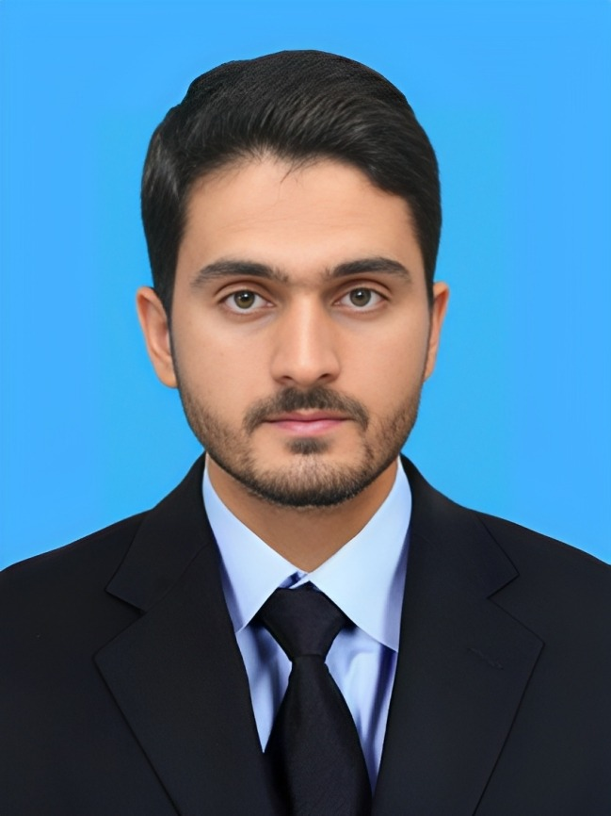
About
Father Name: Shahid Nawaz Khan
Marital status: Single
Religion: Islam
DOB: 17th January 1998
NIC No: 11201-4403111-3

Cell phone:
+92341-9336667

Email address:
asadn657@gmail.com

Postal Address:
Mohalla Baker Khel Village and Post Office Tajori, Lakki Marwat

Languages:
Pashto
English
Urdu

References
Usman Saif Ullah Khan
Ex-Senator
Cell: 0313-9775599

Professor Nasreen Ghufran
University of Peshawar
Cell: 0323-9592325

Interests
- Watching Documentary
- Welfare works
- Meeting friends
- Cricket
- Reading Newspaper

Asad Nawaz
Master’s in International Relations

Objectives

Working hard and having team spirit thereby anticipating and meeting the challenges arising in the contemporary competitive business environment integrity and given to sustained hard work. If provided with an opportunity, I shall try my level best to satisfy my superiors in rightful discharge of my duties.

Education

- MA in IR
762/1100
2017-2020
University of Peshawar
- BA in English literature and Pol Science
Division 1
Government College, Tajori
- FSC
Grade A1
2017
Government Post Graduate College, Lakki Marwat
- Matric
Grade A1
2015
Suffah Public High School Tajori

Courses
- English language Diploma
Marks 92%
KELC Peshawar
2020
- Diploma in Office Automation
Marks 80%
Peshawar technical board
2021
- Certificate of Middle School Teaching
AIOU 2016
- Certificate of Human Resource Management
Great Learning Online website
- Digital Marketing Course
Digi Skills Course 2020
Working Experience
- Working part-time as SEO Content Writer with Info Guard Technologies LLC
- Worked as an Online Multimedia Journalist for Herald Prime Online Newspaper.
- Worked as Office Assistant at Suffah Public High School and College, Tajori
- Worked as an English language teacher at Model School and College, Tajori
- Worked as online Social Media Manager at Ufone.

Key Skills

- MS Office
- MS Excel
- MS PowerPoint
- Office Administration
- Google Analytics
- Project Management
- SQL (Structured Query Language)

