ASMAT KAMAL MAHSUD 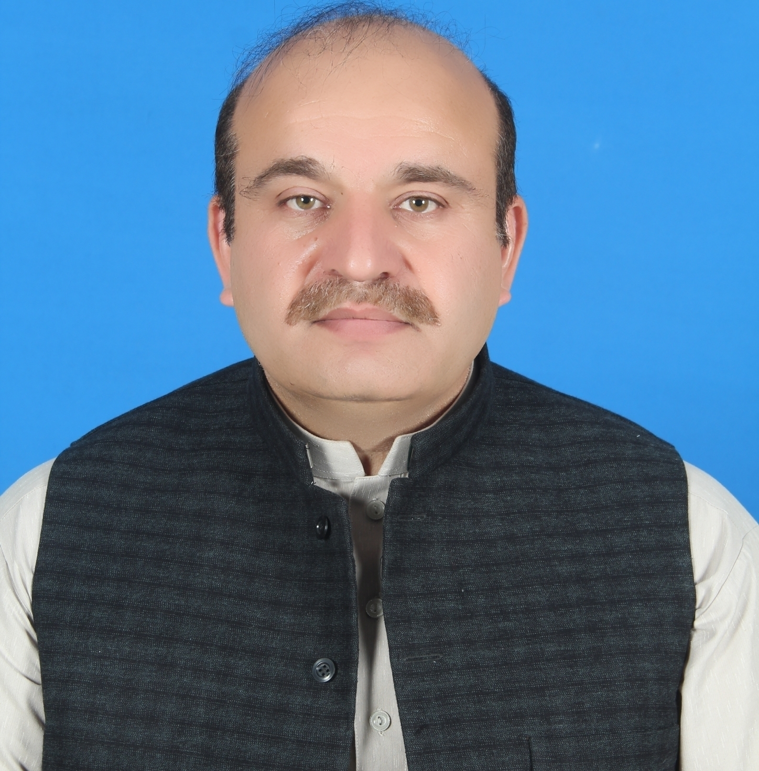
Objective: Having Zeal for Managing Team Through Coordinate Efforts by Using Minimum Resources & Achieving Maximum Output

Personal Profile:
Name | Asmat Kamal Mahsud
Father’s Name | Muhammad Tariq
D.O.B. | 01-05-1976
CNIC | 21703-2447592-7
Domicile | South Waziristan
Nationality | Pakistani
Marital Status | Married
Religion | Islam
Present Address | House# 04, Near EDO (H) Office, Khakwani Town, Sheikh Yousaf, Dera Ismail Khan, Khyber Pakhtunkha
Permanent address | Village Qalandur Spin Kamar, Tehsil Makin, South Waziristan
Telephone # | 00-92-333-9950648 / 00-92-345-5981728
Email Address | kamalmahsud777@gmail.com
Languages | English, Urdu, Pashto, Siraiky, Panjabi
IT Skills | MS Office(Word, Excel, Power point)
Personal Traits | Leadership & Management, Interpersonal Communication, Time Management, Ability to work under pressure & manage stress, Ability to work effectively and efficiently with a culturally diverse team, Flexible and Adaptive to changing needs and priorities
Professional Expertise: (19 Years of Working Experience Including 12 years at Managerial cadre)
Organization | Designation | District | Start date | End Date | Duration | Project | Donor
Khwendo Kor | Project Manager | Bannu | 18-05-2023 | Present |  | Interest Free Loan | PPAF
Islamic Relief Pakistan | Senior Project Officer/ Project Manager | DI Khan | 03-10-2022 | 15-04-2023 | 6.5 Months | Flood Emergency Response KP | DEC
Micro Merger | Field Monitor | South Waziristan | 08-02-2021 | 30-09-2022 | 1 Year 08 Months | Monitoring Polio Eradication Program | UNICEF
Directorate of Social Welfare/ ASK Development | District Coordinator | South Waziristan | 15-04-2019 | 31-12-2020 | 1 Year 8.5 M | Child Protection | UNICEF
Step Towards Empowerment Pupil (STEP) | District Coordinator | Tank | 16-04-2018 | 15-09-2018 | 5 Months | Long Term Observation of General Election 2018 | FAFEN, USAID
Trust for Democratic Education & Accountability (TDEA) | District Coordinator | Tank | 11-12-2017 | 08-04-2018 | 4 Months | Long Term Observation of General Election 2018 | FAFEN, USAID
CHIP Training & Consulting (CTC) | Agency Health Communication Support Officer | South Waziristan | 20-09-2016 | 26-10-2017 | 1 Year & 1 Month | Polio Eradication Initiative Program | UNICEF
Prime Institute Of Public Health Prime Foundation | District Coordinator | Tank | 01-08-2015 | 15-06-2016 | 1 Year | Maternal & Child Health | TVI, Agha Khan University
Community Development Organization (CDO) | Project Coordinator | South Waziristan | 01-06-2014 | 31-07-2015 | 1 Year & 2 Months | CMAM | UNICEF, WFP
UN-IOM | Agency Development Officer | South Waziristan | 02-01-2013 | 20-02-2014 | 1 Year & 2 Months | FATA Secretariat Program | USAID
Khwendo Kor (KK) | Regional Project Manager | Bannu, SD Bannu, Tank, South Waziristan | 13-07-2010 | 31-12-2012 | 2 Years & 6 months | Child Protection,  Adult Literacy & women vocational Skills, Education, Human Rights, Flood relief & Rehabilitation | UNICEF, CIDA UN Women, Action Aid, FOSI, UNESCO , NFSC
Dawood Family Takaful (DFTL) | Takaful Manager | Peshawar | 01-01-2010 | 30-06-2010 | 6 Months | Islamic Insurance | Dawood
Agha Khan Development Network (AKDN) | Master Trainer  M&E Officer | Muzafar Abad AJ&K | 01-01-2009 | 31-12-2009 | 1 Year | MERP/ WASH | Agha Khan Foundation
National Rural Support Program (NRSP) | Training Coordinator,  Master Trainer, M&E Officer, District Recovery Officer, Social Organizer In-charge, Credit Officer | Muzafar Abad AJ&K, Bhakkar, Attock | 01-10-2004 | 31-12-2008 | 4 Years & 3 Months | CBDRM, CLRP, RISE,WASH, SLBAP, BVDP, | Diakonie Emergency Aid, FAO,ERRA, USAID, IFAD, PPAF, World Bank
Pakistan Mineral Development Corporation (PMDC) | Marketing Supervisor | Khwera Jhelum | 01-09-2003 | 30-09-2004 | 1 Year & 1 Month | Salt Production & Export | Govt of Pakistan

Trainings:
Training Name | Conducted by | Start date | End date | # 0f days | Venue
Child Protection | Social Welfare/ECI | 24-06-2019 | 29-06-2019 | 06 | Peshawar
Communication Skills Management | UNICEF | 06-06-2017 | 07-06-2017 | 02 | Peshawar
Leadership & Management Skills | UNICEF | 02-11-2016 | 05-11-2016 | 04 | Nathia Gali
Lot Quality Assurance Sampling | WHO | 04-10-2016 | 05-10-2016 | 02 | Peshawar
Maternal & Child Health Care | PIPH Prime Foundation | 03-08-2015 | 05-08-2015 | 03 | Peshawar
Community Based Management of Acute Malnutrition | CDO | 02-06-2014 | 04-06-2014 | 3 | Dikhan
Pakistan Security Awareness Induction | UN-IOM | 08-10-2013 | 11-10-2013 | 4 | Islamabad
Project Cycle Management & Proposal Writing | Khwendo Kor | 19-09-2011 | 24-09-2011 | 6 | Peshawar
Strategic Vision & Sleep Management | Time lenders | 05-02-2011 | 08-02-2011 | 4 | Peshawar
Strategic Time Management | Time lenders | 02-02-2011 | 04-02-2011 | 3 | Peshawar
Advocacy & Lobbying Skills | Khwendo Kor | 07-12-2010 | 11-12-2010 | 5 | Peshawar
Finance & Accounts | AKDN | 15-06-2009 | 20-06-2009 | 6 | Muzafar Abad
Basic First aid | PRCS | 17-10-2007 | 30-10-2007 | 14 | Islamabad
TOT for Community Based Disaster Risk Management | FOCUS Humanitarian Assistance | 10-09-2007 | 30-09-2007 | 21 | Islamabad
OTW (Orientation Training Workshop) | NRSP | 02-05-2005 | 15-05-2005 | 14 | Islamabad
CART (Credit Appraisal & Recovery techniques) | NRSP | 06-12-2004 | 11-12-2004 | 6 | Islamabad
Qualifications:
Degree | Subject | Institution/Board | Start date | End date | Obtained Marks | Total Marks | %age | Div/Grade
M.sc | Geography | University of Peshawar | 15-01-1999 | 31-01-2001 | 701 | 1200 | 58 | 2nd/C
B.Sc | Botany, Zoology Geography | GDC Tank/ Gomal University Dikhan | 30-09-1996 | 30-09-1998 | 330 | 550 | 60 | 1st/B
F.Sc | Pre-Medical | D.J. Science College Karachi / BISE Karachi | 10-09-1993 | 01-11-1995 | 670 | 1100 | 61 | 1st/B
S.S.C | Science | MLW High School Makerwal/Mianwali/BISE Sargodha | 15-03-1983 | 30-04-1993 | 639 | 850 | 75 | 1st/A

References:
Name | Designation | Organization | Email | Telephone
Mr. Khalid Usman | Executive Director | Khwendo Kor | khalidus2001@yahoo.com | 0345-9644321
Dr. Muhammad Sharif | Deputy Director Health | PIPH Prime Foundation | msharif@piph.prime.edu.pk | 0347-9700252
Mr. Sikandar Sher | Program Manager | CDO | ssmaneri@yahoo.com | 0346-9361335
Mr. Aamir Zaman | Provincial Coordinator | Micro Merger | Pc.kp@pk.micromerger.com | 0346-9196805
Mr. Muhammad Rohail | District Coordinator | Islamic Relief Pakistan | Muhammad.rohail@irp.org.pk | 0300-8436209

