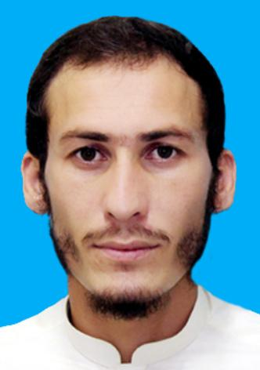***ATTA ULLAH***

***Cell No*: 0300-0035679/0333-3326320**

***Email Address*:attaullah4382@gmail.com.**

**Personal Details**

* ***Name:*** ATTA ULLAH
* ***Father Name***: Sawab Khan
* ***CNIC:***21202-0465133-7
* ***Domicile*:** DistrictKhyber
* ***Address***: Koki Khel, Sher khan Khel Safeer Abad, Jamrud Ghundi District Khyber .
* ***Religion*** :Islam
* ***Nationality*** : Pakistani
* ***Date of Birth***: 01 January 1997
* ***Relationship status:*** Married

***Educational Summary***

|  |  |  |  |  |
| --- | --- | --- | --- | --- |
| Qualification | Marks | Passing Year | Percentage | Institute/Board |
| M.A(Social Work) | 615/1100 | 2021 | 55.90% | University of Peshawar |
| B.Sc | 302/550 | 2018 | 54.90% | University of Peshawar |
| F.Sc | 660/1100 | 2016 | 60% | BISE Peshawar |
| Matric | 844/1100 | 2014 | 76.72% | BISE Peshawar |
| Diploma In information & Technology | 1017/1400 | 2023 | 72.64% | Khyber Pakhtunkhwa Board of Technical & Commerce Education |

***Experience***

* 1 year in administration at Bacha Khan University Charsadda
* One year internship in Special education complex Hayatabad

***Interest & Hobbies***

* Traveling and Tracking
* Learning New Ideas
* Reading Books
* Internet Surfing
* Social gathering

***Languages***

* English
* Urdu
* Pashto

***References***

* **Dean Faculty of Social Sciences Arts & Humanities**

**Professor Dr Syed Salim Shah**

**Email*:***drsmshah@bkuc.edu.pk