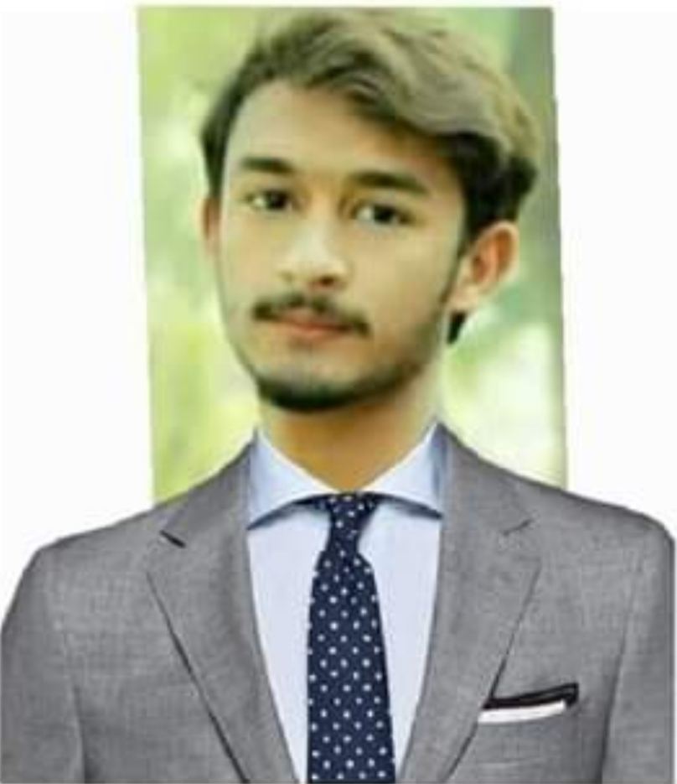

**Atta Ur Rahman**

**S/O**

**Hafeez ur Rahman**

**Mailing Address: Permanent Address:**

|  |  |
| --- | --- |
| Mohalla ismial khel Village totakan  Tehsil batkhela distt malakand, pakistan  Contact No. 03463985288  03189809603 | Mohallah Ismael Khel Village Totakan,  Tehsil batkhela District Malakand,  Kpk, pakistan  Ph# 03463985288  Email:www.attakhan1324@gmail.com |
|  |  |

***CAREER OBJECTIVE***

To contribute through my best efforts to the organization with hard work, sincerity, knowledge and achieve the goal of organization which will utilize my theoretical and practical concept of professional Management.

***EDUCATION***

**BS in English**

2018-2022

Marks: CGPA 3.22/4.00

Department of English literature and linguistics

ABASYN UNIVERSITY PESHAWAR

**SSC**

2014-2016

Marks: 909/1100

Percentage: 82.64

Division: 1st

B.I.S.E Malakand

HSSC

2016-2018

Marks: 813/1100

Percentage: 73

Division: 1st

B.I.S.E Peshawar

***PROFESSIONAL EXPERIENCE:***

* Worked as a teacher in the Oxford education academy batkhela

***LANGUAGES***

* English
* Urdu
* Pashto

***SKILLS***

* Good interpersonal and cross cultural skills.
* Crisis handling.
* Flexible Nature.
* Ability to work in a team to make timely and quality judgments
* Compliance issue resolving.
* Communication in a credible and effective way.
* Expert in Literature and linguistic
* Expert in MS office
* Expert in Excel sheet
* Having the knowledge of bank Account openin
* Having the Good communication skills
* Team player with excellent interpersonal skill
* Having the knowledge and use of information technology
* Strong analytical and problem solving skills
* Excellent verbal and communication skills in English

***REFERENCES: Will be furnished on request.***