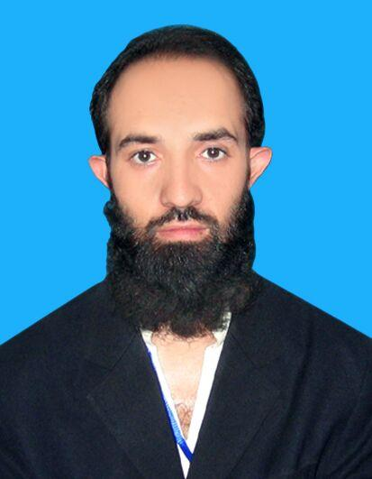
Atta-u-llah

Cell No:​​ 03121992098
ADDRESS: Doura Road Afridi Abad Near Govt S.S College Kohat Road Peshawar .
Email: ansari.khan2010@gmail.com

OBJECTIVE
To join an organization where I can grow on the basis of my personal abilities and to provide effective and efficient service to the best of my knowledge. To work devotedly in dynamic environment to fill full the organization and personal goal.

PERSONAL PROFILE
Father’s Name | : | Muhammad Rasool
DoB |  | 30-Nov-1989
CNIC | : | 17301-1285785-9
Religion | : | Islam
Marital Status | : | Married
Nationality | : | Pakistani
Gender | : | Male
Languages | : | English, Urdu, Pashto

EDUCATION

Certificate/Degree | Year | Marks | Grade/Division | Board/Institutions
SSC | 2006 | 534/1050 | ₂rd​ Div. | BISE Peshawar
S..s.c | 2006 | 534 | ​2nd | Bisep
HSSC(Comp SC) | 2009 | 554/1100 | ₂st​ Div. | BISE Peshawar
H.s.s.c | 2010 | 555 | ​2nd | Bisep
BS(IT) (Hon) | 2014 | 3.10/4.00 | A Grad | The University Of
 |  |  |  | Agriculture IBMS
 |  |  |  | Peshawar

EXPERIENCE:

- 2 Months IT technical support ( North ) PTCL Peshawar Telephone house.
- 3 years Computer Operator and Technical work too in Corvit Center
- 8 Months work in ACC (Afghan citizens card) Nadra Project as System Engineer.( ERP NO 55816).
- 3 year Computer Teacher & computer operator in The knowledge core Education System .
- 2 months IT Admin in Al Kuwait hospital
- 2 years Data Entry Operator in Panahgah (langarkhana) project with Pakistan baitul Mal
COMPUTER SKILLS
Certificate | Year | Institute
MS Office & Internet | 2006 | Skill development council
Web & Development | 2013 | IT all-rounder
Hardware & Software | 2006 | Corvit systems Peshawar
Cwna | 2013 | IT all-rounder
Graphic Designing | 2006 | CVA (creative visual Art)
Hardware | 2013 | Leads training center
MCITP | 2011 | Institute Of Computer And Network Engineering
ISP (1 Day Workshop) | 2011 | Institute Of Computer And Network Engineering

HOBBIES

- Reading Books & News Paper

- Playing Cricket

- Walking

