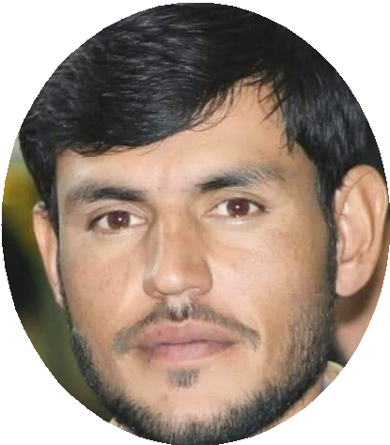Atta ullah

## Community Pharmacist

 +92.313.8517900  [attaksf900@gmail.com](mailto:attaksf900@gmail.com)  Balochistan, Pakistan

# Summary

I hold MSPH ( Master of science in Public Health) and Pharm-D (Doctor of Pharmacy). I Deeply interested in humanitarian work to ease peoples lives and wish to serve deserving and needy community. Currently, I am running my own Pharmacy, and worked as Clinical Pharmacist in Integrated Health Outreach Camps supported by UNICEF.I worked with Indus hospital network IP&C (Infection prevention and control Programe) as Master Trainer at District Killa saifullah. I wish to excel myself towards achieving my aim under your respectable work environment and umbrella.

# Skills

Writing Skills | Warehouse Management | Warehouse Loading | Warehouse Control | Training Material Creation | Training Analysis | Time Management Skills | Team Player | Team Management Skills | Team Management | Stock Management | SPSS | Social Mobilization | Revenue Analysis | Reporting Skills | Report Writing | Record Management | Record Maintenance | Psychosocial Rehabilitation | Problem Solving | Outstanding Time Management | MS Office | Monitoring Policies and Procedures | Monitoring Of Health Facilities | Monitoring and Evaluation | Mobilization Skills | Microsoft Excel | Management Skills | Management Of Stress Disorders | Management Information System | Livelihood | Knowledge Mobilization | Information Management | Human Resource Planning | Horticulture Interventions | Field Visits | Field Activities | Data Base Management | Data Analysis | Dashboard Management | Computer Software Training | Community Pharmacy | Communication Skills | Clinical Pharmacology | Talent Acquisition | Microsoft Office | Analytical Skills | Advocacy & Campaigning

# Experience

Feb 2019 - Present **Community Pharmacist**



### Health care pharmacy, Killa Saifullah, Pakistan

I serve as a community Pharmacist ...

Nov 2022 - Feb 2023

**Master Trainer Infection Prevention And Control (IP&C)**

### Indus Hospital And Health Network, Killa Saifullah, Pakistan

As Master trainer, I trained 260 Healthcare workers from different Public and Private health facilities of Killa Saifullah on IPC.

Mar 2022 - Dec 2022

## Clinical Pharmacist

### UNICEF United Nations, Killa Saifullah, Pakistan

As Clinical pharmacist in the Outreach Sessions on medical camps arranged especially in flood affected areas in district Killa Saifullah

Worked as routine immunization durind camp Attending Genral OPD on different villages in district

We provide free medicine to the patients Under UNICEF Integrated Programe.

Jan 2018 - Mar 2018

# Education

## Internee



### Liaqat National Hospital Karachi, Karachi, Pakistan



2023

2022

2019

2018

2014

## MSPH (Last Semester)

## Master of Science in Public Health

## Nusrat Homeopathic Medical College quetta

### Diploma

Doctor Of Homeopathy & Surgery (DHMS)

## University of Balochistan Quetta Pakistan

### Bachelors of Education , B.Ed Education

Grade: A

## University of Balochistan Quetta Pakistan

Doctor Of Pharmacy

## University of Balochistan Quetta Pakistan

Bachelors in Arts Arts

# Languages

#### English

Intermediate

#### Pashto

References:

1. Dr. Taj Muhammad, District Health Officer – Killa Saifullah.

*Contact: 03330622220*

2. Mr. Rahat Shah, District Coordinator Unicef IHO – Killa Saifullah

*Contact: 03448187433*

3. Mr . Shams Kakar District Coordinator, IP&C Indus Hospital– Killa Saifullah

*Contact: 03138390333*

Expert

#### Urdu

Expert