**Aziz ur Rehman**

# PERSONAL INFORMATION

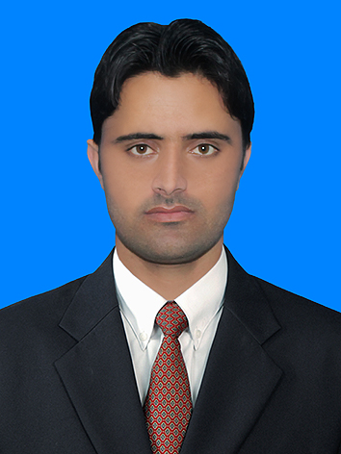

**Father Name: Gulla Khan**

**DOB: 05th Octuber 1995**

**Place of Birth: South Waziristan Tribal District Wana**

**Domicile: South Waziristan Tribal District Wana**

**N.I.C NO: 21708-4375327-7**

**Cell #: +92-335-9100031, +92-305-9100035**

**Email:**  **azizurrehmanwazir@gmail.com**

**Religion: Islam**

**Nationality: Pakistan**

**Marital Status: Single**

**Permanent Address: Village and P/O South Waziristan Tribal District Wana Alyum Ashraf Khel Lal Muhammad Kot Khyber Pakhtunkhwa, Pakistan**

# CAREER OBJECTIVES

To join a dynamic Government & Non-government Organization where I could further explore the skills and capabilities which I gained in the whole academic career, to prove myself as an energetic, enthusiastic and career orienting person under all circumstances and to serve in a challenging work environment and to gain equally vast opportunities of career development based upon achievements and results.

# ACADEMIC DETAILS

|  |  |  |  |  |
| --- | --- | --- | --- | --- |
| **DEGREE / CERTIFICATE** | **Institutions** | **Passing Years** | **Marks Obtained** | **Percentage** |
| **Secondary School Certificate**  **(SSC)** | **BISE Peshawar** | **2011** | **772/1050** | **73.52%** |
| **Higher Secondary School Certificate**  **(HSSC)** | **BISE Peshawar** | **2013** | **755/1100** | **68.63%** |
| **BS (Hons) Medical Laboratory Technology** | **Bacha Khan University Charsadda**  **(BKUC)** | **2018** | **3.42 CGPA** | **85.5%** |

# EXPERIENCE

* 3 Months Internship at Rehman Medical Institute (RMI) Peshawar.
* 6 Months Internship at Town Women and Children's Hospital Peshawar.
* 3 Months Internship at Hamza Foundation Welfare Thalassemia Hospital and Blood Transfusion Services Peshawar.
* 6 Months Internship at Insan Dost Welfare Medical Laboratory Peshawar.
* 7 Months Worked at Madina Medical Laboratory Peshawar.
* 10 Months Worked at The Real Diagnostic Laboratory Dabgari Garden Peshawar.
* Worked as a Medical Laboratory Technologist at Category-D hospital Toi Khula from 1st Janurary 2021 to 21 February 2021.
* Currently Working as a Medical Laboratory technologist at Sheikha Fatma Bint Mubarak Model Hospital Sholam from 22 Feburary 2021 till date.

# PERSONAL SKILLS

* Have a good hand in practical professional and social work.
* Have a good presentation skill.
* Having good team work and group leading capabilities
* High level of maturity and sense of responsibility.
* Excellent English skills.
* Critical and logical thinking.
* Ability to work under pressure.
* Conflict Management.
* Problem Solving.
* Desire to learn.

# COMPUTER SKILLS

* Microsoft Office
* Spreadsheets
* E-mail
* Presentation /Slideshow
* Social Media
* Browsing and Internet.

# LANGUAGES

* **English**
* **Urdu**
* **Pashto**

# HOBBIES

* Sports.
* Reading newspaper.
* Reading books.
* Social activities.