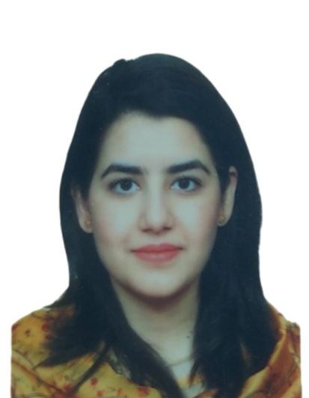 |  |  |  | Bibi Zohra

Paediatric Doctor with MCPS training, known for strong communication and presentation skills, experienced in patient care and community focused social work, dedicated to improving health outcomes.

Experience
- MCPS PAEDIATRICS (NWGH, Peshawar) june 21 to October 23

- Lecturer at clinical skill department rehman medical college, Peshawar june 2021-june 2022

- House officer in General medicine and allied (19/06/2018 to 18/12/2018)
Neurology ( 3 Months)
Pediatrics (2 Months)
Radiology (1 Month
- House Officer in General surgery and Allied (19/06/2018-19/06/2019)
Cardiothoracic Surgery (3months)
Intensive care unit (2 month)
Orthopedic (1 Month)

Education
- MCPS Paediatrics NMGH, Peshawar Training completed
June 21 to october 23.

- Bachelor of Medicine and Bachelor of Surgery (MBBS)
November 2012 to October 2017
Institute: - Rehman Medical college – Peshawar, PK.
Higher Secondary – A Grade (2010-2012)
Institute: - Islamia College girls, board of Intermediate & Secondary Education –Peshawar, PK
Pre-medical Subjects
Matriculation – (2010)
Board of Intermediate & Secondary Education – Peshawar, PK
Science Subjects

Skills:
Communication skills:
Developed a strong verbal and written communication skills through regular patient interaction, medical presentations and interdisciplinary team work.
Clinical skills:
Proficient in managing critically ill paediatric / neonatal patients, ventilator management and advanced life support.
Skilled in performing paediatric procedure such as intubation, surfactant replacement therapy, chest tube, lumbar punctures and emergency resuscitation.

PROJECTS:

  - Clinical outcomes associated with red blood cells transfusion in pediatric intensive care unit,NWGH, Peshawar
  - Effect of iron supplementation during pregnancy on HB levels in Peshawar KPK, Pakistan

Achievements:
- Presented a research paper on “Clinical outcomes associated with red blood cells transfusion in pediatric intensive care unit, NWGH, Peshawar” at the Northwest annual research conference 2023
- Certified in Clinical simulation course PGMI Peshawar March 2023
- Certified in Healthcare Quality & Hospital Management Program, RMI Peshawar. August 2021
- Certified in Neonatal Invasive Ventilation Course, NWGH Peshawar 21 Jan 2023
- Pre hospital emergency care council(Ireland) accredited cardiac first response practitioner care -14th January 2015.

- Winner debate competition (urdu debate competition RMI)

Volunteer experience:
Organized and active participant of a free Medical Camp at RUKHSANA MOTHER & CHILDCARE TRUST HOSPITAL, 17 Nov, 2021

House No. 157, Street No. 4
Sector K-4,Phase 3
Hayatabad,
Peshawar
 |  | 0324-9959096
 |  | zohraibrar@hotmail.com
 |  | Current Registrations :- Pakistan Medical and Dental Council.

