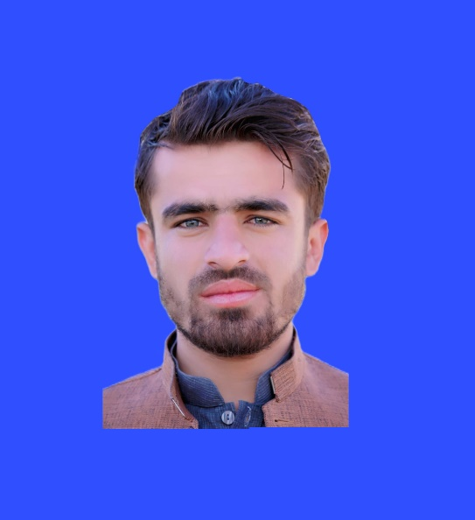

**BISMILLAH**

**SUMMARY**

To secure a rewarding position where I can utilize my skills, knowledge, and experience to contribute to the success of an organization. With a strong work ethic, excellent communication abilities, and a passion for continuous learning, I aim to make a positive impact and grow both professionally and personally. Seeking a challenging environment that values innovation, teamwork, and professional development.



**CONTACT**

Contact Details

 +1 2345 6789

 example@gmail.com

 #1 road, city/state - 0011

03158828051

Princebkkakar777@gmail.com

Masjid Ibrahimzai Killi Karbala, Pishin

**WORK EXPERIENCE**

**Teacher | 2 Years Experience**

Greenwich Grammar High School Pishin

* Facilitated engaging and interactive learning experiences for students at Greenwich Grammar High School, fostering a conducive environment for academic growth.
* Collaborated closely with fellow educators to develop and implement effective teaching strategies, ensuring alignment with curriculum objectives and student needs.
* Demonstrated strong communication skills in conveying complex concepts, fostering a positive and supportive learning atmosphere, and effectively addressing student inquiries and concerns.

**Polio Worker | 3 Months Experience**

* Conducted polio vaccination campaigns in the Pishin region, demonstrating meticulous attention to detail and adherence to vaccination protocols to ensure comprehensive coverage.
* Collaborated with healthcare professionals and community leaders to raise awareness about the importance of polio immunization, effectively addressing concerns and misinformation to promote vaccination acceptance.
* Utilized strong organizational and logistical skills to coordinate vaccination teams, manage vaccine supplies, and navigate diverse community settings, contributing to the success of polio eradication efforts in the region.
* Organizational Skills
* Microsoft Office
* Computer Proficiency
* Teamwork
* Customer Service
* Adaptability
* Problem Solving
* Data Entry
* Time Management
* Interpersonal Skills
* Dedication
* Team Leading

**SKILLS**

Contact Details

 +1 2345 6789

 example@gmail.com

 #1 road, city/state - 0011

* Computer Diploma

**DIPLOMA**

**EDUCATION**

**Bachelor of Science in Sociology**

In Progress (8th Semester)

**(FSC) Higher Secondary School Certificate**

Marks: 834/1100

**(Matric) Secondary School Certificate**

Marks: 794/1100

* English
* Urdu
* Punjabi

**LANGUAGES**

**JOB EXPERIENCE**