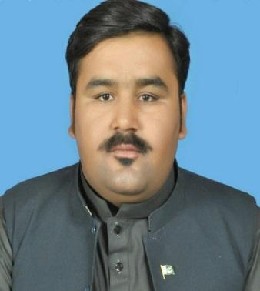  DR. BISMILLAH KHAN  S/o Sardar Muhammad Khan  Objective  To serve an organization wherein I can utilize my skills and abilities and to ensure that Organization benefits from all my previous experience in social & humanitarian programs.  To Work in challenging environment and exposure to enhance my skills and capabilities, working with reputable Organization/Departments and to contribute to organizational goals in dynamic and challenging environment.  Contact No.  Cell/WhatsApp  +92-300-3869336  +92-333-7853273  EMAIL:  Sardarzadabk@gmail.com  Present Address:  Ehsan Chowk Kakar Colony Satellite town Quetta (87500)  Permanent Address:  Killi Mula Yehya Nourak Sulemankhail Tehsil Gulistan, Killa Abdullah  Hobbies  Boxing  Traveling  Body Building  Languages  1-English (Good)  2-Urdu (Good)  3-Farsi (Good)  4-Arabic (Intermediate)  5-Balochi (Intermediate)  6-Barahvi (Intermediate)  7-Pashto (Maternal Language)  COMPUTER SKILLS  MS Office  MS Word  MS Excel  MS PowerPoint  MS in page  Internet & email  Computer all basic and IT.  CERTIFICATIONS & APPRECIATION  - Certificate of appreciation 2012 from Governor Balochistan/Commissioner Quetta division.  - Certificate of Merit (1st prize in Balochistan) 2012 from Governor Balochistan /Commissioner Quetta division.  - Certificate on Information Technology from BUITMS Quetta.  - Certificate on Research Methodology in Health Sciences Research from SZABIST.  - Certificate on an update on treatment and Management of Covid-19 Patients from AKU Karachi.  - Certificate of Ultrasound from institute of Health Sciences Karachi.  - Certificate on an update on treatment and Management of Covid-19 Patients COVINAR-2 from AKU Karachi.  - Certificate on COVId-19 and Chronic kidney disease from British Medical journal BMJ India.  - Certificate on Management of Tuberculosis from Mercy Corp with support of NTP and Global Fund-GF.  - Certificate on tackling the corona virus from London school of hygiene & tropical medicine and UK public health rapid support team.  - Certificate of leader for change.  - Certificate on Ultrasound in Pelvis & Abdominal Ultrasonography from Institute of health sciences Karachi Pakistan.  - Certificate on covid19 from university of health sciences Lahore.  - Certificate of attending Gender based violence and Child safeguarding.  - Certificate on Management of Tuberculosis through engaging Public Private Mix PPM activates and Rider intervention from Mercy Corp for SPO staff.  - Two Days training from SPO-HR on Protection from Sexual Exploitation and Abuse PSEA.  - Certificate of Attendance Virtual Youth Conference. Certificate from Global Forum on TB Vaccine hosted by TOULOUSE FRANCE.  - Member SPO Quetta region Procurement Committee.  - Member SPO Quetta region Anti-Harassment Committee.  - Certificate from AKU on Flood disaster Treatment.  - Certificate from BMJ on Headache and Migraine.  - Certificate on Kidney Disease from BMJ.  - Certificate on Anti-Harassment on KAYA.  - Certificate on safety and security on KAYA.  - Certificate on Project Management on KAYA.  - Certificate of Appreciation on Diabetes on LEO Club.  - Nutrition Course from SZABIST Karachi.  - Environmental Science from SZABIST Karachi.  Area of Expertise  Technical/Skills  - Successfully Completed Health and economic wellbeing Project in IRC.  - Worked as Program & Project Manager in International Recuse Committee (IRC), Mercy Corps International (MC), Strengthening Participatory Organization (SPO), Sardar Medical Center (SMC) etc.  - Work experience with GFFO, Global Fund, and UN funded Projects.  - Health Management.  - Health in Emergencies.  - Infectious Disease.  - TB Control.  - Flood emergencies.  - Nutrition Program.  - Sphere standard.  - Emergency operation First Response.  - Monitoring, Evaluation, Accountability and Learning (MEAL) in Emergencies  - Preventing Fraud and Corruption at the IRC.  - IRC Way, Every Day 2022  - Anti-Sexual Harassment Training - Global  - Medical Camps management.  - Food and NFI Distribution Camps Managment.  - INEE Minimum standard for Health: Preparedness, Response, Recovery  - Hazards, Vulnerability and capacity assessment and analysis  - Early Warning System  - Team Player and led the team in various projects.  - Health and economic wellbeing assistance in Emergencies  - Situational analysis.  - Lead and complete the project with distinction with the given time frame and resources.  - Post project evaluation and reporting and evaluation.  - Skilled in communication, documentation, report writing, project management, data management and M&E.  - Training Workshop on Leadership & Management.  - Managed and controlled the project in the district and provinces.  - Established Community Response mechanism/ feedback response mechanism.  - Ability and willingness to work in a multi-cultural team.  - Ability to work independently and take initiative. |  | EDUCATION  MPH/MS-PH, M-PHIL-Public Health Specialist  2021 Shaheed Zulfikar Ali Bhutto Institute of Science & Technology (SZABIST) KARACHI  Msc, Pharm-D, Doctor Of Pharmacy-Pharmacist  2012 University of BALOCHISTAN, QUETTA  ma, MASTER’S IN SOCIAL SCIENCES (international Relations)  2011 University of Balochistan, QUETTA  ba, BACHELOR’S IN Sociology, Economics  2009 University of BALOCHISTAN, QUETTA  BSc/DHMS Doctor Of Homoeo Medical Scinces  2012 BHMC, Quetta  Fsc (Pre-MEDICAL) INTERMEDIATE/A-Level  2006 BBISE Quetta  SSC (Scince) Matriculation/O-Level  2004 BBISE Quetta  WORK EXPERIENCE  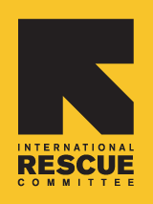  International Rescuer Committee (IRC)  Senior Health Program Manager  Sep 2022- March 2023  ● To Provide institutional and technical capacity-building support to partners PPHI, MERF, TF, TKF etc.● Regularly coordinate Balochistan partner’s project review meetings to supervise progress and spending as per agreed plans.● Conduct compliance monitoring visits to partners in line with agreed monitoring and support plan.●Linkage and referlto of Mal Nurished patient to Nutrition Program. Assist in the development and refinement of benchmarks and indicators to assess the primary health care program progress and impact.● Undertake regular field supervising visits to assess progress and identify technical quality.● Ensure smooth implementation of planned activities.● Check the validity of performance data acquisition, and ensure that the data to be reported to HQ/TU fulfills quality standards for validity, integrity, precision, reliability and timeliness.● As Senior IRC’s health manager and GFFO program manager serve as principal support advisor to team lead for all relevant health program issues.● Stay up to date with international and local innovative health and humanitarian technical approaches.● Analyze and interpret policy, strategy, and technical documents to ensure IRC’s health programming is aligned.● Build and maintain an extensive network of key public health contacts with a focus on Public Health Committees and mobile health teams.● Represent IRC in sectorial technical working groups and coordination meetings.● Serve as the link between IRC’s health and humanitarian activities and the District/Provincial/Central teams.● Regularly coordinate with partners and relevant stakeholders.● Ensure synergy and linkages between health activities and other program elements including Food and winterization assistance while ensuring alignment and linkages with other IRC programs i.e Nutrition ECHO Program. Experience in GFFO Project activities in health and economic wellbeing.  Strengthening Participatory Organization (SPO) 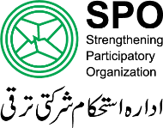  Project Coordinator TB-Program  Sep 2021 – Sep 2022  ● Overall supervision and monitoring of TB Project in all SPO PPM Districts of Balochistan as Regional/Project Coordinator in PR level and Project Coordinator SR Level. ● Overall Coordination and Reporting of TB Project ●Overall supervision of Field staff and field activities in PPM Districts and office based Staffs ●Mobilizing public and private health authorities and Communities for the management of TB project ● Strong linkages with public and private sector working in health projects ● Strong coordination and liaison with Provincial TB control Program linkages with District health authorities and District TB coordinator ● Strong linkages with Private Health Care Providers, DOCTORS, Paramedics and Lab technicians ● Strong linkages with Public Laboratories for GEN Expert testing ● Regular Visits of Laboratories and private health care providers ● Close contact with community notables/ representatives and public sector authorities● Good linkages with private sector organizations working in health sector , particularly TB related projects ● Supervision and monitoring of community gathering at field level ● Monitoring of Quarterly Review Meeting at district level with other stakes holders, Nutrition Program,MNCH,Polio regarding Chest Camps and produce reports ● Conduct Quarterly Review Meetings for data validation at District level and produce reports ●Ensuring maintaining of record of TB patients ● Follow ups TB patients ● Ensuring household Contact screening of TB Patients ● Ensuring household Contacts on Preventive therapy of TB Positive Patients ● Monitoring visit of GPs clinics and Laboratories ●Assist mission for monitoring visits ● Preparation of work plan for all others projects other than Tuberculosis to help them for smooth running of Projects. Coordination with NTP and PTP Baluchistan. Experience in Global funded PPM Project in Baluchistan.● Liaison with other vertical program for smoth running of Project Specially With Nutrition,HIV AIDs, Hepatitis Control Program.  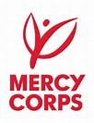  Mercy Corps (MC) International  District field Supervisor Quetta  January 2020–September 2021  ●Coordination with District TB Coordinator, Regional/Project Coordinator, District Lab Supervisor, Private Healthcare Facilities and Private Labs for effective implementation of the TB-DOTS under PPM project. ●Responsibility for carrying out district mapping exercise in consultation with the district health department (Executive District Officer-Health (EDO-H)/District Health Officer (DHO) and District TB Coordinator (DTC) under guidance of the Regional Coordinator ●Timely submission of monthly work plan, monthly progress report, and quarterly TB Recording and reporting (R&R) tools after endorsement from district health authorities. ● Conducting of regular visits of selected private health facilities and labs to ensure proper recording of TB R&R tools, timely supply of anti TB drugs, labs reagents, chemical and registration of TB cases. ●Contact screening of all bacteriologically positive case on regular basis. ●Support of health facility staff in maintaining anti-TB drug stock. ●Regular, follow up mechanism for the identification of TB suspects, MDR suspects and registration of new smear positive cases in selected PPM GPs and label. ● Responsible for the implementation of the PPM activities in the field in close coordination of district health authorities and in support of the Regional Coordinator and DFS. ● Responsible for maintaining chronological record (programmatic and financial) including activity photographs, minutes of meetings and field monitoring reports etc. of all the field activities at district level. ● Responsible for submission of programmatic and financial record to regional office of all field activities on monthly basis in line with the NFR Operational Guidelines and  Coordination with PTP Baluchistan. ● Liaison with other vertical program for smoth running of Project Specially With Nutrition,HIV AIDs, Hepatitis Control Program. ● Support and facilitate supervisory visits from the national, provincial and district level. ●Any other task or responsibility as assigned by the Regional Coordinator. Experience in Global funded PPM Project at quetta district.  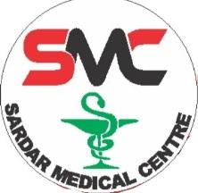  Sardar Medical Centre, Quetta, Pakistan  Administrator/Pharmacist/Manager  Jan 2016–Dec 2019  ●Will be responsible for answering customer regarding medicine use and its interactions. ●Managing any trouble among staffs & customers. ●Will thoroughly collected the required data from the customer required for a fruitful outcome ●Supervise all the required material and managing everything in Centre. Assisting Mal Nurished Neonatal in providing Supplements and referral Severely Mal Nurished patients toward nutrition health centers.  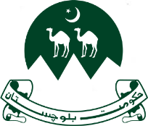  Workers Welfare Board Govt. of Baluchistan, Quetta, Pakistan  Assistant Director Interne  Jun 2016–Jul 2017  ●Handling incoming calls and other communications. ●Managing filing system. ●Recording information as needed. ●Updating paperwork, maintaining documents and word processing. ●Performing general office clerk duties and errands. ●Organizing travel by booking accommodations and reservations needs as required. ●Coordinating events as necessary. ●Aiding with client reception as needed. ●Experience as a virtual assistant. ●Creating, maintaining, and entering information into databases.  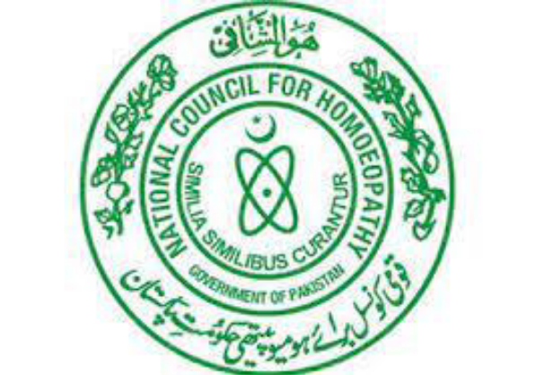  BHMC, Quetta Recognized by NCH Pakistan  Lecturer/Coordinator  Jun 2013- Sept 2022  ●Teaching, including lectures, seminars/tutorials and learning materials. ●Attending and participating in meetings, conferences, and other events in and outside of the institution. ●Participating in training opportunities and initiatives at the institution. ●Providing support to students and other colleagues.  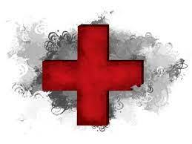  Health way Pharmacy, Quetta, Pakistan  Pharmacist  Jan 2011 - Dec 2012  ●Supporting pharmacy staff and managing. ●Managing medicines storage. ●Providing information to patients and staff as needed. ●Pharmaceutical management and maintaining documents and further processing. ●Helping customers how and when to take medicines. ●Coordinating in distribution of medicines.  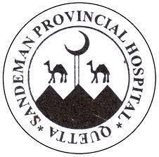  Sandeman Provincial Hospital, Quetta, Pakistan  Pharmacist internee  Feb 2011 - May 2011  ●Internship as hospital pharmacist. ●To work closely with doctors and are responsible for the ordering, quality testing. ●Storing and security of medicines in concern ward. ●To ensure an adequate supply of medicine.  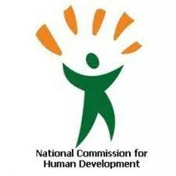  National Commission for Human Development (NCHD) Pakistan  Data collector & Learning Coordinator (DC, LC) at Quetta  May 2007 – December 2007  Data Collector responsibilities include:  ●Entering children’s data from 0-5 year of age and their education data from door to door within time limits. ●Compiling, verifying accuracy, and sorting information to prepare source data. ●Reviewing data for deficiencies or errors, correcting any incompatibilities, and checking output.  Learning Coordinator Responsibilities include:  ●Joint visits along with ADEOs / SPEs to monitor activities of teacher. ●Facilitate teacher held regular community meeting. ●identify training need for teachers and prepare plan along-with ADOEs to provide training to teachers. ●Validation of data on prescribed format in all villages of assigning area. ●Visit of areas to Monitor the data received by Data Collectors. ●After enrollment, visit schools, preferable along with the supervisory staff of the Education Department.  SKILLS  Administrative Management Skills| Collaborative Problem Solving | Communication Skills | Communication Writing Skills | Computer Literacy | Data Collection | Excellent Computer Skills | Excellent in Drafting| Experience in Supervising | Experienced in team management | Field Management | Health Management | Hospital Pharmacy | Knowledge Of Public Health | Linguistic Fluency In Pashto.Persian,Urdu,English | M&E of Health Facilities | MS Word Office | Official Assignments | Pharmacists Skills | Programmatic Data Capture | Project Management | Public Health Education | Report Writing Skills  Refrences  References will be provided as per Organizational Requirements.

