## Resume(CV)

## Burhan-U-Din

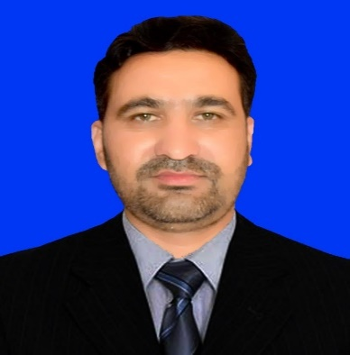

NIC #: 21106-2271240-7

Date of Birth: 02/02/1983

Domicile: Bajour

Permanent Address: Village Odigram Tehsil Salarzai Bajaur Agency.

Mobile#03009009223

Mobile#03339422888

Email: burhan.salarzai@gmail.com

## Objectives:

To work in a challenging environment to improve my skills, knowledge and understanding of the world, to apply the little knowledge I have for the betterment of humanity in general

## Summary:

1. 7 years of data Collection, Data analysis, finance, logistics, HR and admin experience in United Nations WHO
2. 4 years Working in W.H.O as Tehsil Campaign Support Person in polio eradication initiative.
3. More than 6 years Of Banking experience especially in the field of Credits.
4. Teaching experience in Govt. Colleges of Bajaur Agency
5. More than 13 years of overall experience.

## Technical Skills:

1. Installation of different OS like Microsoft Windows.
2. Data Analysis Using Microsoft Excel and Tabluae
3. Microsoft Office and Microsoft Windows configuration and installation

# PROFESSIONAL EXPERIENCE

## Social Welfare Department

**Working As District Child Protection Officer (Mar-2023 Till Date)**

1. Responsible to protect the rights of the children in the districts.
2. Conduction of surveys to collect data of child issues
3. Awareness sessions to public for child rights.
4. Pursuing child cases in the court.
5. Member of juvenile justice committee and criminal justice committee.

## United Nations WORLD HEALTH ORGANIZATION

**Working as Program and Data Assistant Malakand division PEI (12-06-2017-Till 15-03-2023)**

* Responsible for the whole data analysis of the division (Two Districts).
* Collection of data from all districts and sharing with federal office.
* Assisting all districts in terms of Admin and finance assistance.
* Working as Focal Person for HR,
* Working as Security Warden (UNDSS) for the division’s UN staff.
* Working as admin.
* Focal person for Covid-19 Data
* Collection of Covid-19 data and analyzing that data and making Sitrep for Commissioner Malakand division and other provincial leads on daily basis.
* Supervision of data entry in ePMIS and other data management sheets/tools.
* Creation of daily covid-19 reports

### WORLD HEALTH ORGANIZATION

**Worked as Tehsil Campaign Support Person (01-07-2013 To 11-06-2017).**

* Data Collection, Analysis and Dissemination to the next level.
* Monitoring of Campaign in the whole tehsil.
* Responsible for Surveillance Activities.
* Tehsil level microplaning.
* Leading a team of WHO staff(UCPWs).
* Resource management and evaluation.
* Monitoring of anti Polio drives and providing technical support.
* Monitoring of routine (vaccination) and data collection.
* As Technical Support for staff working in PEI.
* Monitoring and supervision of field staff.
* Data analysis and collection.
* Micro plan field validation,
* Routine immunization Data Collection and supervision.

## Khushhali Bank Limited

**Worked as Credit Specialist (Nov-2012-Jun-2013)**

* Credit analysis and assessment.
* Cash flow analysis.
* Credit scoring.
* Computerizing credit cases and forwarding to head office.
* Verifying creditworthiness of the customers.

**Worked as Business Development Officer (Jun-2007 –Oct 2012).**

* Mainly Focus on Customers care.
* Motivating the community
* Sales & Marketing
* Managing Default
* Client acquisition.
* Target based field activities.

## Govt. Degree College Khar Bajaur (Jun 2005-May-2006).

Lecturer Computer Science Department

## Govt. College of Management Sciences Khar Bajaur (Jun 2006-Jul-2007)

Lecturer Computer Science Department

**ACADEMIC**

|  |  |  |  |  |
| --- | --- | --- | --- | --- |
| **Degree** | **College/University** | **Total Marks** | **Marks Obtained** | **Percentage** |
| **BSIT(Hons)-4 Years** | Cecos University of IT and  Emerging Sciences  Hayath Abad Peshawar | 4400 | 3212 | 73.00% |
| **FSc(Pre-Medical)** | Govt. Degree College Khar Bajaur | 1100 | 658 | 58% |
| **Matriculation** | Govt. High School Khar Bajaur | 850 | 615 | 72.35% |

## CERTIFICATIONS

* Default Management & effective loaning In poor community by khushhhali bank limited.
* Customer relation certificate by khushhali bank ltd.
* Office
* Linux end user training.

## References

Upon request