Dad Muhammad. 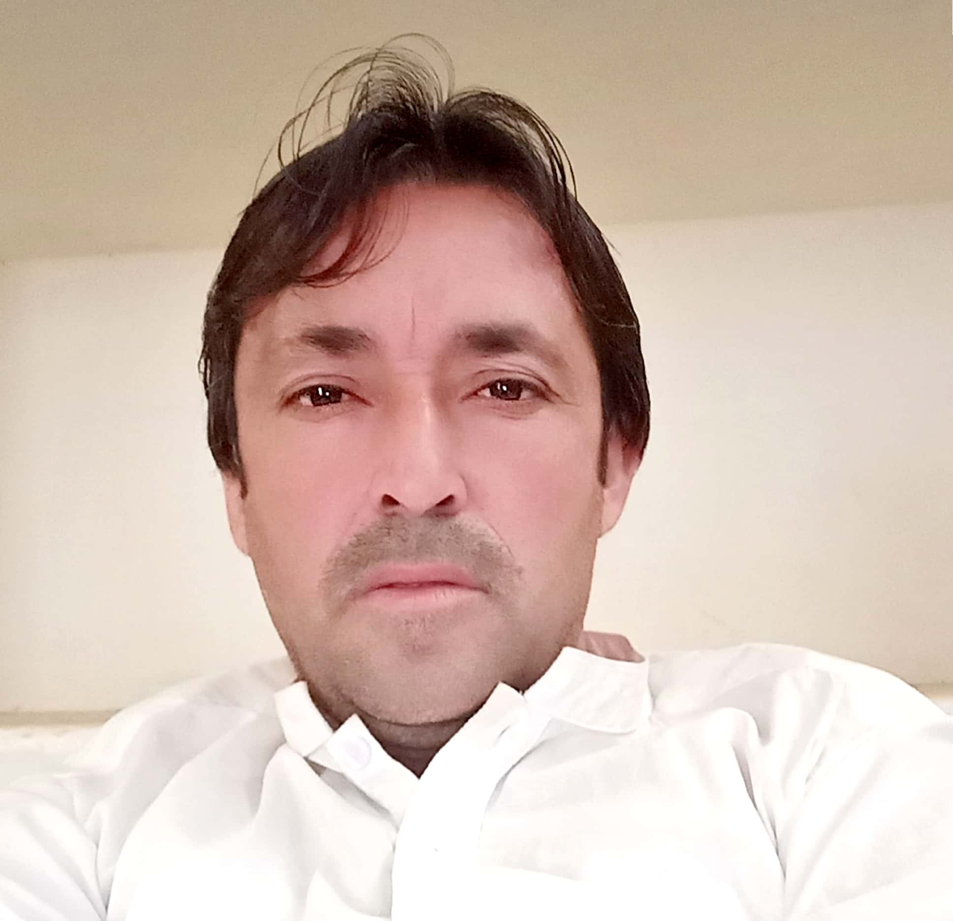
- Mobile 02348156588
- EMAIL :mdad64552@gmail.com
JOB OBJECTIVES
Pursuing a challenging position in any organization, whereby I canutilize and develop expertise and experience in continuation towards achieving a benchmark, with aim of achieving organization goal in an
effective and manner
PERSONAL INFORMATION

- Fathers Name : Haji jalat khan
- Date of Birth :21/03/1986
- CNIC :54203-2436445-7
- Local :killa abdullah
- Nationality :Pakistani
- Religion :Islam
- Marital Status :mered
- Gender : Male
- Postal Address :sharja mobail center killah abdullah.
QUALIFICATION
- Matriculation. :From Baluchistan Board Quetta
- Intermediate. :From Baluchistan Board Quetta
- BSc. :University Of Baluchistan Quetta
- MSc. :University Of Baluchistan Quetta
EXPERIENCE
✓ 2 year Experience as a Social Worker with PIDS.
✓ 4 year Experience as a Area Supervisor (AS) with UNICEF.
✓ 8 Years Experience as a UC Communication Officer with CTC .
✓ 3 Years Experience as a Vaccinator with PRCs.
✓ 5 Month Experience as a social mobilizer with Technical support Unit
Courses
1:Computer Courses (DIT & Office Automation) 2:English level Advance Diplom English
LANGUAGES
- English
- Urdu
- Pashto

