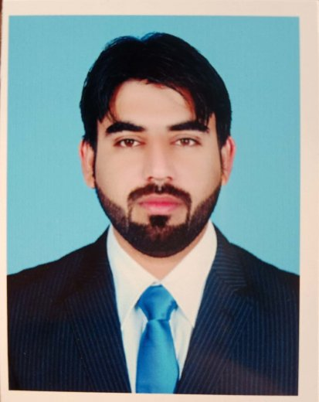DR. ARBAB NADEEM AKHTAR (MBBS)

OLD OPD YDA Hostel Room No: 16 Sandamen (Prov:) hospital Quetta Balochistan

Cell phone # 03353539382

Email : arbabnadeempandrani@gmail.com

**PERSONAL INFORMATION :**

Gender : Male

Date of birth :9th oct 1992

Father’s name : Arbab Sikandar

CNIC No : 53402-5837693-5

Languages : English , Urdu , Bravhi ,Balochi ,Sindhi ,Pashto

**CAREER OBJECTIVE :**

To carry out my duties as a health care provider and fulfil them honestly ,sincerely and with responsibility and compassion.To be able to learn the necessary skills required and to be of service to mankind.

**EDUCATION:**

Six (6) Month Essential Pediatric Emergency Medicine Course from Dow University of Health Sciences (DUHS) Karachi

Master of Science in Public Health (**MSPH**) from Jinnah Sindh medical University (AIPH) KARACHI-2020

Bachelor of Medicine and Bachelor of Surgery **(MBBS)** from Balochistan University Quetta (Quetta institute of medical sciences ) QIMS -2017

Intermediate from Govt Boys College Ghari khairo (Larkana board )-2011

Matriculation from Govt Boys School Kot Mengal (Balochistan Board) -2009

**6 month Diploma in Computer (CIT)**

**CERTIFICATION:** PMDC Registration Number: **6016-B**

**WORK EXPERIENCE:**

**Post Graduate Training in Pediatric medicine** (FCPS) at Sandeman Provincial Hospital Quetta from 01-07-2021 Till 30-09-2024

Worked as Medical Officer in **Mobile Health Units(MHTs) Project** at District Naseerabad with **Pakistan Red Crescent Society** from 26th October,2022 To December 31,2022

SIX (6) month working as **Medical officer in Pediatric medicine** at BMCH Quetta

**NELS**, **PELS**, and **Airway** Workshop from Child life foundation

**BLS** from AHA through College of Physicians and Surgeons Pakistan(CPSP)

**HOUSE JOB:**

3 Months in **General Surgery** (Surgical ward #2) Jinnah post Graduate medical center, Karachi 2017

3 Month in **Accident and Emergency (E&R)** Jinnah post Graduate medical center, Karachi 2018

3 Month in **Medicine and National poisoning control center** (Medicine ward # 5) Jinnah post Graduate medical center, Karachi 2018

3 Month in **Dermatology** (Ward No: 10) Jinnah post Graduate medical center, Karachi 2018

**RESEARCH PROJRCT :**

Carried out a survey and project on **“HOW TO PREVENT DRUG ADDICTION AND ITS RELAPS “** For the Department of Community Medicine Quetta Institute of Medical Science Quetta cantt

**CONFRENCES ATTENDED:**

Attended **“12th Annual Colorectal week 2017”** at Jinnah Post Graduate Medical Center

Attended Seminar on **“PHARMACOVIGILANCE”** at Ziauddin Univeristy Karachi

Attended Seminar on **“MILD TO MODRATE PAIN MANAGEMENT”** at PC Hotel Karachi

Attended **“53rd Annual Medical Symposium”** at Jinnah Post Graduate Medical Center

**SOFT SKILLS:**

Team oriented

Effective communicator

Flexible

Good work ethic