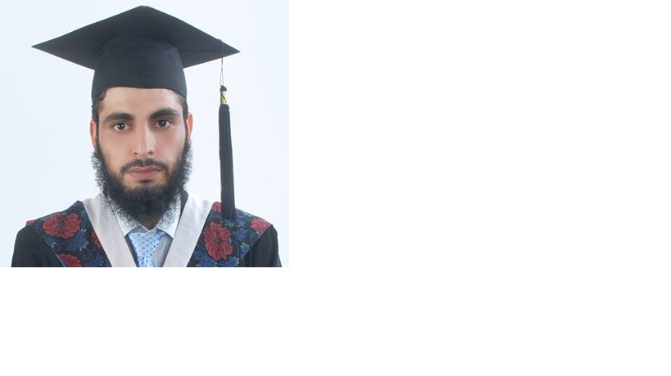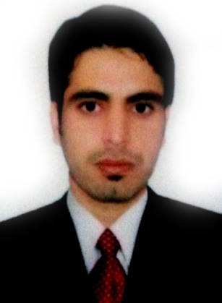Saleem Khan Bhittani

*Doctor*

|  |  |
| --- | --- |
| **Email:**shahzadabhittani@gmail.com | **Tel:**+92 347 907 8257 |

**Personal Dossier**

|  |  |  |
| --- | --- | --- |
| Date of Birth |  | **10-09-1986** |
| Father's Name |  | **Engineer Naeem Khan Bhittani** |
| Languages known |  | **English, Pashto, Urdu, Arabic, Chinese** |
| N.I.C |  | **22101-6213744-9** |
| Passport Number |  | **DM 4107442** |
| Validity |  | **30 Sep 2014 – 27 Dec 2024** |
| Place of Issue |  | **Pakistan** |
| Address |  | **- House no. 487, street 2, G11/1, ISLAMABAD ( Mailing)**  **- Village & PO Box Khan Khel bhittani ,(Tajori),**  **FR Lakki Marwat (Permanent)** |

**Academic Credentials**

|  |  |  |  |
| --- | --- | --- | --- |
| **M.B.B.S.** | Xi’an Jiaotong Medical university (CHINA) | 71.2% | 2011 |
| **HSSC (Pre Medical)** | Pak Islamia Higher Secondary School/ College (UAE)  Federal Board, Islamabad | 67.82% | Apr-2004 |
| **SSC (Science)** | Pak Islamia Higher Secondary School/ College (UAE)  Federal Board, Islamabad | 71.2% | Apr-2002 |

**Professional Membership**

|  |  |  |
| --- | --- | --- |
| **Registered Doctor**  **Reg. no. 17395-N** | Pakistan Medical and Dental Council | Member Since 13/09/2011 |

**Professional Experience**

|  |
| --- |
|  |

|  |  |  |  |  |
| --- | --- | --- | --- | --- |
| **Designation** | **Institution** | Duration | From | To |
| **Medical Officer** | **Health Department KPK**  **BHU Gabar Bagh SD Bhettani Lakki** | 03 years | 20 june 2021 | Till Date |
| **Demonstrator** | **HBS Medical & Dental College**  **(Islamabad)** | 04 Months | 12th Sept, 2018 | 20 june 2021 |
| **Medical officer** | **Al rehman clinic, G 11 markaz, Islamabad** | 17 months | 1st July, 2017 | 10 Sept 2018 |
| **Demonstrator** | **Islamabad Medical & Dental College**  **(Islamabad)** | 07 Months | 20thAug, 2015 | 29 Feb 2016 |
| **Medical Officer** | **Shifa international Hospital**  **(Islamabad)** | 05 Months | 29thMar, 2015 | 1st Aug 2015 |
| **Medical Officer** | **BHU- MashaMansoor**  **Lakki Marwat**  **K.P.K** | 06 months | 1st Nov, 2013 | 30th Apr 2014 |
| **Medical Officer** | **BHU- MashaMansoor**  **Lakki Marwat**  **K.P.K** | 05 months | 1st May 2013 | 30th Sept. 2013 |
| **House Officer** | **Hayatabad Medical Complex**  **Peshawar**  **K.P.K** | 1 Year | 10th Oct, 2011 | 30st Nov 2012 |
| **Internee** | **Hayatabad Medical Complex**  **Peshawar**  **K.P.K** | 1 Year | June 2010 | May 2011 |

**Research Interest Area(s)**

* Family Medicine
* Gastroenterology
* Health Planning

**Internship / House Job/ Medical officer**

* 1 Year Internship ( June 2010 to May 2011) H.M.C Peshawar
* 4 months House Job (Neurosurgery & Head injury Unit ) H.M.C Peshawar (10th Oct 2011 – 14th Feb 2012)
* 2 months House Job (Orthopedic & trauma unit ) H.M.C (15th Feb 2012 – 15thAprl 2012)
* 2 months House Job ( Gastroenterology &Hepatalogy) H.M.C (1st Jun 2012 – 31st July 2012)
* 1 month House Job (Pathology ) H.M.C (1st Oct 2012 – 31st Oct 2012)
* 3 months House Job (Medicine ) H.M.C (1st Sept 2012 - 31st Nov 2012)
* **Medical Officer:** **BHU MashaMansoor, Lakki Marwat K.P.K (Since 5th January 2013- till date)**
* Working in a periphery Basic Health Unit as MO (Masha Mansoor), a village of 6,000 approx. people, with daily 50-70 OPD patients visiting the BHU. Assisted and Overviewed the Preventive Vaccination Programme namely (Polio,Heb.B,Influenza,Pertussis,Whoophing Cough etc).
* The BHU also provided assistance to Mother & Child health Care.
* 1 Year Internship: Internal Medicine (15 weeks), Surgery (15 weeks), Gynea & Obs (8 weeks), Pediatric (5 weeks), Infectious Medicines (3 weeks).
* Neurosurgery and Head Injury Unit: Causality Management, Poly Trauma Patients Management, Assisted in Surgeries i.e., EDH, SDH, Laminectomy, Tracheostomy, and Follow-up of Post OP Patient in Ward.
* Orthopedic and Trauma: Trauma Management, Reduction of Fractures and POP, Traction and External Fixation and DHS.
* **Gastroenterology and Hepatology:** Gastritis, Hepatitis B, Hepatitis C, Upper and Lower Scope.
* **Pathology and LAB:** Blood Screening, Thalassemia, Routine Investigation.
* **General Medicine:** Emergencies and Variety of Diseases.

**Demonstrator**

* As a Physiology faculty member, involved in the teaching of first year, and second year MBBS students.
* Participate in departmental meetings, as well as college taskforces and/or committees as necessary...
* Conduction of OSPE examinations.
* Conduction of physiology practicals.
* Maintain appropriate office hours proportionate to the instructional assignment..
* Invigilation in exams
* Paper checking

**Career Objectives**

* To be a part of a work culture that provides me the opportunity to put my skills to its best use and in turn assist me in my personal development.
* In depth knowledge of the safety measures and hygiene conditions to be maintained under medical care.
* Skilled at interacting with patients in a friendly manner and encouraging them to discuss their medical condition openly.
* Eager on updating knowledge and learning more about the latest development in medical sciences.
* Pursuit of an outstanding professional career in health care.
* Capable of accepting responsibility towards patient’s health and well being.
* Thorough knowledge of medical laws and ethical standards of medical care.

**Referees**

* Dr. Khadija Fatima

Professor Physiology

HBS medical and dental college

Islamabad

* Dr. Farzana Majeed

Associate Professor Physiology

HBS medical and dental college

Islamabad

* Dr. Irfan Mughal

Assistant Professor Physiology

HBS medical and dental college

Islamabad