CURRICULUM VITAE |  | FAHAD ULLAH KHAN  S/O  MAKHOL JAN  03332- 9751330 Always in used  0347-8361196  CNIC No = 11101-3720494-1 | 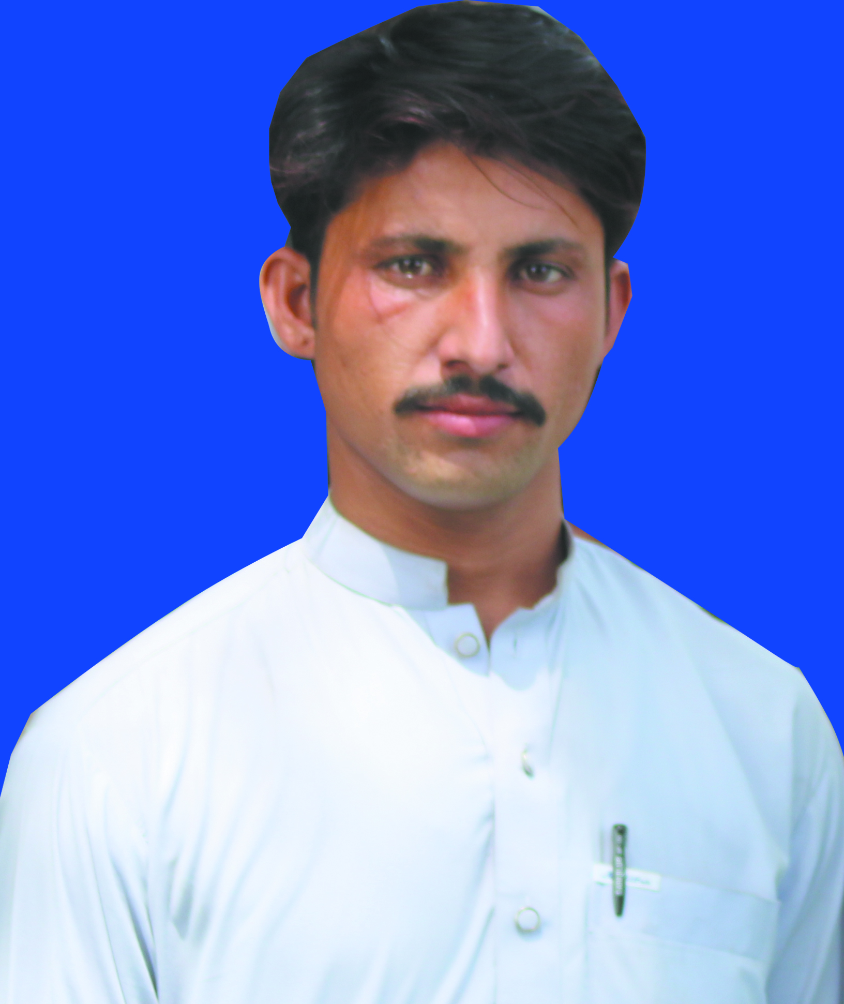
Date Of Birth: 27/02/1995
Address: Village Mamabati Barakzai p/o Nurar Tehsil & Distt Bannu.
Domicile: Bannu (KPK)
OBJECTIVE
I believe in devotion to work hard and testing my professional
Knowledge in creating opportunities in any competitive environment.

QUALIFICATIONS
Degree | Session | Marks | Division | Board/University | Remarks
S.S.C | 2011 | 687/1050 | ^{1st} | B.I.S.E Bannu | Science
F.Sc | 2013 | 581/1100 | 2nd | B.I.S.E Bannu | Pre-Engineering
B.Sc | 2015 | 262/550 | 2nd | U.S.T Bannu | Computer Science
MCS | 2018 | 2.81/4.00 | 1st | KUST Kohat | Computer Scenic
D. I.T | 2016 | 1056/1400 | 1st | KPK Board of Technical Education Peshawar | Computer Science
P.T.C | 2017 | 601/900 | 1ST | A.I.O.U Islamabad | Education
B. Ed | 2020 | 1276/1800 | 1ST | A.I.O.U Islamabad | Education

Experience:
6 Years Experience in English Medium School as a computer instructor in,
(National Model School Faiz Talab Abbas Mandan Bannu)

COMPUTER SKILLS:
6months computer course: M.S Word,M.S Excel, Power point, InPage, Window XP & Internet.
Designing in Alhamra Aid Designing Center, English and Urdu typing.
DISTINGUISH FEATURES
>Excellent Communication Skills >Ability to handle multi-dimensional task
>Fluency in English and Local Languages. >Can work for long hours >Under-take responsibility easily & confidently >Can work in pressure
HOBBIES
Traveling, Reading Books, News Papers, and Net Surfing.

