 |  | FAHIM SAIF ULLAH
 |  | Personal Details
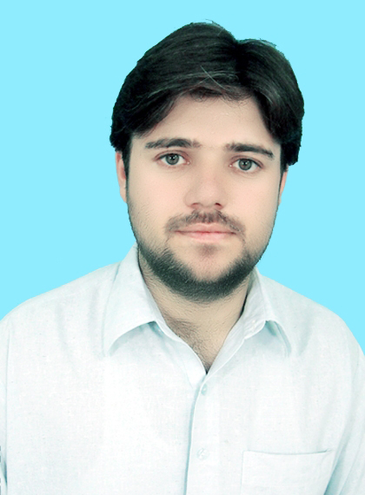 | Cell : 0333 9728080  E mail: fahimsaifkhan@yahoo.com  Nationality: Pakistani.  Union Council: Sokari  Religion: Islam.  Marital Status: Married.  Date of Birth: May 08, 1981.  CNIC # 11101-1489764-1.

Objectives
To explore the challenging role in the corporate environment and emerge as one of the best leaders with my excellent leadership, thereby contributing to the organizations vision.
Education
- S.S.C from Pakistan Government High School No,2 (since 1997).
- Civil Diploma of Associate Engineering (3 years) from Polytechnic institute Bannu (since 2002).
- Bachelor Degree in Computer Science (BSCS (Hons)) from Gomal University D.I.Khan (since 2006).
experience
Assistant Manager (Mobil ink GSM), Pakistan.
July, 2006 to Jun, 2011.
Responsibilities
- Manage Electrical Financial Inventory Control System (EFICS).
- Manage Internet Customer Relationship Management system (ICRM).
- Handling Customer Complains.
- Deal with queries from the Customer.
- Making Customers daily and weekly reports.
- Maintains weekly and monthly performance reports of the departments.
Worked with Etisalat (Telecommunication) as a Sales Executive for promoting E-Life (indoor & outdoor) on behalf of Sha cube Marketing & Promotions at Abu Dhabi, Dubai, and Sharja since FEB, 2011 to May, 2017.
What is E-Life ?
E life is a combined offering of landline, broadband Internet, and TV services. This bundle is based on Next Generation Fiber Optic Technology which allows customers to combine high-quality voice, supersonic Internet, and high-definition TV into one amazing experience.
Responsibilities
- Migrate customers from ADSL to E Life (On Fiber Optic).
- Brings customers to Etisalat as new E life customers.
- Promotion of E Life.
- Receives calls from customers and guide them accordingly.
worked as a Temporary Tehsil Monitor (TTM) with EPI program since 3 years(Augest 2017 to September 2020 .
Responsibilities
- Pre-Campaign, Intra-Campaign and Post-Campaign activities.
- Formation of Micro plan for upcoming campaign.
- Supportive Supervision and Monitoring of polio workers in the field during campaign.
- Data collection and submission.
- Supporting to organize meetings and trainings.
- Influencing polio refusal cases.
- AFP case reporting to concerns.
Worked as a Area Level Social Mobilizer (ALSM) at UC Sukari under the contract of "People" since March, 2021 to March, 2023.
Responsibilities.
- Supportive Supervision of polio workers in the field during campaign.
- Tracking and Conversion of Missed Children.
- Communication and Mobilization.
- Provided support to Epi Technician in EI and Zero Dose coverage.
- Maintain Log Book.
- Maintain Social Profile and monthly Planner.
Currently working as a Union Council Communication Support Officer (UCCSO) at UC Sukari under the contract of "People" since March, 2023 to Date.
Responsibilities.
- Supportive Supervision and Monitoring of polio workers in the field during campaign.
- Tracking and Conversion of Missed Children by Planning RCC and Implementation in the field.
- Communication and Mobilization activities planning and implementation.
- Provided support to Epi Technician in EI and Zero Dose coverage.
- Prepare and update the Social Maps and UC Maps and support the process of updating MP.
- Maintain Social Profile and monthly Planner.

skills

- Dedicated hard working and a good team member.
- Developed the ability to work in a fast paced environment.
- Ability to perform under pressure situations.
- Excellent communication skills.
- Having the command on MS Office & well versed with working on the internet.

