

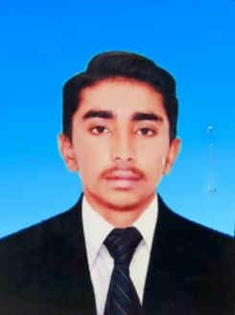FARAZ AHMED

**Address: NEW CITIZEN COLONY HYDERABAD**

**DISTT : HYDERABAD**

**CELL# 0307-927541-5**

**CAREEROBJECTIVE**

To work for challenging position in competitive and dynamic environ mentto build personal credibility through efficient performance, knowledge and skills for long term career development and growth.

**PERSONALINFORMATION**

|  |  |
| --- | --- |
| Father’sName | RIAZAHMED |
| Surname | CHANNA |
| Date of Birth | 01-03-2005 |
| CNIC# | 43403-0421614-9 |
| Domicile | Kamber Shahdadkot |
| Marital Status | Single |
| Religion | Islam |
| Nationality | Pakistani |

**ACADEMICQUALIFICATION**

|  |  |  |  |
| --- | --- | --- | --- |
| **DEGREE** | **GRADE/DIVISION** | **YEARS** | **BOARD/UNIVERSITY** |
| Matriculation | Grade“A” | 2020 | B.I.S.E Larkana |
| Intermediat | Grade “A’’ | 2022 | B.I.S.E Larkana |

**EXPERIENCE**

* 2 Year Expirience as a Computer Operator in Foundation Assisted School Karachi Rashidi Village

 COMPUTER SKILLS

* 1 Year Diploma Course at Muqadas Computer Center Nasirabad

**LANGUAGE**

* Sindhi,Urdu,English.

**REFERENCE**

* Willbe furnished on demand.