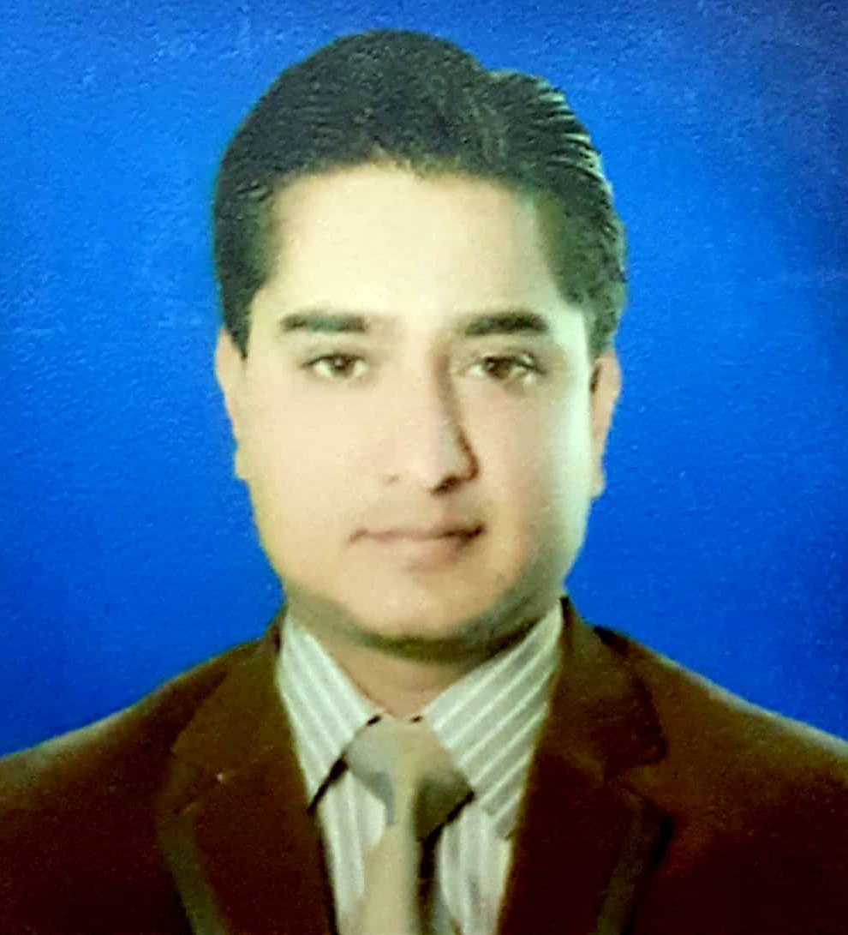

**PTCL- Ufone Quetta & Karachi | August 2019 – Till date**

**(Currently working at)**

Business Centre Executive

Tasks:

* Overseeing the branch or field operations and activities of an organization.
* Developing business strategies and managing staff in line with the corporate and regulatory policies.

**M&P Couriers, Quetta | May 2019 – August 2019**

**(4 Months)**

Team Leader Retail

Tasks:

* Reading and acting on all retail communication and associated tasks

**TCS Pvt Limited Quetta | March 2016 – May 2019**

**(3 Year 2 Months)**

Retail Sales Executive

Tasks:

* Setting sales goals and developing sales strategies.
* Researching prospects and generating leads
* Contacting potential and existing customers on the phone, by email, and in person.
* Handling customer questions, inquiries, and complaints..

**UFONE Franchise (Ideal Communication) | May2008 – November 2009**

**(1 Year 6 Months)**

Manager

.

**UFONE Franchise (Jamali Communication, Quetta) | Feb 2006 – April 2008**

**(2 Year 2 Months)**

Customer Service Executive

Tasks:

* Closing sales for the company
* Filling customer records, including contact information, purchases and billings.
* Conducting surveys and writing reports based on customer feedback on products and services
* Providing customers with clear instructions to resolve issues.

**WORK EXPERIENCE**

**DIPLOMAS Y HOBBIES**

**Formaciones :** Diplomados, Congresos, xxxxxxxxxx xxxxxx xxxxxxxxx xxxxxxxxxxxxxxxxx

**Hobbies:** xxxxxxxxxxxxxxxxxxxxxxxxxxxxxx

**ABOUT ME**

**HASEEN**

**NIZAM-UD-DIN**

I reside in Quetta, Balochistan, born on 10th Febuary, 1987, having marital status as Married. As a professional in the fields of Customer Services, Retail Sales, and Communication, with the experience of 12 years in different well- reputed organizations, I am passionate and commited for performing in competitive environment, and seeking for a position where I can utilize my skills and serve that organization to achieve its goals and mission.



* Teamwork
* Good Communication Skills
* Leadership Skills
* Problem Solving Skills
* Excellent Time Management
* Office Automation
* Strong decision maker

**SKILLS**

**CONTACT**

+9233-23456780

Haseennizamuddin1987

@gmail.com

H. No: 15, Al- Amarat Home,

Ismail Colony, Street: 03,

Sirki Road, Quetta, Balochistan.

**LANGUAGES**

2013 | Quetta

**Masters International Relations**

University of Balochistan

2010 | Quetta

**B.A. Bachelors of Arts**

University of Balochistan

2007 | Quetta

**I.C.S**

Balochistan Board of Intermediate and Secondary Education

2005 | Quetta

**MATRICULATION**

Balochistan Board of Intermediate and Secondary Education

**EDUCATION**

Urdu: Native Punjabi: Good

English: Proficient Pashto: Good

©AZURIUS - My-resume-templates.com