Hassan Mumtaz Aziz  Curriculum Vitae |  |  |  |  |  |  |  | 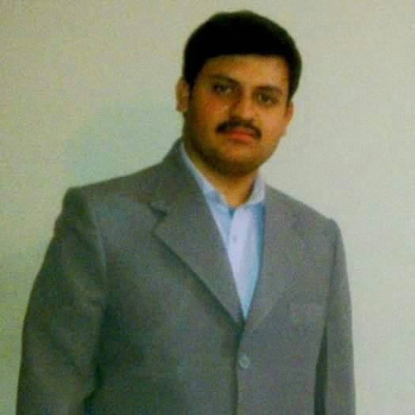
Date of Birth: | 01 | - | 07 | - | 1990 | Age: | 33 Years
Address: | NICN: 32304-4430842-3  (Permanent)P/O muradabad, Tehsil & Distt Muzaffargarh .Punjab.Pakistan.  (Working Address) Contoller of exmination department Nishtar Hospital Multan.  Domicile : District Muzaffarharh (Punjab)
Contact: | +92 3007305745
Email: | Hassanmumtazaziz@gmail.com
PMDC # | 73855-P

Objective: | - To become a good Public health worker with basic knowledge of pediatrics, who would be beneficial for society, who has clinical skills to tackle the emergencies and to become a doctor who can play a role in minimizing the burden of infectious diseases in Pakistan.  - Be a competent specialist able to provide appropriate and cost-effective care to patients at all levels  - To train and educate health workers working in field.  - To build an environment of research and continuous medical education (CME) at my working place.  - Promote health and prevent disease in patients, families and communities.  - Practice continuing professional development.

Professional Career Summary:

Education: | Degree/Certificates | Passing Year | Division | Marks | % Marks | Board/University
Education: | DCH (Part-I Passed) | 2023 | ---- | ------ | ------- | NMU
Education: | MBBS | 2014 | First Division | 2760/4500 | 61% | University of Lahore
Education: | F.Sc. | 2007 | First Division | 862/1100 | 78% | BISE Multan.
Education: | Secondary School Certificate (Matric) | 2005 | First Division | 651/850 | 77% | BISE DG Khan.
Clinical Experience:  House Job | Duration | Disciplines / Hospitals
Clinical Experience:  House Job | 3 Months | Dept. of Clinical oncology MINAR Hospital Multan
Clinical Experience:  House Job | 3 Months | Dept. of internal medicine CMH Hospital Multan
Clinical Experience:  House Job | 6 Months | Dept. of General surgery & Thoracic Surgery Nishtar Hospital Multan.
 | Assistant Controller Examination, Controller of examination Department Nishter Medical Unverisity Multan. |  |  | 15th March 2024 till date
 | Post Graduate Training  Nishtar Hospital Multan |  |  | 1st January 2022 14th March 2024
 | Medical Officer (Regular)  EPI focal person, Distt. Khanewal |  |  | 13thSeptember to 31st December 2021
 | Disease Surveillance officer PEI WHO District Vehari |  |  | 1st January 2021 to 31st July 2021
 | Polio Eradication Officer PEI WHO District Vehari |  |  | 23rd March 2019 to 31st December 2021
 | District surveillance Coordinater |  |  | 2nd September 2018 to 22nd March 2019
 | Deputy District Health OFFICER Tehsil Dunyapur |  |  | 10 June, 2018 to 1st September 2018
 | Deputy District Heakth Officer Tehsil Kehror Pecca |  |  | 23 May 2017 to 09 June 2018
 | Medical Officer BHU 1-4 MPR Tehisl dunyapur |  |  | 04 may 2016 to 22 May 2017
 | Medical Officer RHC Muradabad Tehsil Muzaffargarh |  |  | 29th december2015 to 03rd may 2016
Other Experiences | - Performed duties in Covid-19 isolation.  - Supervised polio campaigns at district level.  - Master trainer for campaign activities like measles campaign, polio campaign & typhoid.  - Master trainer to educate healthcare professional regarding disease surveillance activities.  - Organized EPI crash program and mopup activity.  - Worked as Focal Person of EPI activities at District Khanewal.  - Worked as Focal Person of Covid vaccination activities at District Khanewal

Skills
- Successfully devised crash programs for EPI vaccination, measles mopup activities.
- Handy knowledge regarding invention and implementation of monitoring tools. Invented EPI monitoring check list (can be provided on demand).
- Handy knowledge regarding disease surveillance activities.
- Handy knowledge regarding case reporting, clustering of cases and sentinel event reporting.
- Attended workshops regarding maternal and child health, breast feeding etc.
- Completed rotation in Paeds & Neonatal ICU.
- Completed workshops for Neonatal Resuscitation protocols.
- Participated in organization in Pediatric Pulmonology Symposium, attended workshops Paeds ultrasonography and new TB Guide lines.

Future Interests
- To improvise public health innovations.
- To contribute for the better management of EPI program.
- To Excel as a good Medical Teacher & Master Trainer.
- To do innovative research in relevant field.
- To play critical role in program working in preventive health care.

