PERSONAL INFORMATION | Habib Ullah
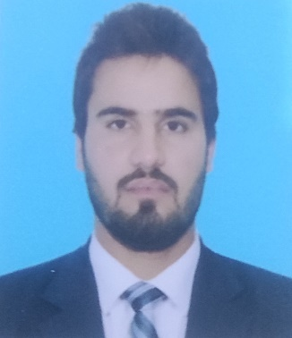 | Mubeen Town Arra Road Dera Ismail Khan.
 | +92 344 4408616
 | habibburki731@gmail.com
 | WhatsApp (Instant Message Service) @ +92 334 5724731
Father Name: Rasool Khan | Date of Birth: May 19, 1998 | Sex: Male | Nationality: Pakistani
CNIC# 21702-8919680-1

Career objective | To seek a job in such an organization where my professional knowledge and technical skill can be properly utilized and optimized, an environment where mutual respect and recognition are based on professionalism.

EDUCATION
Aug 2021 – Dec 2021 Cisco Certified Network Associate
Gomal University, D.I. Khan.

Nov 2017 – Nov 2021 | Bachelor of Science in Software Engineering – CGPA 3.26
Sep 2015 – March 2016 | Gomal University, D.I. Khan.  Final Year Project: COLLEGE MANAGEMENT SYSTEM (Using C#)  Diploma in IT – 1129/1400  Trade Testing Board, Peshawar.
April 2014 – Aug 2016 | HSSC F. Sc (Pre – Engg.) – 676/1100  BISE Peshawar.
April 2012 – Aug 2013 | Matric (Science) – 739/1100
 | BISE Peshawar.

INTERNSHIP

June13, 2021 – 31, Aug 2021 Pakistan Telecommunication Company Ltd (PTCL)
I was assigned to the department under respective officer.
During internship, I performed the following task.

- Access Network
- GPON FTTH / OFC
- Local loop design and survey
- Troubleshooting
- CRM
- Customer Satisfaction
- Professional integrity
- Company loyalty
- Prompt response to customer

PERSONAL SKILLS

Mother tongue(s) | Pashto, Urdu.
Other language(s) | UNDERSTANDING |  | SPEAKING |  | WRITING
 | Listening | Reading | Spoken interaction | Spoken production
English | Excellent | Excellent | Excellent | Excellent | Excellent

Communication skills | - Effective communication skills gained through my experience as university student.  - As project, gave presentations on many topics many a times during academia.
Personal Interests | - Poetry & Book Reading.  - Like to listen some good music.

