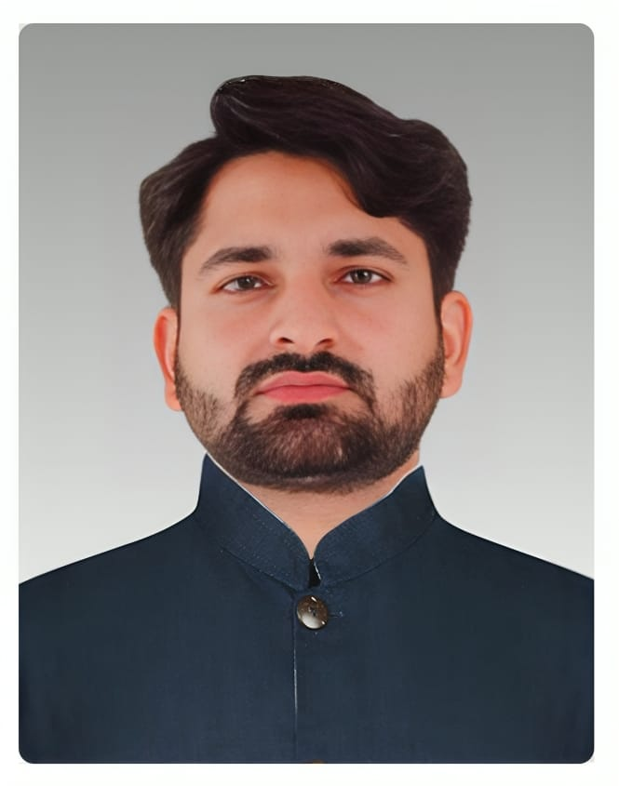**Hafiz Muhammad Hussain**

Community Mobilizer

**PERSONAL PROFILE:**

* + Father’s Name Muhammad Rafique
  + Date of Birth 23-12-1994
  + Nationality Pakistani
  + Religion Islam
  + Marital Status Un-married
  + NIC No 35102-0623810-5

**ADDRESS:**

**Permanent Address.** Basti khadam abad syed hashim street khara road kasur

Near Cenima moor (old bus station)

**Present Address.** University of the punjab quid-e-azam campus hostel Lahore.

Mobile No: 03040444558

E-mail: [hafizhussain5@gmail.com](mailto:hafizhussain5@gmail.com)

PROFESSIONAL PROFILE:

Motivated and adaptable team player, leader, and development Manager offering decades of success in the community. High-performing, strategic-thinking professional with more than 10 years’ experience in employment services in the Social Sector.6 years of experience in polio program, Community engagement, Child health, Child protection, Nutrition, Health & Hygiene, social listening, case investigation to facilitate rapid response unit for polio case investigation. Highly skilled in to develop and maintain strategic partnerships with key stakeholders, including government officials, civil society organizations, community leaders, and other relevant stakeholders. Planning, implementation, Monitoring, Evaluation, Reporting, team building and overall operational exceptional writing, presenting, and interpersonal communication skills. I am a depth in assessing needs, generating options, and implementing solutions in collaboration with team & management, experienced at managing projects from the requirements gathering/needs identifications phases through to completion. Experience and driven person with a proven track of success with effective marketing and superb customer service skills. Excellent communication, Strong creative and analytical skills.

EDUCATIONAL RECORD

**Master of Philosophy (Botany)**

University of the Punjab University 2022-2024

**Master of Science (Botany)**

University of the Punjab University 2020-2022

**Bachelor of Science**

University of the Punjab University 2018-2020

**Intermediate (FSc. Pre-Medical)**

BISE Lahore 2016-2018

**Matriculation (Science)**

BISE Lahore 2014-2016

ADDITIONAL COURSES

**Assistant pharmacist**

Doing two year diploma from the Punjab pharmacy council.

**Hifz-ul-quran**

Completed hifz-ul-quran course in three years with excellency.

PROFESSIONAL SKILLS:

|  |  |  |  |  |
| --- | --- | --- | --- | --- |
| Public speaking  skill | Expert in case work | Mobilization skill | Communication skill | Report writing  skill |
| Counseling skill | Coordination skill | Supervision,  Monitoring and  Evaluation skill | Command over  motivation | Presentation skill. |

Areas of Expertise:

|  |  |  |
| --- | --- | --- |
| Training & Capacity Building Skills | Leadership & Team Management  Skills | Communication & Social mobilization skills |
| Crisis Communication | Facilitation of Rapid Response  Unit | Communication Surveillance |
| Outbreaks Response | Social investigation/ Social  Diagnosis | Advocacy with the stake holders |
| Communication & Social mobilization skills | Monitoring & Evaluation Skills | Report writing skills |
| Proficiency in IT | Decision making under stressfull conditions | Community Based Interventions, |
| Research skills | Digital Literacy | Strategic thinking |
| Relationship Building | Accountability and commitment to results | Health, Hygiene & Nutrition |
| Human resource skills | HR Admin skills | HR Management & Administration skills |
| Database management skills | HR Recruitments skills | Logistics skills |

WORKING EXPERIENCES:

Currently, I’m working as a community Mobilizer (**CM**) in UC 19 Shalimar Town Lahore. I'm serving with people UNICEF CommNet (Communication Network) Staff for polio eradication. I'm responsible for implementation of Community based activities including household visits especially focusing on houses with refusals, persistently missed children and zero dose children. I'm using inter-personal communication (IPC) techniques with caregivers to encourage them to immunize children. I'm also providing communication support to vaccinators and other out-reach workers, especially in case of refusals.

Responsibilities;

* Updating Social profile
* Updating of the area micro plan
* Participation in UPEC Meetings to support campaign preparedness
* Providing support in area in-charge (AIC) and polio teams training
* Identification of influencers for addressing refusals and Missed children 6. Planning and implementation of Community engagement activities
* Mapping of all the High risk and mobile population (HRMP) settlements.
* Analysis of tally sheets for missed children
* Conduct School sessions
* PMCs,SMCs and refusals profiling
* Vaccinator support to cover Zero dose, defaulter and due defaulter children.
* Focus on Community sessions for vaccine importance awareness.

1. 1.5 Years’ Experience in teaching as a teacher in Allama iqbal public high school kasur (Since 2018 to 2019)
2. 3 Years’ Experience as a researcher in Microbial molecular biology Lab university of the Punjab Lahore(Since 2020 to 2023)
3. 4 year’s working experience as a team leader in polio campings in different union councils of Nishtar town, Lahore.
4. Six month’s experience in child vaccination as an assistant in union council 143, Nishtar town, Lahore
5. Six month’s working experience as an area in charge in polio campings , supervision of polio teams and management of logistics.

TRAINING/WORK SHOPS/SEMINAR:

* + Attended 3 days induction training on Interpersonal communication (IPC) & Social mobilization in hotel park lane lahore organized by **UNICEF**. 14-02-2024 to 16-02-2024
  + 01 day training Session on **NA and Missed Children** Regarding Polio Eradication arranged by **UNICEF**
  + Training on IPC and Media by **UNICEF.**
  + Training on COVID-19 SOP, s by **WHO & UNICEF**

COMPUTER SKILLS:

|  |  |  |  |  |  |  |  |
| --- | --- | --- | --- | --- | --- | --- | --- |
| MS DOCs | MS  Windows | MS Office | In page | MS power  point | Corel Draw | Proficient in Internet. | Artificial ntelligence |

REFRENCES:

Muhammad Arshad Dr. Muhammad Ilyas Gondal sb

Assistant Director DG Health Punjab

PHCIP-PSPA Director Health Services Lahore

0300-4689488 0333-8007872