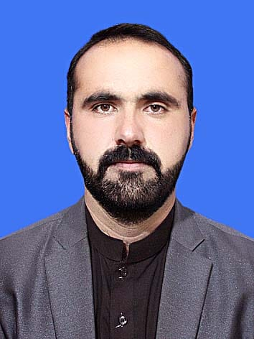***CURRICULUM VITAE***

**Personal Bio Data**

**Name:** Hafiz Sheryar Wazir

**Father Name:** Khan Bahadur

**Date of Birth:** 15 March, 1996

**Gender:** Male

**Nationality:** Pakistani

**Passport No:** waiting

**CNIC:** 21708-8756790-3

 **Domicile:** District South Waziristan Agency

 **Cell**: +92 3059665366/+92 3345251458

**Email Address:** Sheryaragri@gmail.com

**Postal Address:** Room No 149, Star hostel, The University of Agriculture Peshawar

**PERSONEL STATEMENT**

I am an energetic and enthusiastic person who enjoys challenges and achieving personal goals. My present ambition in life is to understand nature, promote peace and harmony, and help community. The opportunity to learn new skills and work with professional teachers is particularly attractive and important to me. I believe there is always a room for self-improvement both personally and professionally.

|  |  |  |  |  |
| --- | --- | --- | --- | --- |
| **Degree** | **Division/Grade** | **Marks/GPA** | **Passing**  **Year** | **Institute** |
| **Matric (Science)** | 51.92 /C | 545/1050 | 2013 | BISE DI Khan, KPK,  Pakistan |
| **F.Sc (Pre-Medical)** | 68.81%/B | 757/1100 | 2016 | BISE DI Khan, KPK,  Pakistan |
| **BS (Hons) (Horticuture)** | 73 % /B | 3.27/4.00 | 2020 | Gomal University DI Khan, KPK |
| **M.Sc (Hons) (Horticuture)** | 85.52% /A | 3.80/4.00 | 2022 | The University of  Agriculture Peshawar |

**Master of Sceince Honour In Horticulture**

I have completed my **M.Sc. (Hons)** in Horticulture**.** I have studied a wide range of subjects related to life sciences, mainly focusing on postharvest of fruits, landscaping, vegetable productions Advance Fruit Science and Experimental Design and Analysis.

**TRAINING AND CERTIFICATES**

• One month AutoCAD landscaping training.

English Language Proficiency Certificate.

**EXPERIENCE**

* **Fresh**

**~~TECHNIQUES LEARNED~~**

Use of statistical software i.e. Statistic 8.1

* Microscopy (use of different microscopes).
* Refrectometer
* Penetrometer
* Titration method
* Postharvest Data Collection Experience & Report skills.
* Tissue Culture

**RESEARCH SKILLS**

* I did my M.Sc. Hons research on **“Effect of tragacanth gum concentrations on the storage performance of sweet orange”**
* I did my B.Sc Hons research on “**comparison of different varieties of okra at DI Khan** ”
* Guide and Assist junior students in their study and research work.

|  |
| --- |
| **LANGUAGES** |
| 1. **English** (Professional working proficiency) 2. **Urdu** (Full professional proficiency) 3. **Pashto** (bilingual Proficiency) 4. **Afghani** (Full professional proficiency) |
| **COMPUTER SOFTWARE’S SKILLS** |

* Competent with most Microsoft office programs.(Word, Excel and PPT)

**EXTRA CURRICULAR ACTIVITIES**

* Reading books, Exercise.
* Watching classical & biological movies.
* Helping colleagues.
* Regular user of Internet.
* Sportsman (Cricket).

**REFERENCES**

**Lecturer. Dr. Syed tanveer Shah. Deptt: Horticulture The University of Agriculture The University of Agriculture Peshawar Pakistan Peshawar Pakistan.**