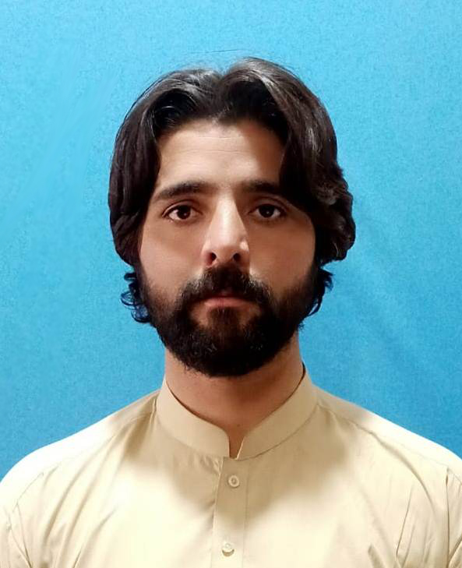
HAMDULLAH
S/O HAJI NAWAZ ALI
 +92332-5977728 hamdullahtareen99@gmail.com

PERSONAL PROFILE:

- Date of birth: 28, Dec, 1993
- Nationality: Pakistani
- Marital Status: Single
- N.I.C No: 54303-8129563-9

MISSION:

To work and grow with a prestigious organization that offer growth opportunities for professional advancement, where people with vision are mattered, and where talent is considered as competitive edge over competitors.
VISION:

To create identification throughout the world by my work and by utilizing all available resources.

ACADEMIC QUALIFICATION:

DEGREE NAME | INSTITUTE NAME | BOARD NAME | GPA/%
M.Phil | IIUI | IIUI | 3.53/4.00
BS Honors | IIUI | IIUI | 3.54/4.00
FA | Government College Pishin | BBISEQ | 56.27%
SSc(Science) | BRC Khuzdar | BBISEQ | 63.14

COMPUTER LITERACY:

- MS-Word 2003/2007
- MS-Excel 2003/2007

SKILLS:

- Self-confident, hard-working and result oriented
- Proactive to do work in challenging environment willing to accept responsibilities.
- Good command on English, Urdu, & Pashto.
- Social worker
EXTRA CURRICULARS:

- Reading Books & Articles
- Playing Cricket.
- Traveling.

LANGUAGES:
  - PASTHO
  - URDU
  - SARAIKI
  - ENGLISH

_EXPRIENC:_______________________________________________________________________

- WORKED AS A MEMMBER WITH NATIONAL PEACE COUNCIL OF PAKISTAN.
- WROTE A THESIS ON NATIONAL ACTION PLAN; AS A PAKISTAN COUNTER TERRORISM STRATEGY.
- WORKED AS CEO (COMMUNITY EDUCATION OFFICER) WITH BRSP BASED AT LORALAI.
- WORKED WITH RIZ CONSULTANT AS GCSS FACILITATER’.
- CURRENTLY WORKED AS A VOICE CHAIRMAN CITY ISLAMABAD WITH NPCP.
- Worked as supervisor with Himat Consultant in PPAF project
- Worked with taraqi foundation in district pishin based on wheat distribution assessment
- Worked with Aourat foundation as deta collater on NSER project based at islamabad
- Worked with Contech International as supervisor based at quetta on project of SMART

