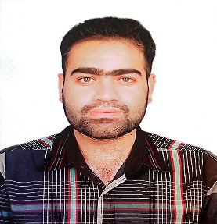HAMZA

SHAHBAZ TOWN PHASE 2 QUETTA CANTT.

CONTACT NO: 03128067807/03043078025

EMAIL:hk939948@gmail.com

OBJECTIVES

Secure a responsible career opportunity to fully utilize my training and skills, while making a significant contribution to the success of the any organization

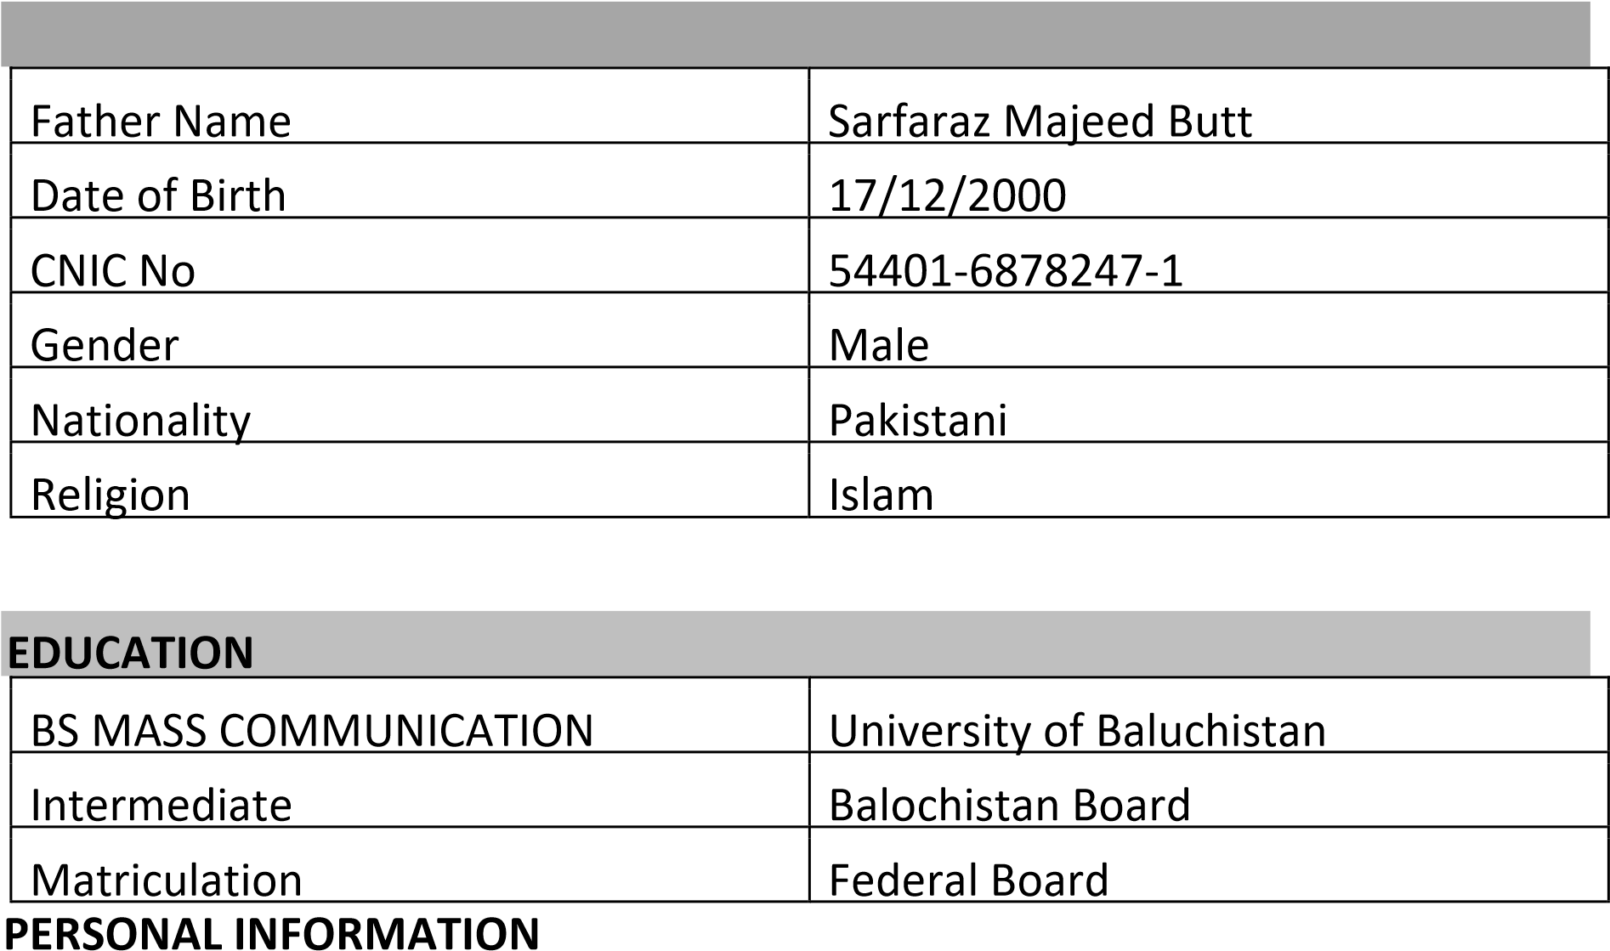

WORK EXPERIENCE

* 5 month experience as a field monitor in MICROMERGER work a 3rd party field monitoring on EPI (EXPANDED PROGRAM ON IIMUNIZATION).
* 5 Month experience as a marketing officer in BA mall Quetta.
* 3 years and 10 Months experience as Monitoring and Evaluation officer in PROVENCIAL HEALTH DIRECTORATE BALUCHISTAN QUETTA.
* 2years and 5 Months experience as a admin assistant in NGO (Baluchistan women Skills and educational Center).

SKILLS

* Good written and oral English skills
* Good communication skills
* Can work under pressure
* Can work as independently and as a team member
* MS office
* Graphic designing

COURCES

* 1 year English language diploma from pearl language center.
* 1 Month diploma in Basic IT Course

CERTIFICATES

* Attended one-day training on Amendment of CMRA 1929 National Strategy, National plan of Action. Country Analysis & Project Replication End early/ forced marriages.
* Completed The Online Training Introduction to Digital Journalism sponsored by Meta journalism project by REUTERS.

REFERENCE

Will be furnished on demand.