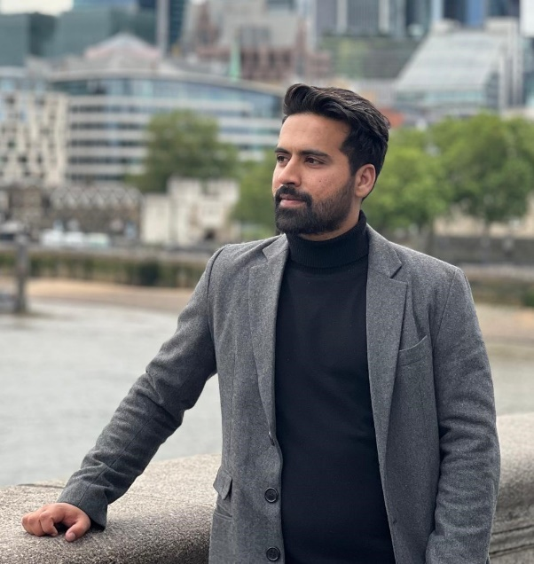 |  |  | Hamza Zahid
 |  |  | Doctor
contact  +923138574212  Hamzazahid23@gmail.com  House No. 410-c, Samungli Housing Scheme, Samungli Road, Quetta.  LANGUAGES  Urdu  English  Punjabi  Pashto  SKILLS  Direct Patient  Medical Histories  Pharmaceuticals Prescription  Pre-operative Vital Checks  Pain Management  Wound Care  Follow-up Care  Patient Counselling  Teamwork and Collaboration  Record Management  MS Office  INTERESTS  Photography  Videography  Travelling  Financial Education |  |  | Profile  Organized and dependable candidate successful at managing multiple priorities with a positive attitude. Diagnosed and treated patients and prescribed medications to mitigate medical/surgical conditions and illnesses. Offers compassionate bedside manner and dedication to quality patient care. Motivated to learn, grow and excel in the field of health and healing.  EDUCATION  2015-06 -  2020-12  MBBS: Medicine/Surgery  Bolan Medical College - Quetta  A-LEVEL: Pre-Medical  The City School - Quetta  - Received Bright Students Scholarship.  2012-08 -  2014-08  2010-08 -  2012-08  O-LEVEL: Science Subjects  The City School - Quetta  WORK EXPERIENCE  Medical Officer, 2023-06 – 2023-12  Tehsil Headquarters Hospital, Muslim Bagh  - Responded to medical emergencies to help stabilize and treat patients.  - Monitored post-operative recovery and educated patients on at-home recovery.  - Conferred with specialists to obtain expertise on patient conditions and referred individuals in need of additional care  - Implemented therapeutic regimens involving medications and other interventions to mitigate symptoms and prevent reoccurrence.  - Teamed with other physicians, specialists and health care providers to provide well-rounded care for complex cases.  Medical Officer, 2022-01 – 2022-12  Amna Medical Centre, Pirwadai, Rawalpindi  - Interviewed patients concerning physical complaints, discussed symptoms, asked questions and suggested treatment options.  - Assisted patient medication administrations using various methods such as intravenous, intramuscular, oral and subcutaneous.  House Officer, 2021-01 - 2022-01  Sandeman Provincial Hospital & Bolan Medical Complex Hospital, Quetta, Balochistan  - Completed 3 months rotation each in the departments of Medicine, Surgery, Dermatology and Radiology.  - Evaluated patient histories, complaints and current symptoms.  - Shadowed resident physicians, taking notes and asking questions.  Professional Registrations  - Pakistan Medical and Dental Council (PMDC) - 2022  - General Medicine Council (GMC), UK, - 2024

