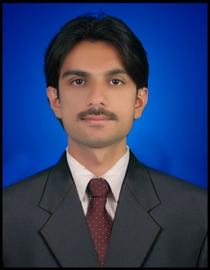
Haris Masood Ayubi

Email: haris.ayubi@gmail.com

Contact No: 03003805065

Career Objectives
To build career in growing organization, where I can get the opportunities to prove my abilities by accepting challenges, fulfilling the organizational goal and climb the career ladder through continuous learning and commitment.

Academic Qualification.
- Bachelor of computer Science (BSCS) University of Balochistan.
- Intermediate Govt Degree College from Balochistan.
- Matriculation Qandeel model public high school from Balochistan.
- Diploma in electronics trade testing board Govt of Balochistan.

Computer Skills
- Excellent knowledge in the use of computer and general purpose
Application software.

- MS Words, MS Excel & MS Access.
- Operating Systems (Win XP, Win XP PRO & Win Vista).
- Internet, Email.

Experience
- Worked as an office manager with Govt Construction Company Quetta Balochistan.
- Worked as a warehouse supervisor with PTCL (Pak telecom Ltd) Quetta Balochistan.
- Worked as a representative with Mobil ink GSM (Pakistan mobile communication Ltd) Quetta Balochistan.
- Worked as an engineer with (pronet Ltd) installation hot line UBL Bank branch to branch Quetta Balochistan.
- Worked as an office in charge with time tag (LLC) Dammam KSA.
- Worked as a Supervision of jointing excavation civil work and optical fiber cable in the field complete hold in the field of optical fiber laying, pulling, jointing, excavation, trenching, ducting and back filling as per SOP with Faws Enterprises Quetta Balochistan.
- Worked as a office manager pole to pole GIS Survey QESCO project Quetta Balochistan.

Personal Skills
- Honesty

- Team Spirit

- Accepting Challenges

Personal Profile
- Father Name: Farhan Ayubi

- Date of Birth: 29-09-1988

- Nationality: Pakistani

- Marital status: Married

- Languages Known: Urdu,brahvi,English

References
Available on request.

