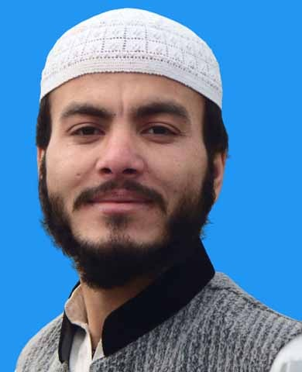
Imdad ullah khan

Permanent Address: Degan Shah Jalal Surrani Bannu
Post Office: Fazal Haq Malwana Surrani Bannu
Mobile No: +92.3329720910
G-mail: imdadsurrani@gmail.com

Objective:

To Become a part of a dynamic group where I could further explor the skill and capabilities which I gained in the whole academic career, and to serve in a challenging work environment and equally vast opportunities of career development based upon achievements and result.

Personal Information

- Father’s Name : Zafar Ullah Khan
- Date of Birth : 01-05-1993
- C.N.I.C : 11101-7807826-5
- Gender : Male
- Domicile : FR Bannu
- Nationality : Pakistani
- Religion : Islam
- Marital Status : Unmarried

Academic Qualification:

Qualificatin | Board or University | Obtain/Total Marks | Passing Year | Grade | %age
SSC | BISE Bannu | 515/1050 | 2009 | C | 49%
FSc | BISE Bannu | 659/1100 | 2011 | B | 55%
BSc | UST Bannu | 388/550 | 2012-2014 | A | 71%
MCS | UST Bannu | 1513/2400 | 2014-2016 | A | 62%
DIT | BTE Pshr | 1059/1400 | 2013 | A | 70%

Experience
Community Research & Development Organization (CRDO)
Posting: Computer Operator
Duration: From Jan 2017 to Dec 2018

Computer Skills
- MS Word
- MS Excel
- Access
- Power Point
- Data Entry
- Internet Browsing

Language Skills:
- English Good
- Urdu Good
- Pashto Good

