***CURRICULUM VITAE (CV)***

**IQRAR KHAN**

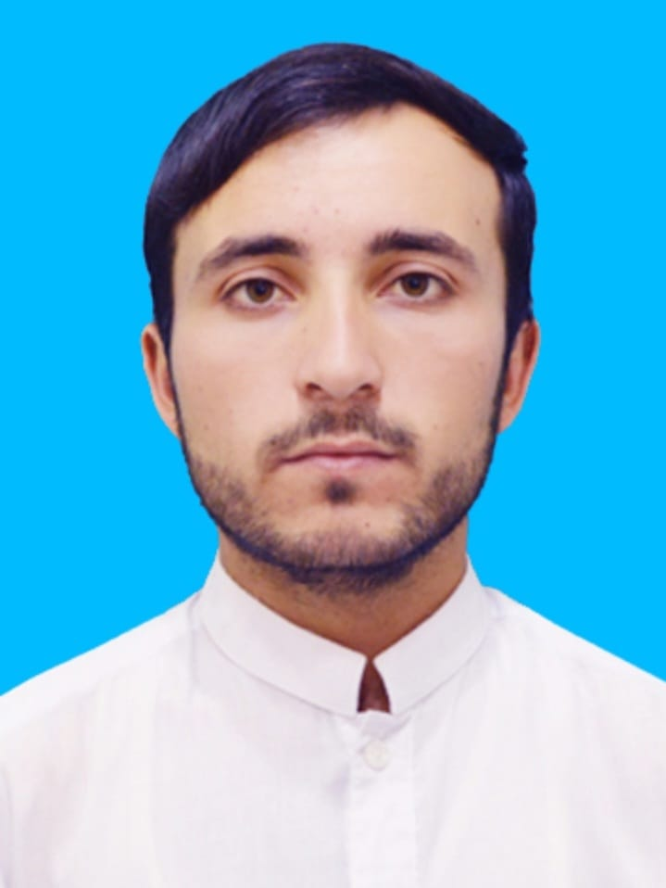

**PERSONAL INFORMATION:**

Father Name: Ibrar Khan

Religion: Islam

Nationality: Pakistan

Domicile: Khyber

Date of Birth: 14.09.2000

C.N.I.C: 21202-1240419-5

**EDUCATIONAL QUALIFICATION:**

**Certificate/Degree Year Board/University**

MATRIC (Science) 2016 B.I.S.E Peshawar, Pakistan

D.I.T 2017 B.T.E Peshawar, Pakistan

D.COM 2018 B.T.E Peshawar, Pakistan

BS Commerce 2018-2022 University of Peshawar

Computerized Accounting 2022 NAVTTC Program

**EXPERIENCE:**

**Organization Year Duration**

KP_IPRs Project Associate 2022-23 1 Year

(Social Media Influencer)

The Bank of Khyber 2023 08 Weeks

**LANGUAGE:**

**Language Written Spoken**

Urdu Good Fluent

Pashto Excellent Mother Language

English Good Good

Chinese Beginner Basic

**Personal Qualities:**

|  |  |
| --- | --- |
| 1. Active Mind | 1. Team Work Aptitude |
| 1. Reliable and Trustworthy | 1. Hardworking |

CONTACT & POSTAL ADDRESS:

Home address: *New Abadi, Koki Khel, Sher Khan Khel, Jamrud Tehsil District Khyber, Pakistan.*

Cell: 0304-9565163 | Email: afridiiqrar@gmail.com