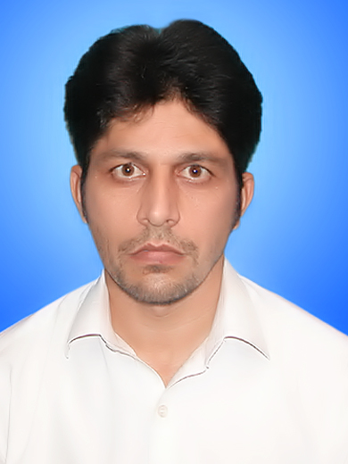
ISHFAQ AHMAD
Email: ishfaqahmad074@gmail.com

Cell: 03431193937 WhatsApp 0333-9429198
Personal BioData

Date of Birth | : | 15th April 1983
Nationality | : | Pakistani
Domicile | : | Swabi
NIC Number | : | 16202-8387836-1
Marital Status | : | Single
Postal Address | : | Village & Post Office Dagai(Mathra) Tehsil Razaar District Swabi .

Aims & Objectives

To join a well-organized & reputed organization, where the organization itself is always through a process of learning and provides opportunities to its employees, for utilizing their abilities in a proper way. Where it workers believe in common vision, teamwork, trust and respect for each other.
Academic Qualification

Certificate/Degree | Board/University | Year of Passing | Division
BS (IT) | KPK Agricultural University Peshawar. | 2001-2005 | 1st
F. Sc (Pre-Engineering) | Govt: Degree College Swabi(BISE Peshawar) | 2001 | ^{2nd}
Matric (Science) | Govt: high school Sikandari Swabi | 1999 | 1st
Computer Expertise

- MCSE Windows 2003 Server Administration
- MS office
- Internet browsing
- Hard ware skills
- Web designing
- Strong Theoretical computer background

Professional Experience
Designation: Union Council polio officer (UCPO)
Date: From 1st September 2016 to 28thFebruary 2021.
Organization: World Health Organization (WHO)
Designation: Temporary Tehsil Monitor (TTM)
Date: From 1st January 2015 to August 2016.
Organization: World Health Organization (WHO)
Designation: MIS Officer/Data Entry Operator
Date: From 15th September 2014 to 10 December 2014
Organization: Centre of Excellence for Rural Development (CERD).
Responsibilities:
- Keeping record of all Protection case of Bannu,Lakki and Karrak Districts.
- Ensure that up-todate and appropriate data tools are in place at all levels for smooth and timely flow of requisite monthly data from field to provincial office
- Collate and cross validate the data for inconsistencies before transmission to the HO in required format and as per timeline.
- Ensure that demographic and service delivery data in the MIS system are complete and accurate at all levels
- Provide regular feedback on project activities to project officer on regular basis
- Assist Senior project officer in data analysis and preparation of monthly and quarterly reports.
- Regularly update all programme files.

Designation: Child Protection Facilitator (CPF)
Date: From September, 2011 to 15th January, 2014.
Organization: Centre of Excellence for Rural Development (CERD).
Responsibilities:

- Registering children specially separated, unaccompanied orphan and child headed households.
- Maintaining daily attendance.
- Providing recreational facilities to the children and conducting recreational activities.
- Conducting sessions on health and hygiene and different child protection issues with the children.
- Inquiring from the children about their dreams, fears problems, identifying of CP issues with the children, recording the issues and notifying to the CP Monitors and CP Coordinator and suggesting the solutions.
- Meeting with parents as per need to solve protection issues with their children.
- Follow up of the children on regular basis
- Referring of children to formal education
- Any other task as assigned by CP Coordinator

Designation: Media Assistant
Date: From September, 2010 to August, 2011
Organization: Centre of Excellence for Rural Development (CERD).
Responsibilities:
- Assist Media Manager in their daily work
- Designing of title page and annual report
- Preparation of PVC cards of staff
- Preparation of training certificate
- Preparation of Banners for different activity/events
- Cutting of Ads from the newspaper
- Placing of Ads on all the notice board
- Taking and keeping pictures of all the Projects
- Video editing of all the Projects
Designation : Computer Operator/Office Assistant.
Date: From June 2007 to June 2010
Organization: KPK Agriculture Department Civil Secretariat Peshawar.

Personal Skills

- Posses interpersonal & communication skills
- Can work under pressure.
- Able to complete special assignments with in stipulated time.
- Able to perform any other duty that may be assigned by the
Management.

Languages Known

English Ability to understand, read, speaks & Write.
Urdu Ability to understand, read, speaks & Write

HOBBIES

I take interest in reading News Papers, Play Cricket, and Traveling.

REFERENCES

References will be furnished on demand.

