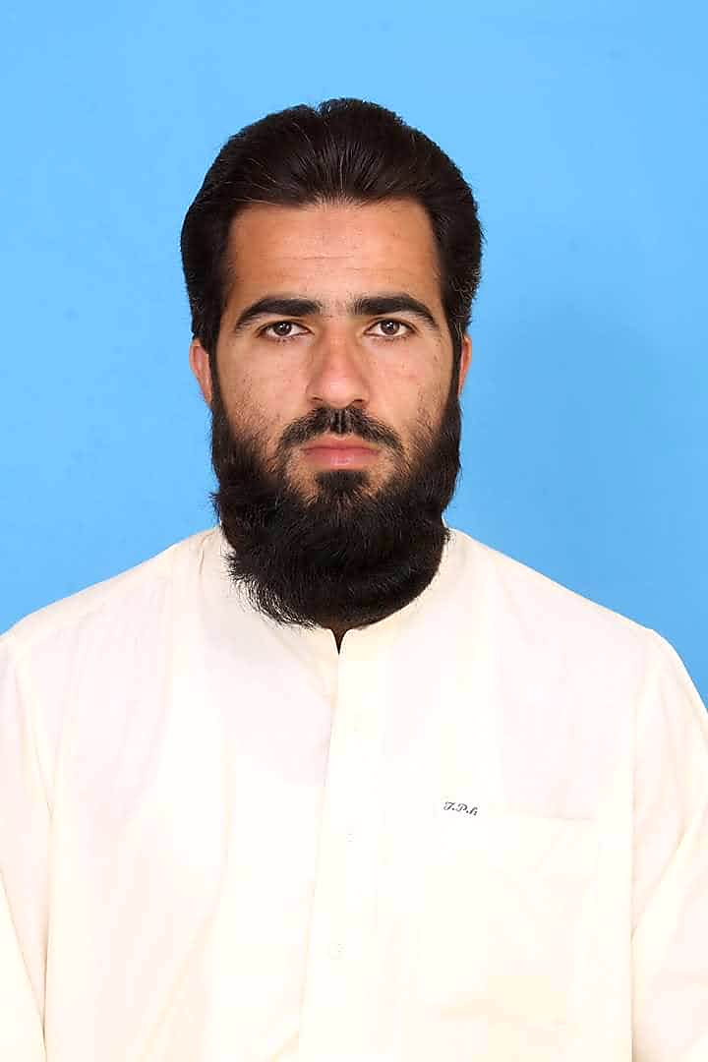**Israr Ahmad Afridi**

5th November, 1988

|  |  |
| --- | --- |
| Address: | Village Sangu Landi Bala, Bara Road Sarband, PO: GPO, Bara, Pakistan |
| Email: | vitalafridi1988@gmail.com |
| Nationality | Pakistani |
| Sex | Male |
| Phone: | +92 332 9206321 |

|  |  |  |
| --- | --- | --- |
| **Education** | **MPA – Human Resource Management**  **Institute of Management Sciences, Peshawar**  **69 CH with 3.3 CGPA (Principles Of Management)**  **Public Administration, Strategic Management**  Change Management, Human Resource Management, Statistics, Public Policy, Financial Accounting, Financial Administration, Project Management, Strategic Human Resource Management, Economic Analysis | **Jan 2010 – Dec 2012** |
|  | **B.A.**  **University of Peshawar (Pakistan Standard Marking System)**  **CH - 281/550 2nd Division (Political Science, Islamic Studies)**  Islamiat, , English | **Sep 2008– Dec 2010** |
|  | **F.Sc**  **Higher Secondary School Certificate (Pakistan Standard Marking System)**  **571/1100 Grade C**  Physics, Mathematics, Chemistry, English, Islamic Education, Urdu, Pakistan Studies | **July 2005 – Aug 2007** |
|  | **Matric**  **Secondary School Certificate**  **669/1050 Grade (Pakistan Standard Marking System)**  Physics, Chemistry, Biology, Maths, English, Pakistan Studies | **Feb 2003 – June 2005** |

|  |  |  |  |
| --- | --- | --- | --- |
| **Experience** | **UC Operation Officer (CTC)**  Responsibilities Includes,   * Supporting AS/CHW for quality MCB updation and recording * Pre Campaign quality Microplaning 100% . * Teams and AS training before campaign. * Microplan preparation. * Routine/zero dose/Defaulter/Due reporting/reaching. * Microplan Desk and Field validation. * Deployment of CHWs/AS to field. * Intra-campaign monitoring and supervision. * Data Compilation/Analysis and reporting. * Make sure Induction of training of new internee/hired | **July 2023 – Till Date** |  |
|  | **UC Delivery & Operations Officer (PEOPLE )**  Responsibilities includes,   * MCB updation and data collection through CHWs/AS. * Teams Training and AS training before campaign. * Monitoring and Supervision of CHWs/AS. * Data compilation/Reporting * LQAS Pass 100% * Timely Reporting of issue to next cadre/Town/District. | **April 2021 – June 2023** |  |
|  | **UC Delivery & Operation Officer (CTC)**  Responsibilities includes,   * Supporting AS/CHW for quality MCB updation and recording * Pre Campaign quality Microplaning 100% . * Teams and AS training before campaign. * Microplan prepartion. * Routine/zero dose/Defaulter/Due reporting/reaching. * Microplan Desk and Field validation. * Deployment of CHWs/AS to field. * Intra-campaign monitoring and supervision. * Data Compilation/Analysis and reporting. | **July 2020 – March 2021** |  |
|  | **UC Polio Officer (CTC)**  Responsibility Includes,   * Microplan preparation 100% accurate. * Microplan Desk and Field validation * CHWs/AS Monitoring * AFP Surveillance * Zero report submission * Monitoring CHWs/AS MCB updation * CHWs/AS training. * Strengthening Routine Immunization/zero dose/due/defaulter reporting and outreach sessions. * Data compilation and reporting |  | **February 2019 - June 2020** |
|  | **Union Council Polio Worker (WHO)**  Responsibilities Includes,   * Microplan Preparation according to field through volunteer Area incharges * Desk and Field Validation of Microplans * Selecting and training of suitable team members and area incharges * Monitoring teams and area incharges * Data compilation/collection and reporting * Supporting and having strong liaison with UC Partner staff * Providing vaccine and logistics to team and area incharges * Facilitating partner staff in other health related interventions * DDMs Submission * AFP Surveillance and stool collection/submission |  | December 2014 - January 2019 |

|  |  |
| --- | --- |
| **Qualification** | * Cross Cultural Communication Training * Roll-out for Presiding Officer and Assistant Presiding Officer KPK * MS Office Suit |

|  |  |
| --- | --- |
| **Skills** | * Strong Analytical, Administrative and Organizational skills * Work Effectively both as a Team Member and Independently * Excellent Communication and Public relation skills * Convincing and Leadership skills |

|  |  |
| --- | --- |
| **IT Skills** | MS Word, MS Excel, MS PowerPoint, MS outlook, OS Installation, Networking |

|  |  |
| --- | --- |
| **Languages** | English – Professional Fluency  Pashto - Native  Urdu – Native |

|  |  |
| --- | --- |
| **Interest** | Walking, reading newspaper, Swimming, Grilling |

|  |  |
| --- | --- |
| **References** | Available on request |