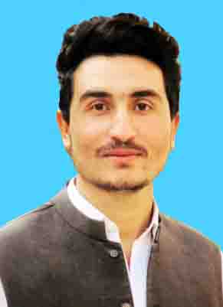

ISRAR ULLAH
Address: Usman Road Quetta.
Mobile #. 0331-2580610

PERSONAL PROFILE:

- Father Name : Saad Ud Din
- Date of birth : 08-02-2001
- Nationality : Pakistani
- CNIC : 54303-9591226-1
- Religion : Muslim
- Local/Domicile : Pishin
- Email Address : israrkhantareen344@gmail.com
OBJECTIVE:

To secure a position in an organization that would fully employ my personal skills, my experience as well as my academic training in a rewarding career that affords professional and personal growth.
ACADEMIC QUALIFICATION:
DEGREE | BOARD | DIVISION
Metric | BBISE, Quetta | 1st
F.Sc | BBISE, Quetta | 1st
BA | UOB Quetta | 1st
MA | UOB Quetta | 2nd
EXPERIENCE:

- 07 Months Experience in World Bank (BHCIP) Survey as a Enumerator (Feb 2022 )
- 01 Year Experience in World Bank (BHCIP) as Assistant/Associate.
- 01 Year Experience as a (UCO) Officer in Polio .
- 01 Year Experience as a Data Collecter in (PRC).
[[[[[[[[[[[[[[[[[[[[[[[[[[[[[[[[[[[[[[[[[[[[[[[[[[[[[[[[[[[[[[[[[[[[[[[[[[[[[[[[[[[[[[[[[[[[[[[[[[[[[[[[[[[[[[[[[[[[[[[[[[[[[[[[[[[[[[[[[[[[[[[[[[[[[[[[[[[[[[[[[[[[[[[[[[[[[[[[[[[[[[[[[[[[[[[[[[[[[[[[[[[[[[[[[[[[[[[[[[[[[[[[[[[[[[[[[[[[[[[[[[[
COMPUTER SKILLS:
- Basic Course Computer.
- ADIT, Typing, Ms Office, Ms Excel.
- Good Communication Skills Spoken & Written, Including Drafting Reports.

LANGUAGES:
- English
- Urdu
- Pashto

HOBBIES:
- Reading Books
- News Papar
- Football

