**JUNAID ZAMAN**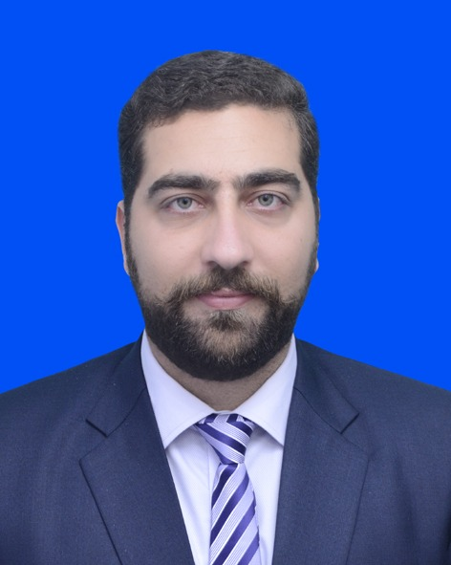

BS (Banking&Finance) Hons

CELL # +92-332-9060603

Father Name: Noor Zaman

CNIC #: 11201-4297014-1

E-mail: [Junaid_dawar@ymail.com](mailto:Junaid_dawar@ymail.com)

**OBJECTIVE**

Committed to secure a challenging / responsible position in a reputed organization in order to utilize my educational and excellent interpersonal skills for the betterment of the whole human being and myself as well.

**QUALIFICATIONS**

**EXAMS YEAR OF PASSING %AGE BOARD/UNIVERSITY**

BS Hons (Banking & Finance) 2007 - 2011 73% University of Science & Technology Bannu

B.A (General Group) non-regular 2008 - 2010 60 Allama Iqbal Open University Islamabad

* **EXPERIENCE**
* Worked as an Admin Logistic & NIS Officer in Prime Foundation Kohat.
* Worked as an Admin & Logistic Officer in Prime Foundation Kohat.
* Worked as an Admin and Procurement Officer in Muslim Aid Bannu.
* Worked as a Field Manager in USAID Power Distribution Programme Peshawar.
* Worked as an Admin/Finance Officer in Standard Engineering Associate Pvt Co,Ltd Peshawar.
* Worked as an Enumerator in USAID Power Distribution Programme Peshawar.
* Worked as an Admin officer in KSB Pumps Company Ltd at Ghani Enterprises/KSB Partners (North) KSB Franchise Network.
* **GENERAL SKILLS**
* The ability to use knowledge creatively and innovatively to solve problems.
* Pragmatism and practicality to turn a concept into reality.
* Effective communication (Spoken and written).
* Good team-working and time management.
* Good project management.
* A professional approach and ability to work to an ethical code of conduct.
* **COMPUTER SKILS**
* Windows 98, Windows 2000 Advance Server, Windows XP, Windows Vista, Windows 7, Hard disk partition any kind of software’s installation and Internet expert.
* MS Office all versions Complete Training.
* 6 months deploma of Windows installation, MS Office. from Peshawar technical board.
* Complet course of peachtree and quick book from Capital Institute of IT and Management Sciences Peshawar.
* M I S (Management Information System) Expert.
* **INTERESTS AND ACTIVITIES**

Badminton, Traveling.

* **LANGUAGES**

English, Urdu and Pashto (Native).

* **REFEREANCES**

Furnished on demand