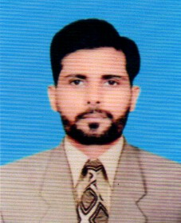
CURRICULUM VITAE
KAMRAN ANWER
Address: Gulshan Ravi, Lahore.
Cell: 0322-4645065
Email: kamrananwer098@gmail.com
CAREER OBJECTIVE
To face the challenges with reward in competitive environment to achieve excellence by working in reputed and world class organization
PERSONAL DATA
Father’s Name : Muhammad Anwer
Date of Birth : 06-09-1990
Marital Status : Married
Nationality : Pakistani
Religion : Islam
CNIC : 35202-5902582-7
QUALIFICATION
- F.A 2013
(Lahore Board)
- Matric 2011
(Lahore Board)
- B .A ( AIOU) CONTINUE
EXPERIENCE
- 3 years Experience Electronics Items Barakers, Purchase & Sales Out (2012-2014)
- 1 year Working Experience as a order Booker & Merchandiser Nutrilov food Uniliver Sigma (2014-2015)
- 6 Months experience in Saeed Ghani Beauty & Care as an Merchandiser in Imtiaz Mall.
- 1year Working Experience as a Store incharge in SBG Garments
- 2 years’ experience in Bahadur Industries Co. As Order Booker, 2016 to 2017.
- 2 year experience as a Sales Supervisor in Hardees. 2018 to 2019
- 3 years working Experience in Malkani Traders as a Order Taker & Sales Supervisor. 2020 to 2022
- 6 Months Working Experience as a Order Booker & Merchandiser Dhari Much Company
EXTRA ORDINARY SKILLS
- 3 Months MS OFFICE from AIM College
- Internet
REFERENCE : Will be furnished on demand

