KALEEM ULHAQ 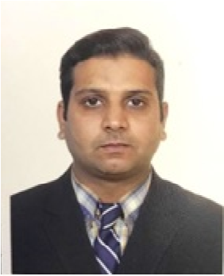

**Peshawar, K.P.K, 25000 Pakistan.**

**Telephone: 92345-6888697**

**Email: kaleem54_4@live.com**

**Kaleem.ulhaq25@gmail.com**

**PROFESSIONAL PROFILE**

**OBJECTIVE**

*To become a part of a dynamic group where I could further explore the skills and capabilities which I gained in the whole academic career and to serve in challenging work environment and equally vast opportunities of career development based upon achievements and results.*

**EDUCATION AND QUALIFICATIONS**

|  |  |  |
| --- | --- | --- |
| Examination | Institution/Board | Recently Complete |
| M.A | Peshawar University | 2014 |
| B.A | Peshawar University | 2012 |
| F.Sc | B.I.S.E Malakand | 2010 |
| SSC | B.I.S.E Malakand | 2008 |

______________________________________________________________________

**PROFESSIONAL QUALIFICATIONS**

|  |  |  |
| --- | --- | --- |
| Certification | Institution / Academy | Subject |
| DIT | Proftech Leading  Pakistan | Computer Course |
|  |

**PERSONAL PROFILE**

Father Name: Muhammad Naeem Gul

CNIC: 15401-1518728-7

Domicile: Peshawar

Religion: Islam

Address: Muhallah Muzafar Abad near Canal Road Danish Abad Peshawar

**WORKING EXPERIENCE**

4 months work as DEO (data entry operator) in SIF (SECOURS ISLAMIQUE FRANCE) from 21st June. To October

3 months work as DEO (data entry operator) in SIF (SECOURS ISLAMIQUE FRANCE) from 1st October to 31st of December.

2 Year work as DEO (data entry operator) at Women Empowerment program WEP from Nov 2019 to Dec 2021.

1 Year Work as Computer Operator Community Development Organization CDO from June2017 to June 2018

1 Year Work as Computer Operator at Global Vision Organization GOV from 01-Nov-2015 to Dec 2016

________________________________________________________________________

**DUTIES AND RESPONSIBILITIES**

* Proven experience as a data entry clerk
* Fast typing skills
* Excellent knowledge of word processing tools
* 5 years of experience with spreadsheets (MS Office Word, Excel, etc.)
* Basic understanding of databases
* Good command of English both oral and written and customer service skills
* Great attention to detail
* Sense of ownership and pride in your performance and its impact on the company’s success
* Critical thinker
* Team player
* Good time-management skills
* Great interpersonal and communication skills

.

**___________________________________________________________________________**

**KEY TECHNICAL SKILLS**

* Self-motivation, initiative with a high level of energy.
* Flexible to different situations.
* Decision making, critical thinking, organizing and planning
* MS Office, Typing, Internet and Email
* Full Computer Software and Hardware,

______________________________________________________________________

**LANGUAGES**

ENGLISH

URDU

PASHTO

________________________________________________________________________

**INTERESTS AND ACTIVITIES**

**Currently include** Traveling, Fitness, Training, Cooking, Painting, andFootball

________________________________________________________________________

**REFERENCES Will be Furnished Upon Demand**