Kaleem Ullah
PERSONAL INFORMATION:  House No. D2, Street No.2, Haji Town Bashirabad  Pajaggi Road, Tehsil City, District Peshawar.  E-mail: kaleem991@gmail.com  CNIC:17301-9431781-1  Mobile No: +92-344-5441199  +92-334-5441199 | 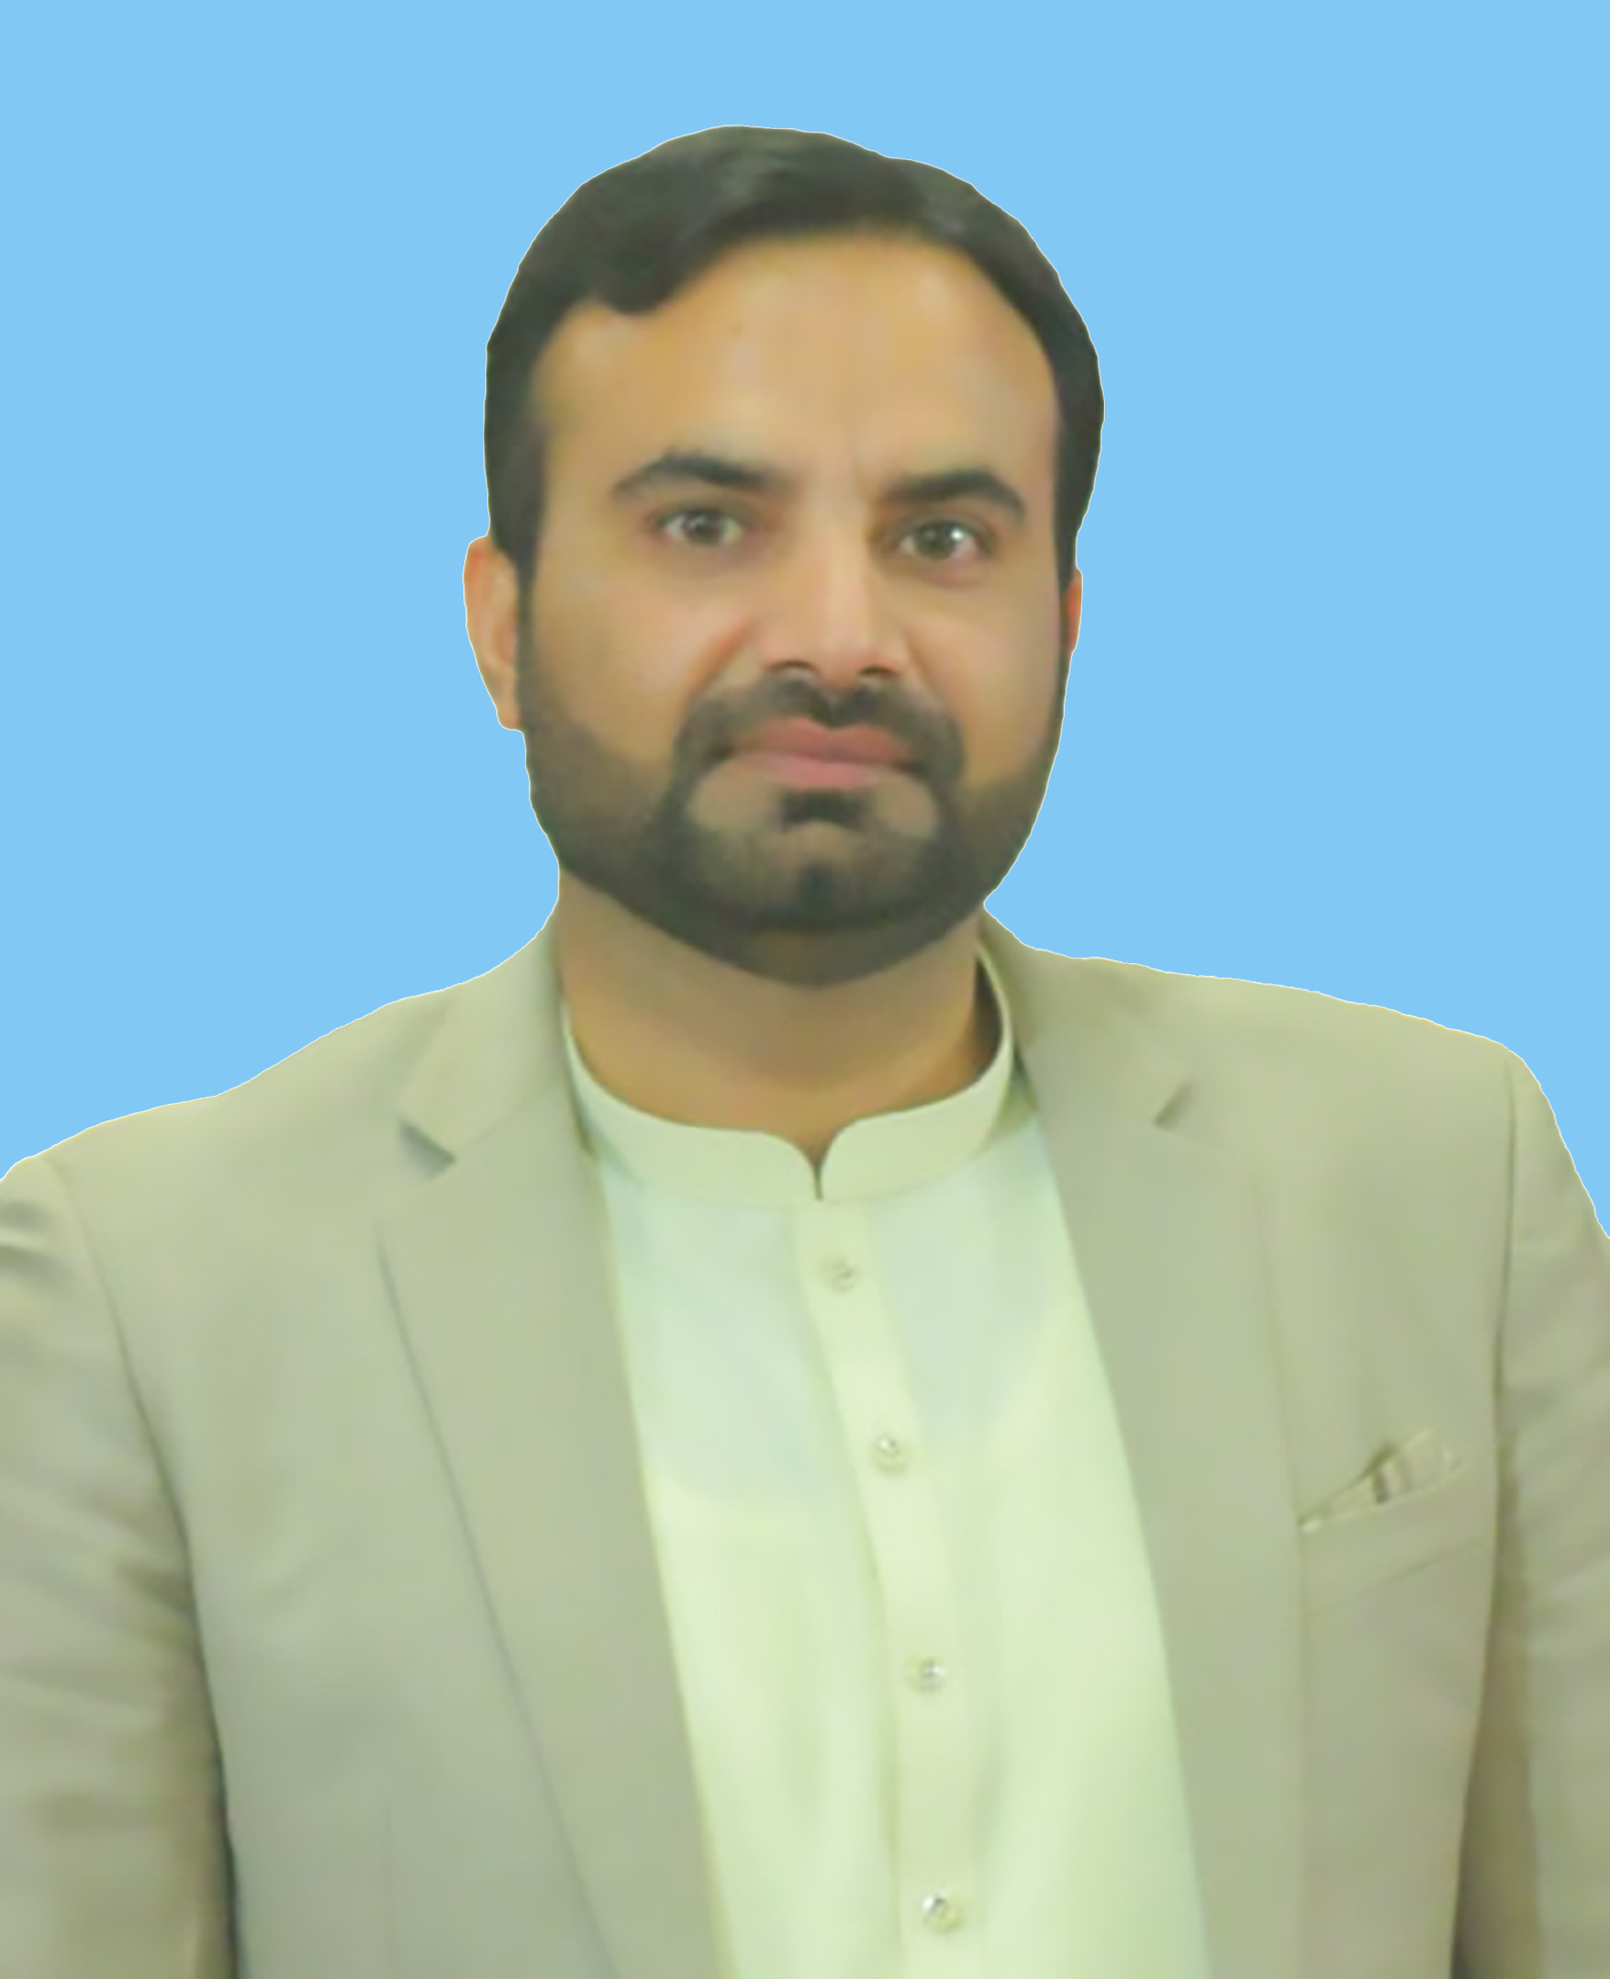

Objective: | To contribute my expertise and dedication to a respected organization that values innovation, teamwork, and continuous growth. I aspire to leverage my skills and experience to make a meaningful impact, while fostering personal and professional development in a collaborative and dynamic work environment.
Personal Details: | FATHER’S NAME : Abdur Raziq  DATE OF BIRTH : 10th April 1990  NATIONALITY : Pakistani  RELIGION : Islam  DOMICILE : District Peshawar  MARITAL STATUS : Married
Summary of Qualifications:
  QUALIFICATION | YEAR | Division | INSTITUTIONS
  M.Sc(Computer Science) | 2012 | 1st Division | Islamia College Peshawar(Chartered University)
  DIT(Diploma in Information Technology) | 2014 | 1st Division | Government College of Management Sciences and Commerce
  B.Sc | 2010 | 1st Division | Government College Peshawar
  F.Sc | 2008 | 1st Division | Government Superior Science College Peshawar
  S.S.C (Matriculation) | 2006 | 1st Division | Government Higher Secondary School No.1 Peshawar city
  ADE(Associate Degree in Education) | 2016 | In Progress | Allama Iqbal Open University Islamabad
Computer skills:  Work Experience:  Languages:  Interests: | - S Y S T E M S E X P E R I E N C E  - Working Knowledge of Ms office (MS Word, MS Excel, MS Power Point)  - Graphic Designing (Adobe Photoshop, Adobe Illustrator)  - Video Editing (Adobe Premier Pro, Cap cut, Filmora)  - E-Commerce (Amazon, Daraz, Shopify)  - Windows Installation and Operation.  - Back Up & Recovery  - Professional Employees Pvt Ltd ( PEOPLE)  UNICEF Project  Designation: (Tehsil Communication Officer) from 31st March 2021 to Present.  - Key Responsibilities:  - Engaging with communities on a large scale to enhance awareness of Vaccine Preventable Diseases, fostering informed decision-making.  - Collaborative meetings with Community-Based Organizations, Civil Society Organizations, and Non-Governmental Organizations to strengthen partnerships for impactful initiatives.  - Advocacy meetings held with community leaders and political representatives to garner support and facilitate the acceptance of vaccination programs.  - Engaging with families who may be hesitant about vaccines to build trust and promote vaccine acceptance within the community.  - Providing training programs to Union Council Officers to enhance their capacity and effectiveness in managing vaccination efforts.  - Implementing rigorous monitoring to ensure the quality of training programs and using Training Needs Assessment reports for continuous improvement.  - Assessing the quality of micro plans to ensure the success of vaccination campaigns.  - Consistent monitoring of teams and area supervisors to maintain and improve the quality of work during vaccination initiatives.  - Providing weekly progress reports to the administrative team, including the Deputy Commissioner of Peshawar, the District Polio Officer, and the SBC (Social and Behavior Change) Officer from UNICEF.  - Chip Training & Consulting(CTC)  UNICEF Project  Designation: (District Health Communication Support Officer) from 1st Feb,2019 to 30th March 2021.  - Key Responsibilities:  - TOT (Training of Trainers)  - Building IPC (Inter Personal Communication) skills  - Enhancing BCC (Behavior Change Communication)  - Monitoring and Evaluation of Polio Teams and Supervisors.  - Conducting Awareness Sessions at schools and the community.  - Keeping Logistics records.  - Weekly Progress Reports and Monthly assessment reports to the District Team.  - Chip Training & Consulting(CTC)  UNICEF Project  Designation: (Union Council Communication Support Officer) from Nov 18th 2013 to January-2019.  - Key Responsibilities:  - TOT (Training of Trainers)  - Building IPC (Inter Personal Communication) skills  - Enhancing BCC (Behavior Change Communication)  - Monitoring and Evaluation of Polio Teams and Supervisors.  - English (competent)  - Urdu (National language)  - Pashto (Native)  - To serve humanity with passion and create a positive environment for the well-being.  - Positive use of Social Media.  - Graphic Designing.  - Multimedia Software.  - Working in a team to achieve goals.  - To improve and share the latest development and up-to-date technology.

