***CURRICULUM VITAE (CV)***

**Kashif Ur Rehman**

**PERSONAL INFORMATION:**

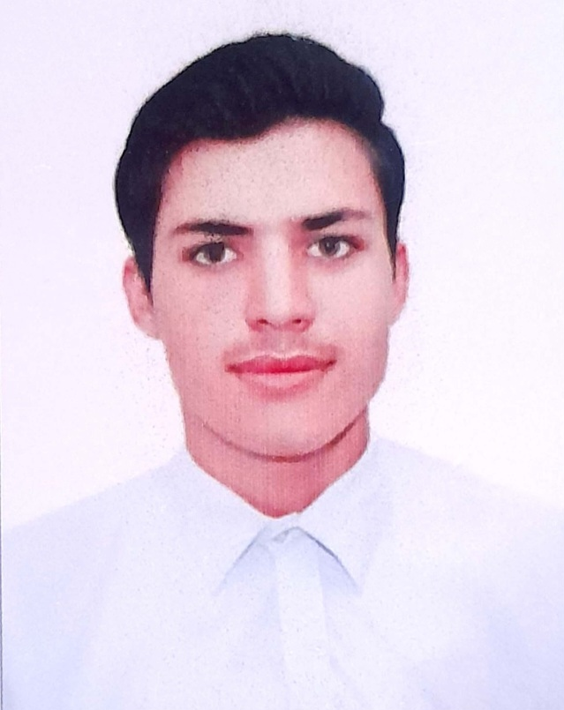

**Father Name:**  Muhammad Rehman

**Religion:**  Islam

**Nationality:**  Pakistan

**Domicile:**  Khyber

**Date of Birth:**  12/09/ 2003

**C.N.I.C:** 21202-7168440-5

**EDUCATIONAL QUALIFICATION:**

**Certificate/Degree Year Board/University**

MATRIC (Science) 2019 B.I.S.E Peshawar, Pakistan

FSc (Computer Science) 2021 B.I.S.E Peshawar, Pakistan

**COMPUTER SKILL:**

DIT 2020 B.T.E Peshawar

**DIPLOMA PROGRAMS:**

HVAC (AC Technician) 2022 B.T.E Peshawar

FM (Fire Man) 2024 C.D.T.S Peshawar

LFM (Leading Fire Man) 2024 C.D.T.S Peshawar

SFO (Station Fire Officer) 2024 N.I.F.T Islamabad

**EXPERIENCE:**

* 6 Months experience in PMS Incharge (packing material store) in Raka Poshi Pharmaceutical industry, Hayatabad Peshawar.
* 12 Months salesman experience in Electrical Shop in Karkhano Market Peshawar.
* 3 Months salesman experience in Blankets shop in Karkhano Market Peshawar.
* 12 months experience in Data Entry Operator.

**LANGUAGE:**

**Language Written Spoken**

English Good Fluent

Urdu Good Fluent

Pashto Excellent Mother Language

**Personal Qualities:**

|  |  |
| --- | --- |
| 1. Communicative | 1. Team Work Aptitude |
| 1. Reliable and Trustworthy | 1. Hardworking |

**CONTACT & POSTAL ADDRESS:**

**Home address:**

*New Abadi, Koki Khel, Sikandar Khel, Jamrid Tehsil District Khyber, Pakistan.*

**Email:** [kashifafd054@gmail.com](mailto:kashifafd054@gmail.com)

**Cell: 0333-8782854 0304-5003042**