URRICULUM
v
c
ITAE

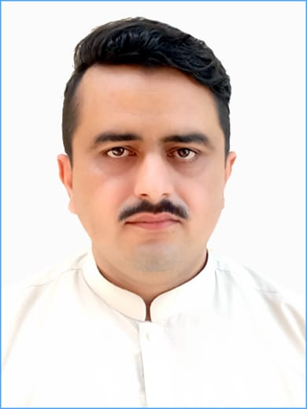
Mehran Khan
Main City Kohat Tehsil & District Kohat (KP)
mehranbettani@gmail.com

OBJECTIVE

- To use my skills and potential to assist an organization in achieving its goals while seeking long term career with optimum growth.

PERSONAL INFORMATION

- Father Name : Muhammad Ayub Khan
- Date of Birth : 15-09-1994
- C.N.I.C. No. : 12201-9217694-5
- Domicile : District Kohat (KP)
- Nationality : Pakistani
- Marital Status : Married
- Religion : Islam
- Cell #. : +923025804366 / +923439355670

QUALIFICATION

Degree | Marks | Division | Board / University | Year
D.I.T | 1048/1400 | 1st | B.T.E Peshawar | 2016
M.A (Islamiat) | 567/1100 | 2nd | Gomal University D.I K | 2015
B.Sc (Computer Science) | 322/550 | 2nd | Gomal University D.I K | 2013
F.Sc (Pre-Engineering) | 716/1100 | 1st | B.I.S.E D.I Khan | 2011
Matric | 583/900 | 1st | B.I.S.E D.I Khan | 2009

COMPUTER SKILLS

- Good command on MS Excel
- Good command on MS Word
- Internet
- PowerPoint
- Email
- Access

Working EXPERIENCE
Experience No 12
Organization Name Sarhad Rural Support Program (SRSP)
Organization Type Child Protection (CP Project Tank)
Designation MIS Assistant
Location District Tank (KP)
Period April 2023 to November 2023
Experience No 11
Organization Name UNFPA
Organization Type Free Medical Camps in Flood Affected Area
Designation Social Organizer (SO)
Location District Tank (KP)
Period June 2022 to Aug 2022
Experience No 10
Organization Name MERF
Organization Type Distribution of LLINS
Designation Supervisor
Location District Tank (KP)
Period April 2022 to May 2022
Experience No 09
Organization Name BEST-PAK
Organization Type General Food Distribution (GFD)
Designation Distributor Officer (DO)
Location District Tank (KP)
Period Sep 2022 to Dec 2022
Experience No 08
Organization Name CRSS
Organization Type Center for Research & Security Studies
Designation Field Researcher
Location District Bannu (KP)
Period Sep 2021 to Nov 2021
Experience No 07
Organization Name Apex Consulting Pakistan
Organization Type Consulting
Designation Internal Field Monitor
Location District Tank (KP)
Period 18 Round (LQAS)
Experience 06
Organization Name Weitek Consulting Pakistan
Organization Type Consulting
Designation Field Monitor
Location District Tank (KP)
Period 8 Rounds
Experience 05
Organization Name Taleem Foundation
Organization Type NGO
Designation Social Organizer
Location District Tank & D.I Khan (KP)
Period July 2019 to May 2020
Experience 04
Organization Name Aurat Foundation
Organization Type NGO
Designation Field Supervisor
Location District Tank (KP)
Period Aug 2017 to July 2018

Experience 03
Organization Name World Health Organization (WHO)
Organization Type NGO
Designation Tehsil Monitor
Location District Tank (KP)
Period Sep 2015 to Aug 2016
Experience 02
Organization Name Community Development Organization
Organization Type NGO
Designation Community Mobilizer
Location District Tank (KP)
Period October 2014 to Sep 2015
Experience 01
Organization Name Prime Foundation (MCCP2)
Organization Type NGO
Designation Survey Enumerator
Location District Tank
Period Aug 2013 to July 2014

Surveys

- 20 days survey conducted by National Nutrition Survey 2018 (NNS) worked as a line lister in District Tank (KP)
- Work as a Enumerator for one month with Glow Consulting Pakistan on Out of School Children Survey in District Tank (KP)
- 02 Months survey with PRCS in LLINS, distribution survey in district Tank (KP)
- 01 Week survey with HGO work as Enumerator in district Tank (KP)
- 02 Month survey with PHC Global (TPVICS) worked as a Data collector, district Tank (KP)
- 01 Month survey with NSER worked as Monitoring Officer in district Tank (KP)
- 02 Month working experience as a Monitoring officer with IDS survey in District Tank (KP)
- 01 Month working experience as a Field enumerator with SDPI survey in South Waziristan.
- 20 days working Experience as a Field Monitor with SMAARI INTERNATIONAL in District Tank & D I Khan (KP)
- 15 Days working Experience as a Quality Control Officer QCO with VTT GLOBAL (OOSC survey 2021) in District Tank (KP).

Trainings

- Attend 2 days training at Royal Ambassador Hotel D.I Khan of VHC on Social Mobilization and VHC Role and Responsibilities
- Attend 1 day training conducted by MDM on Village Health Committees on health inclusive CBDRR (Community based Disaster Risk Reduction) and Preparedness at Ambassador Lodge D.I Khan
- Attend 1 day training by MDM on Social Mobilization and VHC role and responsibilities at Ambassador Lodge, D.I Khan.

Professional Skills
- Ability to conduct /participate assessments
- Report Writing
- Educational Event (Trainings / Workshops / Seminars)
- Management
- Communication and Mobilization Skill
- Ability to travel as per requirement
- Planner
- Mature
- Humble conflicting Resolving Personality
- Data Collection
- Supervision

LANGUAGE

- English, Urdu, Pushto, Saraiki

REFERENCES

Haroon Mehsud
District Coordinator
Child Protection (CP project Tank)
Sarhad Rural Support Program (SRSP)
03327232772
haroonmehsud@yahoo.com

