**Muhammad DAWOOD .** 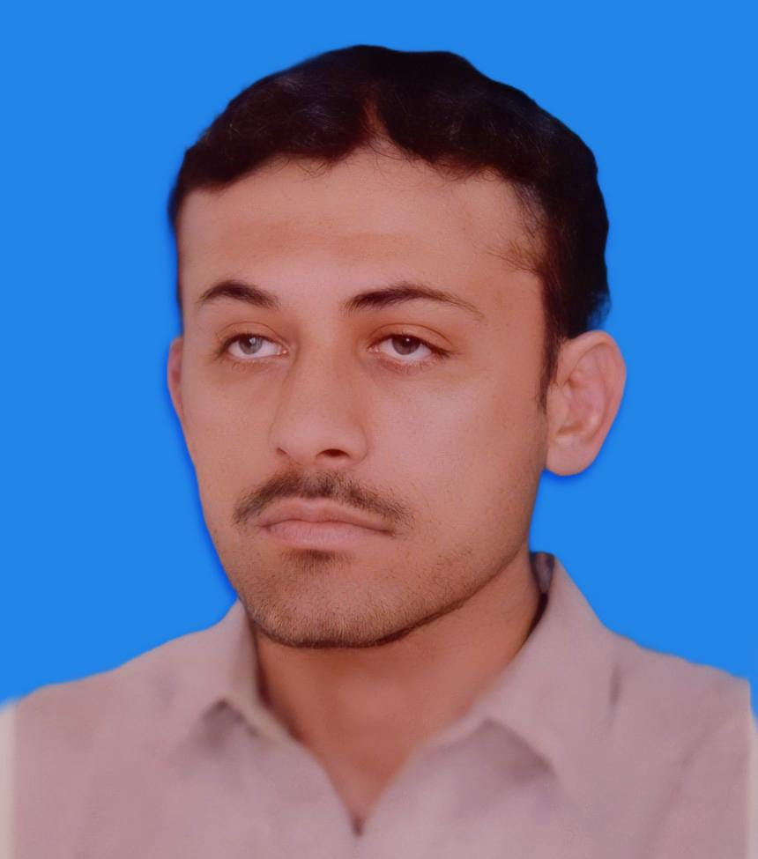

**CNIC # 54203-4049182-9**

**Cell : 03018090445**

**Address : Killi khojadad janghal piralizai**

**Addaa, Tehsil Killa Abdullah, District Killa Abdullah**

**E-Mail Address: mdawoodachakzai3@gmail .com**

***M.A(Masters in Political Science) University of Balochistan Quetta*.**

**Technical / Professional Skills:**

* Excellent Mobilization, Team Leader & Office management skills;
* Excellent Communication & Coordination Skills;
* Best Training and Management Skills;
* Excellent Monitoring & Reporting skills;
* Demonstrate capacity to plan, prioritize and deliver tasks on time to meet goals in a high pressure; and working in multi-disciplinary/cross-sectoral team;
* Ability to work independently as well as with a team of stakeholders, manage competing priorities and perform well under pressure;
* Ability to work and act under pressure with tight deadlines and with discretion in multicultural politically sensitive environment of the Balochistan province with a minimum of comfort;
* Vast Experience of Monitoring and Evaluation.
* Vast Experience of Social Mobilization.
* Ability to collect any assigned data.
* Computer skills, including MS office, Emailing, Windows Installation and MIS skills;
* Languages: Excellent in English and other local languages; Farsi, Pashtu, and Urdu.

**Experience:-**

**1. Area Supervisor (Area Incharge) in**

**Expandad for Polio Eradication**

**Initiatives. In U.C Mussazai.**

**Tenure: September, 2008 till 2011 Three (03) Years.**

**Location: Killa Abdullah.**

**2. Social Mobilizer with C.T.C in Expandad for**

**Polio Eradication Initiatives. In U.C Mussazai.**

**Tenure: September, 2012 till 2014 Three(03) Years.**

**Location: Killa Abdullah.**

3. U.C.C.S.O (Unioun Council Communication Support Officer) i**n Expandad for Polio Eradication**

**Initiatives. In U.C Mussazai.**

**Tenure: 2015 till 2019 Four (04)Years.**

**Location: Killa Abdullah.**

4. U.C.D.O (Unioun Council Delivery and Operations Officer) i**n Expandad for Polio Eradication**

**Initiatives. In U.C Mussazai.**

**Tenure: September, 2019 till 2020 Six (06) Months.**

**Location: Killa Abdullah.**

**5 . Community Mobilizer (CRVS).**

**Tenure: 01st April-2021till 30th June 2021 Three (03) Months.**

**Location: Killa Abdullah U.C Mehmood Abad 2.**

**Major tasks and responsibilities;**

* Responsible for Strong Vaccination of the Children under Five (05) Years.
* Mobilization and Motivation for Polio Campaigns, and providing awareness to the People and Community living / residing in my assigned / Catchment Area.
* Monitoring the field, Area Supervisors and Teams working under Supervision.
* Collecting Data from the Area Supervisors and Teams and submitting it to the Higher ups.
* Microplaning, Profiling and Taking regular Clusters.
* Providing Conducive Environment to the Teams in terms of ease to the Sub-Ordinate Staff.
* Solving and Convincing the People of the Catchment Area for Vaccination.
* Regular Meetings with the Political, Social and General Members of Society.
* Monitoring and Controlling the Vaccine Management.
* Having a strong command over the Sub-Ordinate Staff and best cordial relationship with the people residing in the Catchment Area / Unioun Council.
* Ability to prepare tentative plans for any desired activity.
* Ability to prepare Maps at any level.
* Best Communication Skills with reference to any assigned task or responsibility.

