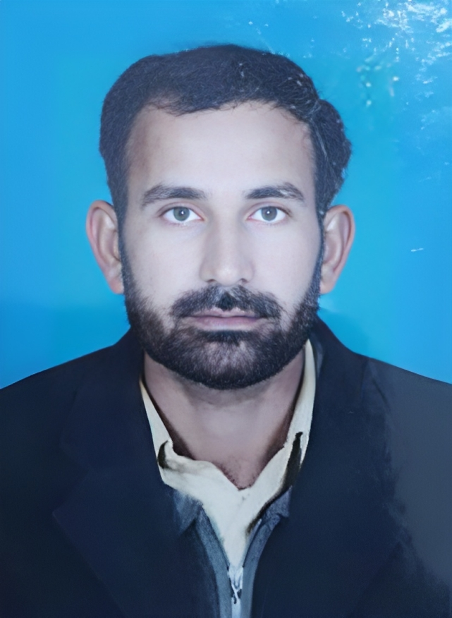
Muhammad Khalid
Resume
ADDRESS:
Baloch Abad, Zafar Abad Colony, Teh & Dist: DIKhan.
Mob # +92-306-1732826 | 0336-7525698
Email: khalidttm64@gmail.com

OBJECTIVE
To seek a career position in a progressive organization which should be challenging and demanding where I can practice my repertoire and learnt new skills.

Hints
- Education: Master in Islamiat
- Computer Skills: Has Good Knowledge.
- Experience: 4 Years working experience as a data collector
- Good Communication Skills: Speaking, Listening, Writing, and Reading In English, Urdu & Saraiki.

PERSONAL INFORMATION
Father Name: Alam Sher
Date of Birth: 25th May, 1988
Nationality: Pakistani
CNIC No: 12101-6897371-3
Religion: Islam
Marital Status: Married
Domicile: Dera Ismail Khan

ACADEMIC QUALIFICATION
EXAM | Year | Subject | BOARD / UNIVERSITY
M.A (Islamiat) | 2015 | Islamiat | Gomal University DIKhan.
B.A | 2012 | Arts | Gomal University DIKhan.
F.Sc | 2010 | Pre-Engineering | BISE DIkhan.
Matric | 2007 | Science | BISE DIKhan.

PROFESSIONAL QUALIFICATION
EXAM | Year | Subject | BOARD / UNIVERSITY
Computer Course | 2007 | IT Advance Basic Course | Al-Hamd Group of Education Islamabad.
Experince:
- Working as Data collector in appex consulting Pakistan DIKhan From 2018 to 2022 .

- 06 Years working experience in Online Software Management (Oracle), Excel, Documentation, Database, Data Collection & Data Analysis.

Professional Skills:
MS Office, Typing, Documentation, Communication, Public Dealing, Management, Team Leadership, Internet Surfing, Emailing.

