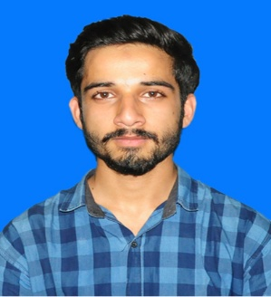
Curriculum Vitae

Muhammad Naseeb Ikram
Address: Warsak Road New Defense Colony near Behari colony food street Peshawar.
Contact #: 03169529459
Email : std104888@uop.edu.pk
Permanent Address: Village and post office Latamber, Tehsil and District Karak

Objective:
Seeking an opportunity where I can furnish myself in all aspects with a good professional to be and to make valuable contribution to the organization. If given an opportunity, it’ll be my earnest endeavor to perform to the best of my abilities and will strive to maintain the standard of your esteemed organization in most promising way with sincerity, loyalty, hard work and utilizing my skills to the entire satisfaction of my superiors.
Self-Profile:
- Excellent communicator.
- Comfortable with fellow at any level with a positive hand on approach especially in a productive environment.
- Dedication, loyalty and confidentiality are the keys to my success.

Academic Qualification:

BS (2019-2023) | 8th semester result (waiting)  CGPA: 3.72 / 4.00 till 7th semester | Department of International Relations, University of Peshawar
F.SC Pre-Medical  (2017-2019) | 941/1100 | Edwards college B.I.S.E, Peshawar
SSC (2015-2017) | 977/1100 | Happy day School System B.I.S.E, Peshawar

Personal Profile:

- S / O Ikramullah
- DOB 26-12-2000
- Gender Male
- CNIC # 42301-5864394-1
- Religion Islam
- Nationality Pakistani
- Domicile Karak KPK
Language:

- English Reading, Writing, Speaking
- Urdu Reading, Writing, Speaking
- Pashto Being the mother language
Computer skills:
- MS Office
- Internet
- E-mail
- Social Media Promotion
Experiences
- Worked as a leader in Dosti BlackBoard Banao- Pakistan Parhao volunteer welfare work in 2019.
- Worked as Programming and gaming head in 3 days camp on Climate change at Baragali Campus University of Peshawar, Organized by Department of IR.
- Worked as a Security Co-lead volunteer in Grand Peace Fair 2022, held in UOP, Organized by Department of International Relations.

Hobbies:

- Browsing internet
- Playing Outdoor Games
- Discussion with friends on relevant subject, and current issues.

