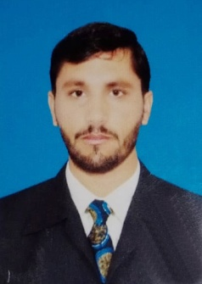

MUHAMMAD RIZWAN

Postal Address: Village Murtaza Tehsil and Distt Tank

Mobile No : 0304-9923067 0305-2607818
OBJECTIVE

I Want to achieve a respectable professional position in the society and in my own

Region through knowledge,hard work efficiency,skills and service

PERSONAL INFORMATION

- Father’s Name : Muhammad Jamal
- Date of Birth : 03/02/1998
- Cnic No : 12201-5888402-5
- Domicile : TANK
- Nationality : Pakistani
- Religion : Muslim
- Marital Status : Married

Permanent Address : Village Murtaza Tehsil & Distt Tank
ACADEMIC QUALIFICATION

EXAM | Session | MARKS/DIV | GRADE | BOARD / UNIVERSITY
SSc | 2014 | 707/1100 | B | BISE D I KHAN
FSc | 2017 | 687/1100 | B | BISE D I KHAN
BSc | 2019 | 385/550 | A | Gomal University DIK
MA ist | 2023 | 566/1100 | D | Gomal University DIK
DIT | 2020 | 1116/1400 |  | BTE PESHAWAR
HEALTH TECHNOLOGY | 2021 | 819/1450 |  | FPMA PESHAWAR
EXPERIENCE
1 Year as a vicsenater in DHQ TANK
6 Manth as soical mobilazer in BHU Kot Hakeem
1 Year as health tacnation in DHQ D I KHAN
Languages:

Urdu, , Pashto , English .

