**CURRICULUM VITAE**

**CAREER OBJECTIVE**

A full time purposeful position in a dynamic organization that confederate opportunities of professional growth, performance improvement, though training & vocational recognition and challenging assignment.

**ACADEMIC & SCHOLASTIC QUALIFICATION**

M.COM (Accounting) University of Science& 2010-2014 **71%**

Technology Bannu

B.Com University of Science& 2008-2010 **55%**

Technology Bannu

D.Com Govt, College of Commerce& 2005-2007 **63%**

Management Sciences Bannu

S.S.C GOVT.H.S Ismail Khel Bannu 2004-2005 **56%**

**PROJECTS**

* Internship report on “BANNU WOOLLEN MILLS LTD”
* Financial Analysis of “BANNU WOOLLEN MILLS LTD”.
* SWOT analysis and SWOT Matrix Interpretation of “BANNU WOOLLEN MILLS LTD”.

**PROFESSIONAL EXPERIENCE**

* **1. Working as Data Assistant in Qurtaba School & Collage Gulshan-E-Seahat E18 Islamabad from 05.04.2021 to Date.**
* **2. Worked as Computer Operator/Assistant in Pakistan Post Office (EMTTS Project) From; 01/05/2015 to 31/01/2021.**

* **3. Eight Weeks internship at ““BANNU WOOLLEN MILLS LTD”.**
* **4. Worked as a as Data Assistant at Relief Pakistan form 01.01.2013 to 28.04.2015**

**TRAINING**

Training Of CMAM, MUAC, OTP, SFP, Nutrition

**PROFESSIONAL CERTIFICATES**

1. DIT from Sarhad University.

**COMPUTER SKILLS**

* Knowledge of Internet.
* Email Use. .
* Knowledge of MS Office.
* Window driver &software installation

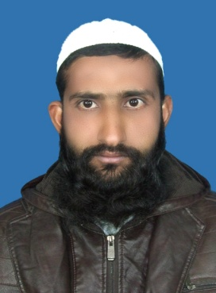

**MUTTAHER ULLAH KHAN**

**S/O**

**ALIF GUL**

**NIC: 11101-9733520-1**

**Domicile: Bannu**

**Date of Birth:**

**10-05-1989**

**HOME ADDRESS:**

**Village & P/O Ismail Khel**

**District Bannu**

**K.P.K Pakistan.**

**Cell# 0334-8856873**

**Email:**

[**muttaherullahkhan@gmail.com**](mailto:muttaherullahkhan@gmail.com)

**References:**

**Are available on request**