# **MASSUD UMER**

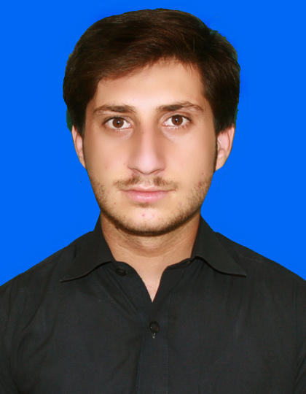

### Personal Information:

### Father’s Name : Muhammad Aurang Zeb Khan

Domicile : Bannu, KPK, Pakistan.

National Identity Card No. : 11101-4800305-3

# Mobile No. : +92-334-9722880

# E-mail : massudumer0334@gmail.com

Date of Birth : 04th September, 2002

Blood Group : A+

Marital Status : Single

Gender : Male

Nationality : Pakistani

Religion : Islam

Permanent Address : Village Kafshi Khel Babu Jan, **UC Garhi Sher Ahmad**, District Bannu,

KPK, Pakistan.

**Academic Qualifications:**

|  |  |  |  |  |  |  |
| --- | --- | --- | --- | --- | --- | --- |
| **Degree** | **Year** | **Grade** | **Marks** | **%** | **Institution Attended** | **Board/University** |
| BS Maths  16 Years | 2023 | “A+” | 3969/4700 | 84% | GPGC NO.1 Bannu | University of Science and Technology Bannu |
| FSC  (Pre-Eng)  12 Years | 2019 | “A” | 774/1100 | 70% | GDC No.2 Bannu | B.I.S.E Bannu |
| Matric  (Science)  10 Years | 2017 | “A+” | 931/1100 | 85% | Iqra Public High School Bannu | B.I.S.E Bannu |

**Professional Qualifications:**

|  |  |  |  |  |  |  |
| --- | --- | --- | --- | --- | --- | --- |
| **Degree** | **Year** | **Grade** | **Marks** | **%** | **Institution Attended** | **Board/University** |
| Diploma In Information Technology  (DIT) | 2022 | “A+” | 1135/1400 | 81% | Bannu Institution 0f Education Science & Technology Bannu | KPK Board of Technical Education Peshawar |
| Computer and Typing Courses | 2023 | “A+” | 181/200 | 91% | Fahim Commerce Academy | Fahim Commerce Academy |
| English Language | 2021 | “A+” | 169/200 | 85% | English Study Institute | English Study Institute |

**Languages: Speaking Reading Writing**

English : Excellent Excellent Excellent

Urdu : Excellent Excellent Excellent

# Pashto : Excellent Excellent Excellent

**Computer Skills:**

* Windows XP, 7, 8 and 10.
* Expert in managing Computer Hardware and all kinds of Software.
* Installation and operation of all types of Driver’s and Software’s.
* Strong command in Microsoft Office.
* Internet with all necessary Application’s.

**Experience:**

* 1 Year Experience in **CEM** Bannu as a teacher of Mathematics.
* I had worked in **Own** **Academy** for about four years.

**From July 2019, to till date.**

* I had worked as **mobile team leader** for about two years.
* I am working as **member of PTP team** for three years.

**From June 2020, to till date.**

**Career Objectives:**

I am seeking to obtain a position that will enable me to increase my skills and advancements and to pursue a challenging career in a prestigious field. I have excellent interpersonal and administrative skills.

**About Me:**

* I am a workaholic person.
* I always look for innovation.
* My strong point is to turn instructions into production.