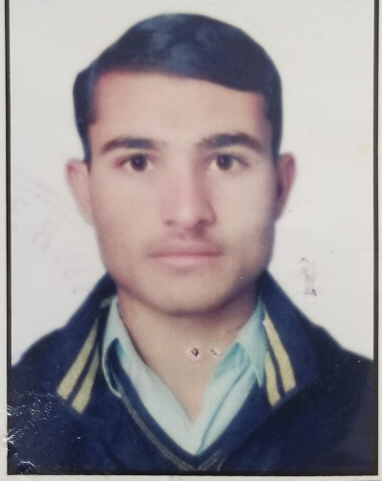

**Dr. MEHMOOD KHAN**

**Registered dental surgeon**

**Cell:03128026219**

**Email: mehmoodkhan368@gmail.com**

**Address: Quetta**

.

Profile Summary

*My name is Mehmood Khan I am graduate Of BOLAN MEDICAL COLLEGE, QUETTA batch 2016-19*

*I completed my house job from Sandmen Provincial Hospital Quetta.*

*Besides, my medical schooling, I have volunteered in several health sciences activities i.e.; medical camps first aid programs, dental research, and health associated seminars.*

*With the aim to deploy my Personal and Professional goals in medical sector, I am working to enhance my capacity as medical trainee, developing my surgical skills and increase my knowledge in concerned field.*

Education

**SSC (METRIC)**

**FBISE**

**QUALIFYING YEAR 2013**

HSSC (Intermediate)

FBISE

Qualifying Year: 2015

Bachelor of dental surgery

University of Baluchistan

Qualifying Year: 2022

**MHCM** ( Masters in health care management) 3rd Semester

Ziauddin University Karachi

Dental and medical seminars/camps/symposium

During my career I have attended / conducted following:

3 days seminar on orthodontics and prosthodontics {PPA-PAO conference 2019}

1 day seminar on oral hygiene by helping hands

Experience

House officer in Sandmen Provincial Hospital, Quetta.

JULY 2022 to JULY 2023

**Brief of Activities:**

*Carried out survey in the multiple Districts  regarding fluorosis, water fluoridation and its wide spread.*

**Worked as Polio Officer in zhob for one year**

Dental and surgery skills

Scaling

RCT

Restorations

Extractions

Minor Oral Surgeries

Dentures

Impressions

Orthodontic wire works

**Languages.**

|  |  |  |  |  |
| --- | --- | --- | --- | --- |
| Language | Understand | Speak | Read | Write |
| Urdu | Excellent | Excellent | Excellent | Excellent |
| English | Excellent | excellent | Good | Good |
| Brahvi | excellent | excellent | Good | Good |
| farsi | excellent | excellent | Nill | Nill |
| Pashto | excellent | Good | Nill |  |