Curriculum Vitae
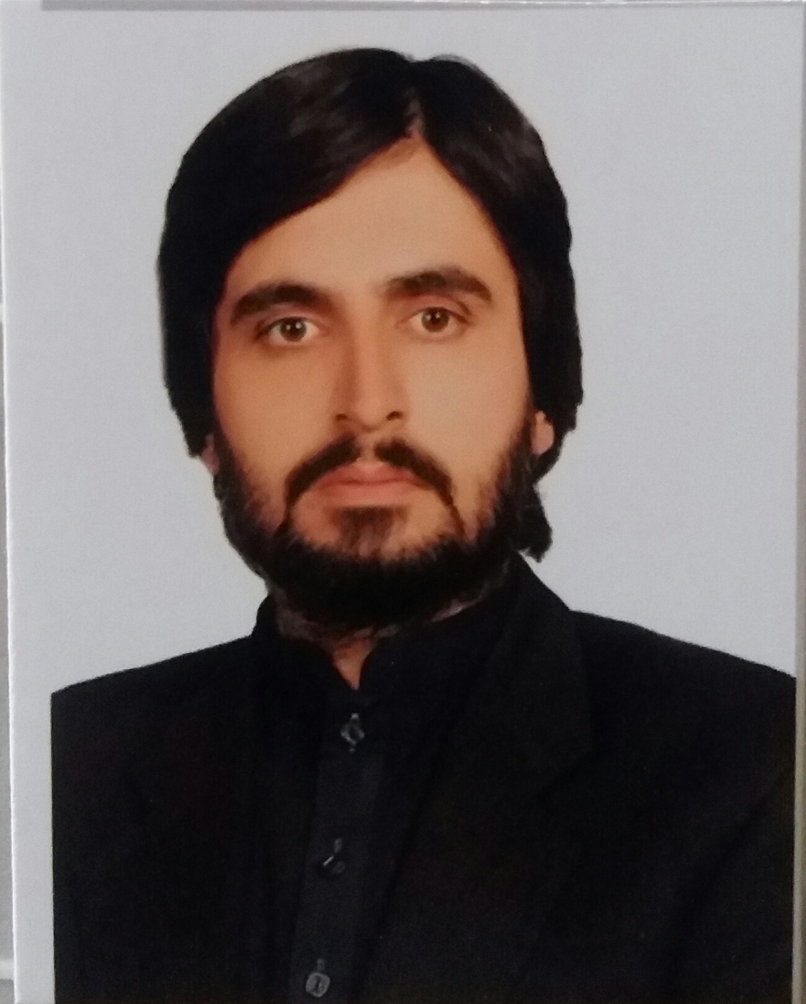
Muhammad Amir
S/O Abdul Kareem
E-MAIL:haji39544@gmail.com
Mobile No: 03337931973
UNION COUNCIL PIRALIZAI 1 KILLA ABDULLAH
``````````````````````````````````````````````````````````````````````````````````````````````````````````
Objectives:
To work in challenging environment where I can
Use my expertise to make valuable contribution.

Personal details:
N.I.C.NO 54203-7088540-7
Date of Birth 14-08-1988
Marital Status Married
Religion Islam
Local Killa Abdulah
Nationality Pakistani
Education:

2014 Bachelor of Education ,
1ST Division
Universty of Balochistan Quetta

2006-2010 BUITEMS Quetta Balochistan
BS (International Relations)
CGPA 3.14

2006 B.R.C Loralai Balochistan

Intermidate 2nd DIVISION

2004 Cambridge Secondary School
Quetta Balochistan

H.S.SC 1st DIVISION

SOCIAL EXPOSURE:

- Attended Seminar on Research Methodology on August 4, 2010
- Attended online Seminar between the University of Malaya and BUITEMS on Democracy in Myanmar in June 2010.
- Attended Red Cross International orientation session and a Seminar in BUITEMS
- Attended Pakistan Red Crescent Society workshops
- Being the part of Organizing committee BUITEMS 5th Convocation
- Attended three days workshop on Youth in Governance by Transparency International, Pakistan in April 2008

WORK EXPERIENCE:

○ Worked as third party monitor in TKF from march 2021 to march 2023.
○ Worked as a union council polio officer from march 2016 to march 2021.
○ Worked as social mobilizer in polios from 2015 to 2016.
o worked in private school for one year 2014 to 2015.

COMPUTER PROFICIENCY:

- MS Office including MS Word, MS excel, MS Access, MS Power Point
- Adobe Photo Shop
- Advanced internet searching.
- Microsoft Windows (98,2000,XP, Vista)

PROFESSIONAL SKILLS

- Good Oral and Communication Skills
- Good Analytical Skills
- Team Building and Leadership Skills

MANAGEMENT SKILLS

- Analyze to solve the problems
- Work Closely with others in team
- Work in difficult situation with tact.

LANGUAGES

- English (Speak, Read and Write)
- Urdu (Speak, Read and Write)
- Pashto (Speak, Read and Write)

REFERENCES

- Mr. Tariq Mehmood
Chairperson, Department of Social Science at BUITEMS
Cell No: 0345-8169068
E-mail: tmuzi@yahoo.com

- Mr. Haider Iqbal
Lecturer in International Relations at BUITEMS
Cell No: 03465241843
E-mail Address: hihb_79@yahoo.com

